Chemistry A-LEVEL: SUPPORT SHEET FOR STUDENTS AND PARENTS
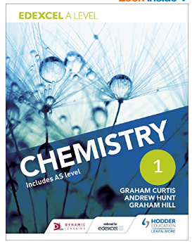
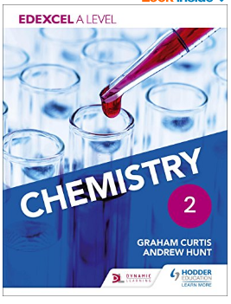
Chemistry 2018-19
Teachers
Fiona Kennard (Head of Dept) fvk@godalming.ac.uk
Mona Chaudhury
Harriet Broughton

Exam board Pearson (often known as Edexcel)
Chemistry rules!
Recommended Textbooks – Copies are in the Library as well as online
- Show up
- Do the work
- Ask if you get stuck
Students should aim to complete 4-5 hrs outside of class as additional work, either as homework or consolidation. At A level we expect 50% of the learning to happen outside of the classroom.
Chemistry clinic Every Friday 1-2pm in lab 141. Every Tuesday after college
Revision sessions will run after Christmas.
Students: Where can students get help for themselves?
Teachers are there for guidance with your studies but we maybe different from your school in that we would expect you to have accessed support materials and tried to work out any misunderstandings yourself before seeking out extra help. Rather than coming to a teacher saying ‘I do not get moles’, try to look at websites, textbooks etc. to answer the question yourself first, there is guidance on this in the front cover of every pack. You can then approach the teacher with more specific questions, either in the lesson or at one of the chemistry clinics. The onus is then on you to take responsibility for your learning. If you have finished the work set and still have some of your 4-5 hrs left the packs will also give guidance of the extra work you could be doing.

Parents: How can you help?
We often get asked by parents of students studying for the A level examinations what things they can be doing to help them achieve the best possible grade.

Whilst almost all the work that is required to be successful at A level must come from the student there are some things that parents can do that can help :-
- Students work through booklets which build into a complete set of notes for the course. These packs contain notes as well as exam questions and should be completed to the best of their ability. They should be spending 4-5hrs per week on their chemistry.
- At the end of every topic they will be given an assessment– ask how they performed in the test and encourage them to spend time revising and consolidating content ahead of it.
- Encourage them to attend the drop in workshops run by the Department Tuesdays, after college and Fridays lunchtimes for extra help with topics they are finding difficult.
- Learning cannot happen just in the classroom. They have to be responsible for that learning as well. It is something we drill into them from the beginning of their studies. 50% of their learning is expected to happen in the classroom but 50% is also expected OUTSIDE the classroom.

Chemistry Benchmarks
 | Topic | Dates | time
Benchmark 5 | Organic & Spectra | w/b 5/11 | 1.5 hrs
Benchmark 6 | Paper 2 (Organics and Kinetics) | w/b 07/01 | 1.75 hrs
Benchmark 7 | Paper 1 (excluding transition metals | w/b 23/04 | 1.75 hrs

Chemistry Papers (A Level)
Paper 1 All blue and green packs
Paper 2 All yellow and green packs
Paper 3 All topics with the emphasis on Practical work

What happens if a student is underperforming?
At Godalming College, there is an ethos of ‘dealing with the student first’. We will work with you to achieve your studies as best we can and parents are only contacted at the review times of January, June in the first year and November and March of the second year. However some students struggle with Chemistry and find they are unable to learn effectively for whatever reason. If your teachers are significantly worried about your progress, the department will place you onto a ‘Departmental Action Plan’ (DAP) as sanctioned by the Head of Department outside of these review periods. This is where we formalise contact with your parents through a bespoke action plan so that you, the department and your parents can all help you to achieve your potential. These action plans are a supportive mechanism to get you back on track. A failure to meet the action plan will mean that you are referred to your Senior Tutor for further support. Where a student is culpable for their underperformance, the Senior Tutor may decide to place you onto a Formal Warning under the College’s disciplinary procedures. Where a student is struggling for health or other extenuating circumstances, the Senior Tutor may place you onto a ‘Supportive Warning’ to further support your studies.

