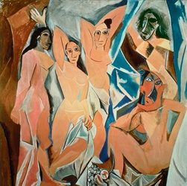Key work: Picasso

**Les Demoiselles d’Avignon**

* **Date:** 1907
* **Size:** 243.9 cm × 233.7 cm
* **Material:** oil on canvas
* **Current location:** MOMA, New York
* **Scope of work:**
* Painting influenced by **primitive** ideas by a **non-French** artist
* The **female figure** by a **non-French** artist

NB: (Do NOT use this as a Portrait painting)

**Research questions:**

1. What does the title translate to?
2. Where and what was the Avignon street?
3. How many figures are there?
4. One critic said that these figures have “been carved with an axe”. Which figures do you think this particularly applies to?
5. Write down the ‘primitive’ influences/sources for EACH of the figures.
6. How does this work challenge conventions of beauty in art?
7. How does this work challenge conventional depictions of space and depth in painting?
8. How does this work challenge the conventional use of pose and gesture in paintings of the female figure? *(Make sure you make your commentary detailed by referring to specific figures)*
9. How does this work challenge the conventional use of colour?
10. This work is usually referred to as a ‘Proto-Cubist’ work. Explain what is meant by this term and the features that are used to link this work with this term?
11. 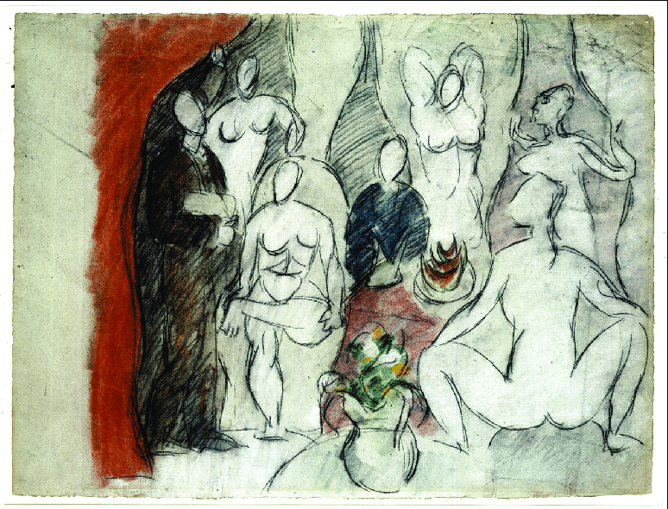Picasso made many preparatory sketches for this work. Look carefully at the example on the right. What changes can you find between this and the final work?
12. The medical student on the left of this sketch holds a skull. This is an example of a ‘memento mori’. What do you understand by this term? How do you think the narrative of the painting would have been changed if these figures and this element had been included in the final version?
13. Now look at the ‘still life’ element at the front of the work – both in the sketch and in the final version. How do you interpret this? How can this be seen as yet another challenge to traditional art?

**Further research:**

* Khan Academy Les Demoiselles: <https://www.khanacademy.org/humanities/ap-art-history/later-europe-and-americas/modernity-ap/v/picasso-les-demoiselles-d-avignon-1907>
* Les Demoiselles Painting of the Week: <https://www.youtube.com/watch?v=io_dP5Tm0Qw>
* Overview of Cubism: <https://www.youtube.com/watch?v=DSZMlfm1Ln0>
* Joachim Pissarro (MOMA) discusses the work with students: <https://www.youtube.com/watch?v=pngGDycLQuE>
* **Documentary (2002): Matisse meets Picasso** <https://www.youtube.com/watch?v=_b2eTU6fOEE> (This will offer you some great material for critical texts and debates) We will also explore Cubism and Picasso’s Still Life with Chair Caning is another key work, so please watch the programme to the end and take notes on both the style and development of Cubism and specifically short quotes on Matisse to support your knowledge of your ‘specified painter’ for this module.
* Read this article by Alastair Sooke for BBC Culture <http://www.bbc.com/culture/story/20170113-the-moment-that-changed-picasso> Think carefully about the relevance of his claims of the importance of Romanesque art on the ‘primitive’ art debate
* Alastair Sooke’s documentary series on Modern Masters is excellent. All three are on the GOL estream. The link to the Picasso one is here: <http://estream.godalming.ac.uk/View.aspx?id=5728~4w~xZCtoHiB> but you should certainly watch the Matisse one too, if you have not already done so.
* And Andrew Graham Dixon’s Culture Show special on Picasso is also on GOL estream: <http://estream.godalming.ac.uk/View.aspx?id=4642~4q~qOPdeqUL> Use this as a guide **to produce an image sheet which covers Picasso’s early years in Paris between 1900 and the date (1907)** of Les Demoiselles.

*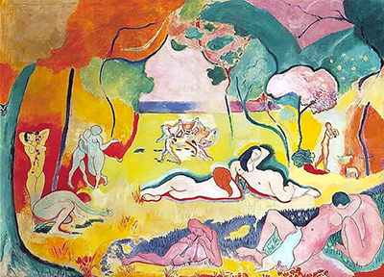On lined paper, write up the following:*

1. Compare Matisse’s **Joy of Life** (1906) to Picasso’s **Les Demoiselles d’Avignon** (1907)

*Make sure you cover the following:*

* Handling of subject matter (and challenges to the conventional depiction of the female figure/nude)
* Colour
* Size
* Space and depth
* Light and tone

1. Time yourself: In 5 minutes, explain why Picasso’s Les Demoiselles is considered a Proto-Cubist work. Make sure you have detailed and specific evidence to support your argument.
2. 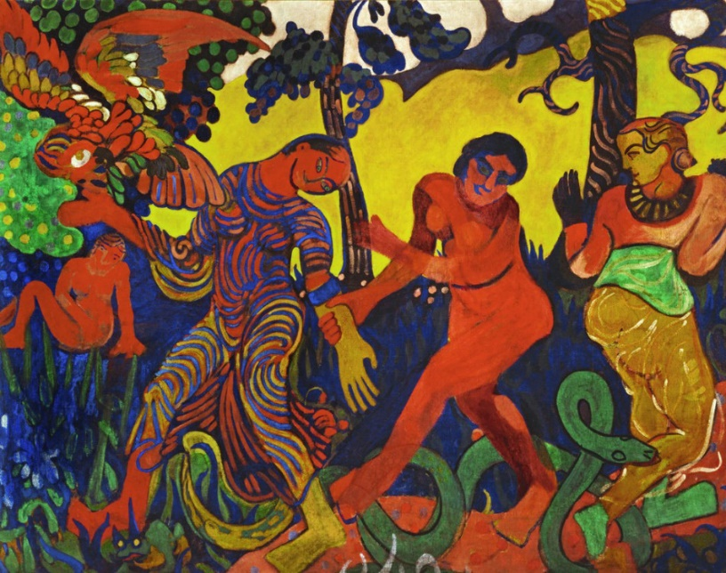Now compare Picasso’s work with Derain’s **Dance** (1906) in terms of their individual response to ‘primitive’ ideas:

*Make sure you consider the following:*

* Sources of primitive inspiration
* Reasons for their significance
* Comparison of the ways in which each artist has used these ideas

**Summer holiday homework:**

*To be completed for the first week back in September:*

1. Ensure that all your key work booklets and notes for **Identities** are complete and that your files are properly organised.
2. Make sure you have detailed notes on EACH of the following KEYWORKS for **European Modernism** that we have completed so far. You should use the holidays to add to your independent research to the best of your abilities on each work. Suggestions are listed in the key works booklets and always remember to check SmartHistory etc. These five works are:
   1. Matisse **Madame Matisse in a Hat**
   2. Derain **Charing Cross Bridge**
   3. Derain **The Dance**
   4. Paula Modersohn-Becker **Reclining Mother and Child**
   5. Picasso **Les Demoiselles d’Avignon**
3. Write two short essays (750 words each). These must be handed in on your first lesson of next year, which will be week beginning 10 September.
4. Explore and evaluate the representation of the female figure in two paintings.
5. Explore and evaluate the appeal of ‘primitive’ artefacts in two works of art produced during this period.