Los personajes en la casa de Bernarda Alba

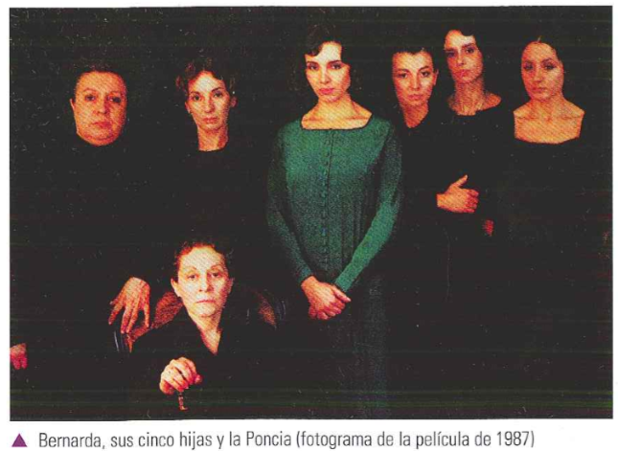

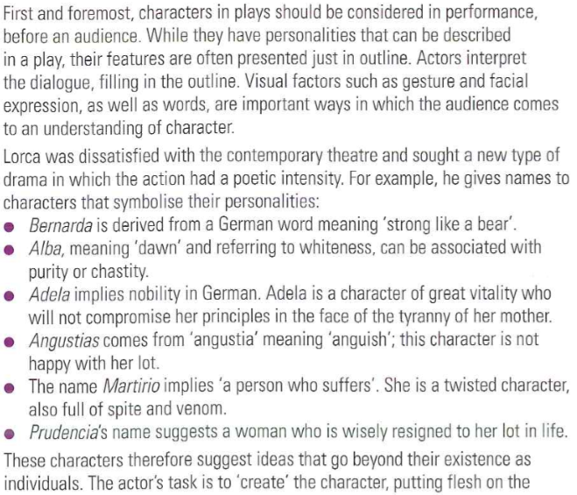

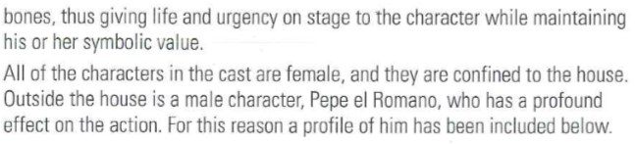

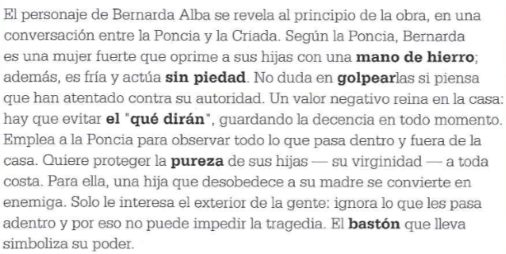Bernarda

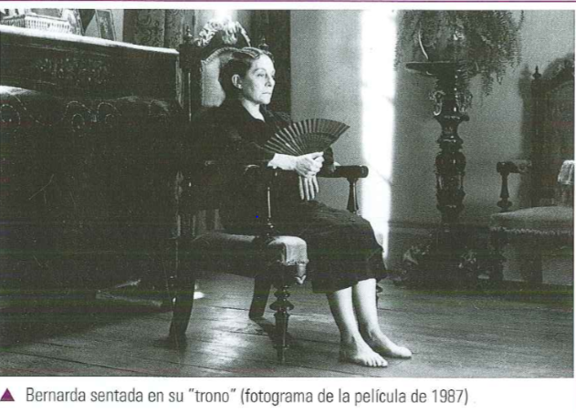

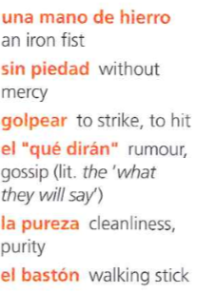

Task 1 :

Encuentra cinco adjetivos que demuestren la personalidad de Bernarda

1. ____________________________________________________________
2. ____________________________________________________________
3. ____________________________________________________________
4. ____________________________________________________________
5. ____________________________________________________________

Task 2

Quote : Explica “hasta que salga de esta casa con los pies por delante mandaré en lo mío y en lo vuestro” (acto primero)

____________________________________________________________

____________________________________________________________

____________________________________________________________

____________________________________________________________

____________________________________________________________

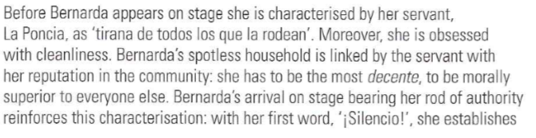

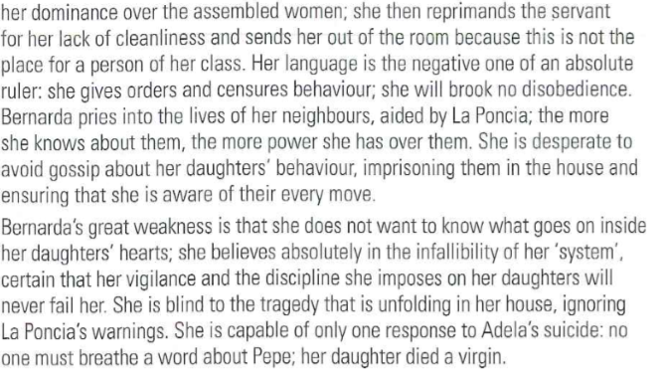

Task 3

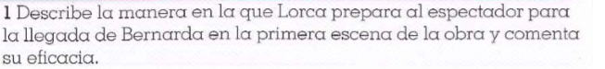

________________________________________________________________________________________________________________________________________________________________________________________________________________________________________________

________________________________________________________________________________________________________________________________________________________________________________________________________________________________________________

________________________________________________________________________________________________________________________________________________________________________________________________________________________________________________

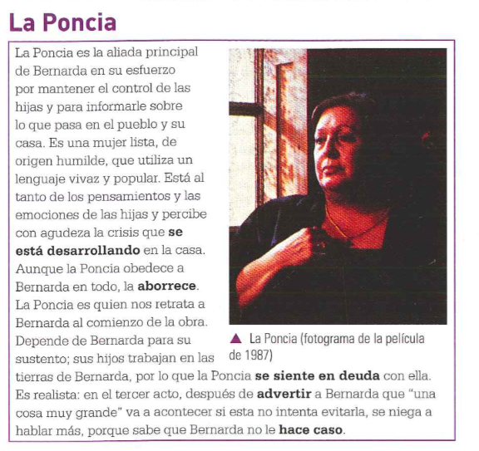

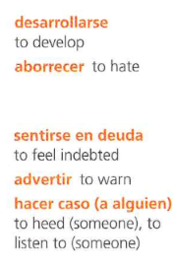

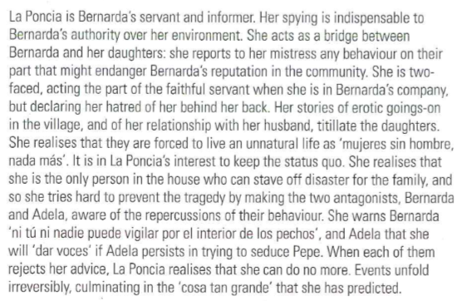

Task 4 :

Encuentra dos ocasiones en las que la Poncia actúa como “buena perra” para informar a Bernarda de lo que pasa en la casa o en el pueblo

________________________________________________________________________________________________________________________________________________________________________________________________________________________________________________

________________________________________________________________________________________________________________________________________________________________________________________________________________________________________________

________________________________________________________________________________________________________________________________________________________________________________________________________________________________________________

asasas

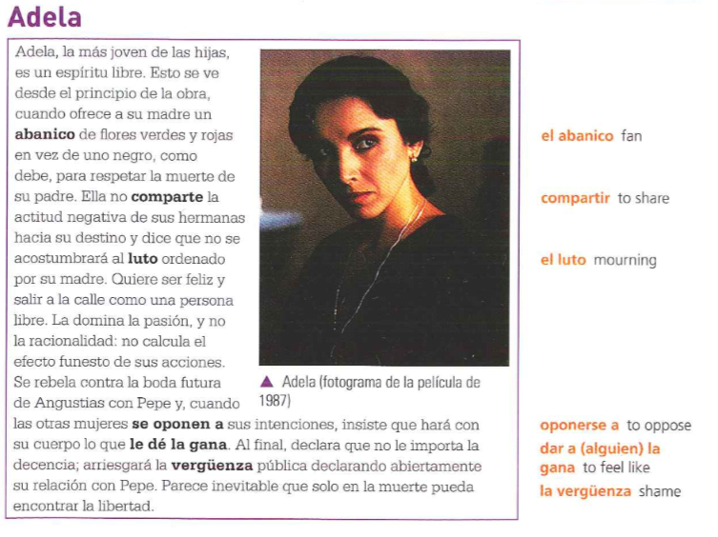

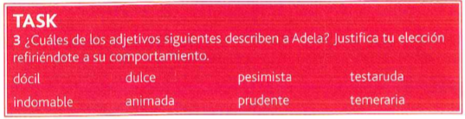

________________________________________________________________________________________________________________________________________________________________________________________________________________________________________________

________________________________________________________________________________________________________________________________________________________________________________________________________________________________________________

Task 6

Quote : Explica “Seré lo que él quiera que sea. Todo el pueblo contra mí, quemándome con sus dedos de lumbre, perseguida por los que dicen ser decentes…” (acto tercero)

________________________________________________________________________________________________________________________________________________________________________________________________________________________________________________

________________________________________________________________________________________________________________________________________________________________________________________________________________________________________________

________________________________________________________________________________________________________________________________________________________________________________________________________________________________________________

________________________________________________________________________________________________________________________________________________________________________________________________________________________________________________

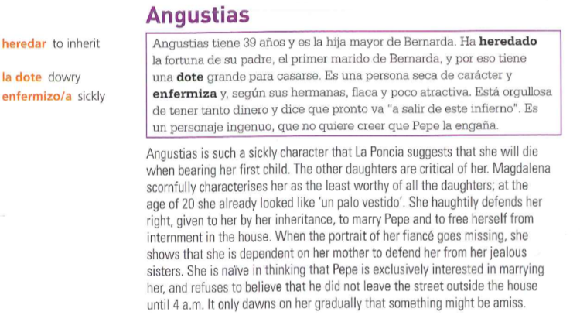

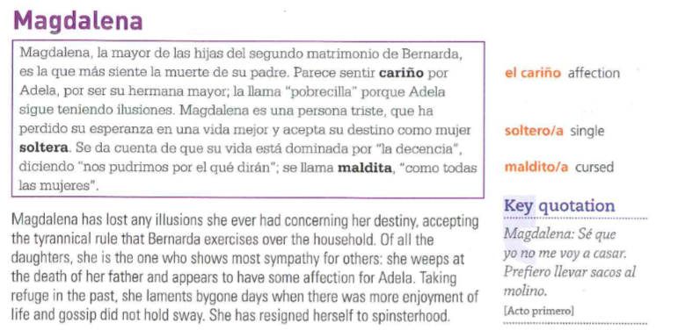

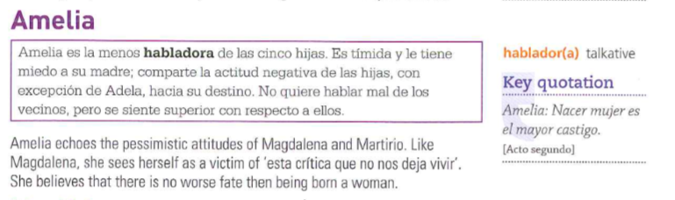

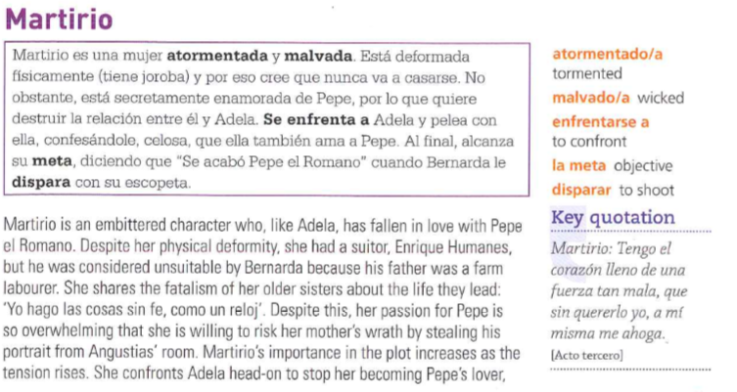

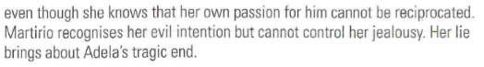

Task 7:

Compara los personajes de Martirio y Adela y explica porque las dos hermanas pelean al final de la obra .

________________________________________________________________________________________________________________________________________________________________________________________________________________________________________________

________________________________________________________________________________________________________________________________________________________________________________________________________________________________________________

________________________________________________________________________________________________________________________________________________________________________________________________________________________________________________

________________________________________________________________________________________________________________________________________________________________________________________________________________________________________________

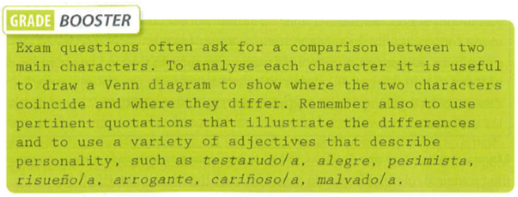

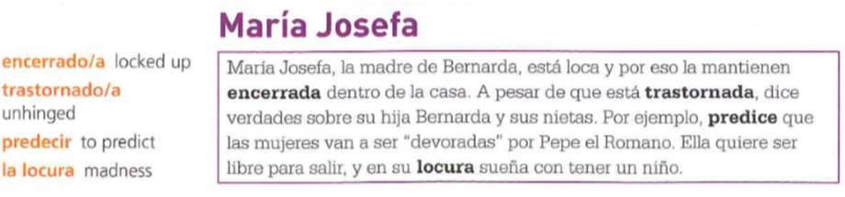

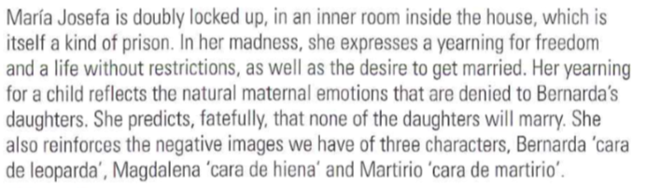

Task 8:

Encuentra tres maneras en las que Maria Josefa comenta sobre la situación de Bernarda y sus hijas .

________________________________________________________________________________________________________________________________________________________________________________________________________________________________________________

________________________________________________________________________________________________________________________________________________________________________________________________________________________________________________

________________________________________________________________________________________________________________________________________________________________________________________________________________________________________________

_______________________________________________________________________________

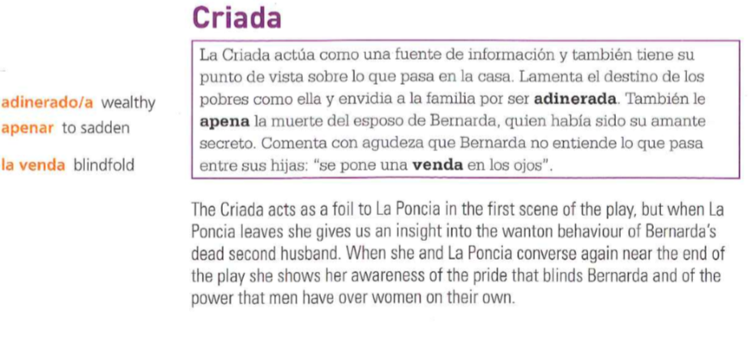

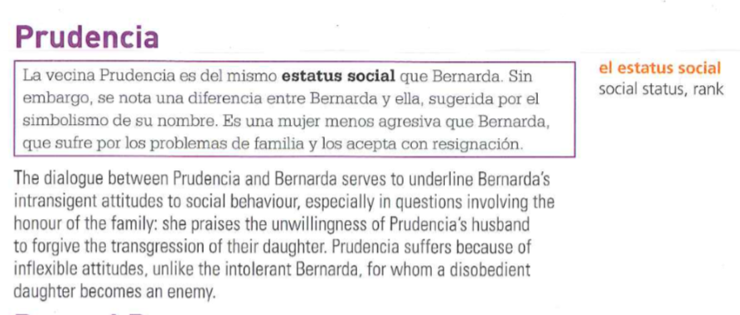

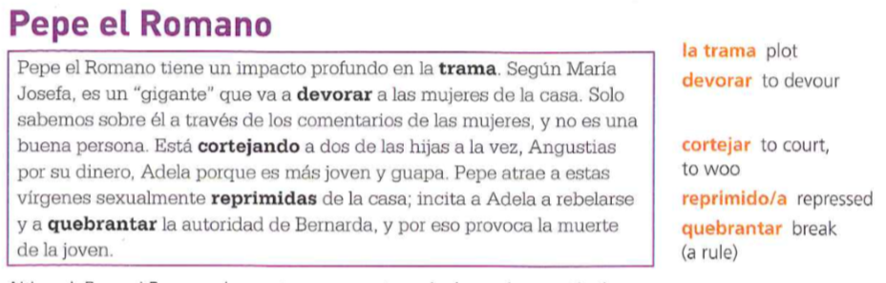

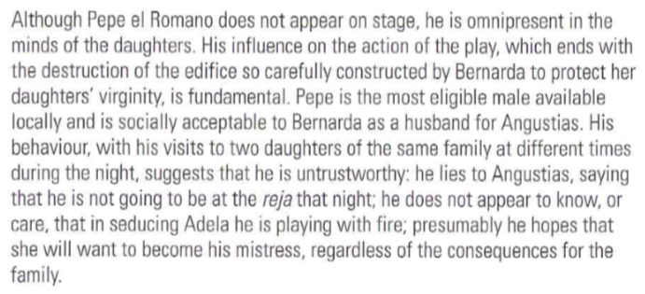

Task 9:

Identifica tres ocasiones en la obra en las que se mencione a Pepe el Romano y describe la reacción que esto provoca en la casa .

________________________________________________________________________________________________________________________________________________________________________________________________________________________________________________

________________________________________________________________________________________________________________________________________________________________________________________________________________________________________________

________________________________________________________________________________________________________________________________________________________________________________________________________________________________________________

_______________________________________________________________________________

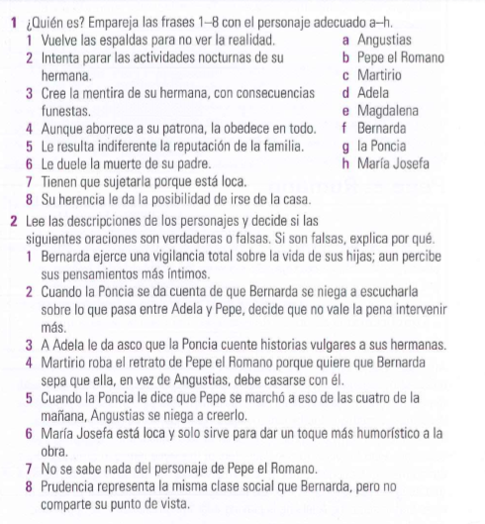**Task 10**

**Tasl 11**

**Lee la pregunta y escribe un ensayo (mínimo 300 palabras) para responderla.**

1. **¿Hasta qué punto estás de acuerdo con estas opiniones?**

*“Bernarda no es un personaje real, sino simbólico. Carece de sentimientos humanos y se muestra unidimensional. Seca por dentro, sin lágrimas que llorar, muerta en vida, no puede ser un personaje identificable en nuestra realidad inmediata. Su terreno es la literatura.”*