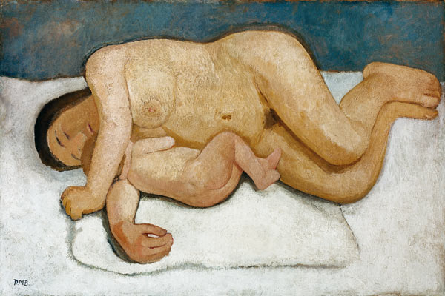Key work: Paula Modersohn-Becker

**Reclining Mother and child**

* **Date:** 1906
* **Size:** 32.5 x 49 inches
* **Medium:** oil on canvas
* **Display location**:
* **Scope of work**: The female figure

**Research:**

1. Where did she train?
2. What was Worpswede?
3. When and why did she come to Paris?
4. Which artists was she influenced by?
5. How does this influence show in her work?
6. Find her life dates. When and how did she die?
7. Compile an image sheet of a further four works by Modersohn-Becker to give yourself a better understanding of her portfolio.
8. What media did she work in? Evaluate the significance of this choice?
9. Where was her work displayed and sold?
10. What was the critical response to it at the time?

**Visual Analysis**

Comment on the following formal features of this work:

|  |  |
| --- | --- |
| Composition: |  |
| Colour: |  |
| Space and depth: |  |
| Light and tone: |  |
| Line and brushwork: |  |
| Size and scale: |  |

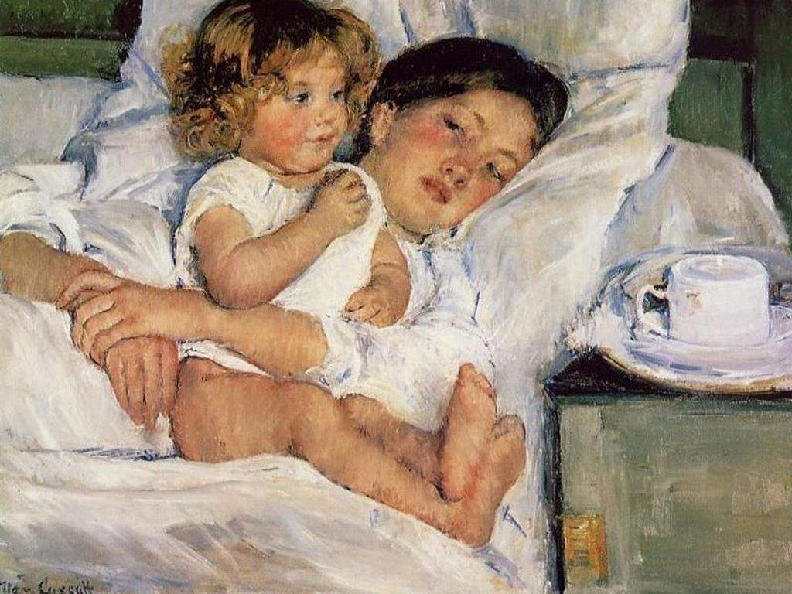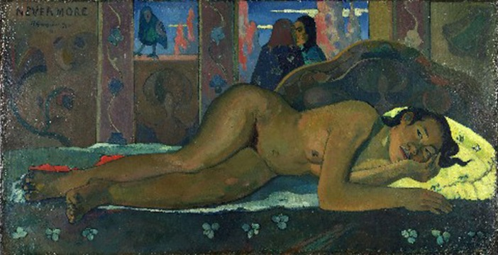[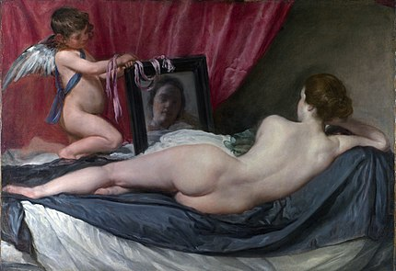](https://en.wikipedia.org/wiki/File:RokebyVenus.jpg)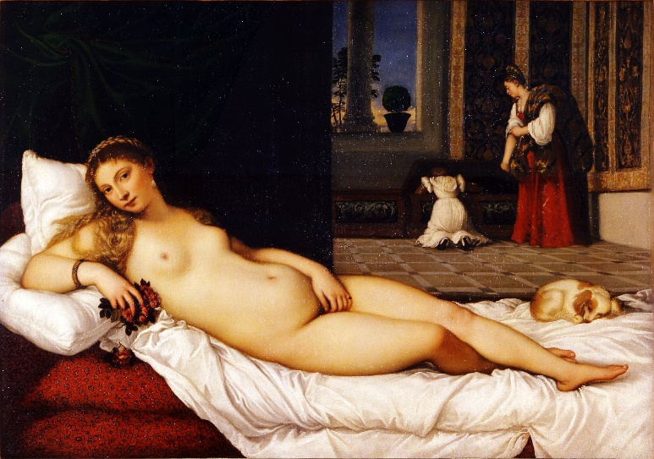Now think about her choice of subject matter and the message/meaning behind this. Look at the following images of mother and child, reclining female figure by other artists, to help you think and evaluate Modersohn-Becker’s ideas and achievements.

Modersohn-Becker is described stylistically as a ‘proto-Expressionist’. Explain – in your own words – what this term means and the characteristics associated with it.

Key characteristics of Expressionism:

Whitney Chadwick writes that Modersohn-Becker painted at a time when art drew its stylistic innovations from an “erotically based assault on the female form”. While her contemporary male artists, painted prostitutes, nudes, ‘primitives’ in a world in which women were dominated by men, is it possible to argue that Modersohn-Becker (along with Frida Kahlo and Suzanne Valadon) turned to women’s bodies as the central subject of the female experience? The figures here have not been organised or displayed for male viewing pleasure.

How is the female figure presented here?

**Written response** (approximately 500-750 words): Assess the impact of being a female artist at this time. Make sure that you refer to this work in detail while exploring the following ideas:

* Choice of subject matter
* Training and influences
* Commissioning and selling opportunities
* Techniques, materials, innovation
* Critical response
* Evaluate her achievement