Pierre Auguste Renoir, *Bal du Moulin de la Galette,* 1876, oil on canvas, 131cm x 175 cm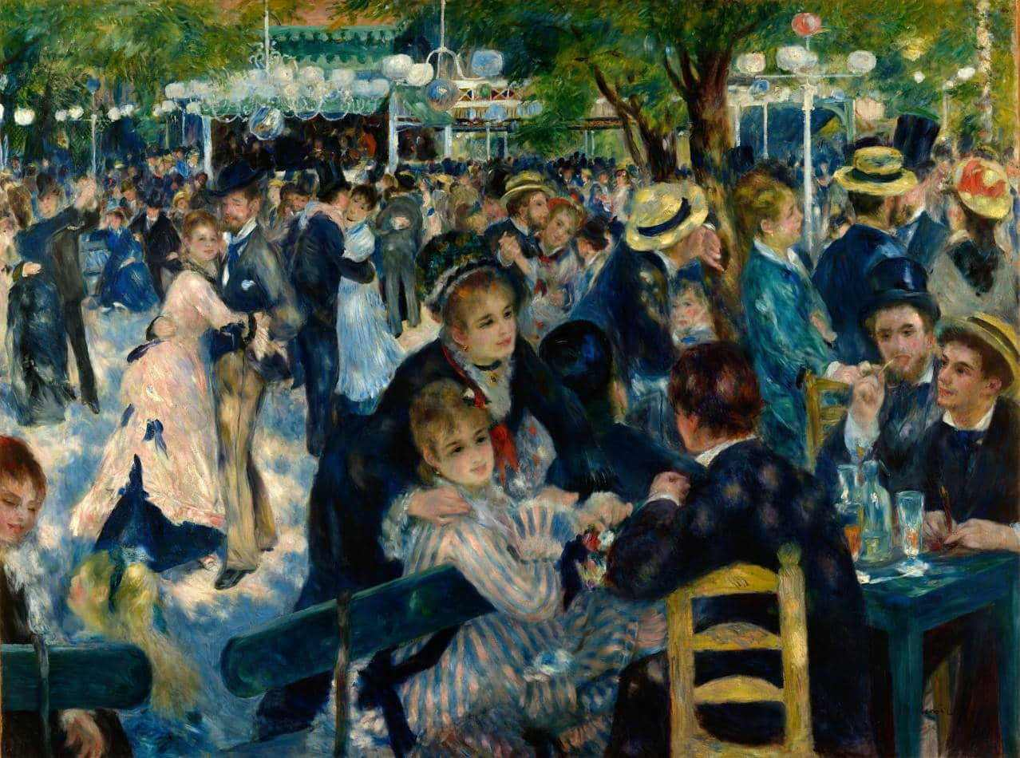

Considered an iconic example of Impressionist painting, this large scale work was painted outdoors by Renoir in the Montmartre area of Paris. At this time Montmartre was a village on the outskirts of Paris and was predominantly working class. Accessible by train, it was a popular destination for people on Sunday afternoons. The owners of the moulin, which is French for ‘windmill’, specialised in a pastry known as a galette. They had an open-air dancehall and people would come here to eat, drink, dance and socialise.

We see a large group of people of all ages placed outside on a sunny afternoon. Both male and female figures are shown dancing, chatting and in pairs or groups. A canopy of leaves above the crowd creates a dappled effect and Renoir shows the bright sunlight falling in patches on the figures beneath.

The composition is crowded and appears asymmetrical. A group in the foreground near the viewer are seated on benches and wooden chairs around a table. One man appears bareheaded, emphasising the relaxed atmosphere of the scene. A man smokes, while another, the art critic Georges Rivière appears to be writing. Two young women have joined this group and converse with the men. One sits with her arm draped over the back of the bench while the other rests her hand on the seated girl’s shoulder. There is an air of casual informality to the figures. The seated foreground figures placed on either side of the painting have been cropped, suggesting this is a snapshot of daily life and possibly showing the influence of photography on artists at this time.

Behind them we see a man leaning against a tree who appears to be whispering into the ear of a woman who stands on the other side of the tree. A dancing couple on the left seem to have made eye contact with the viewer, gazing directly back at us, she leaning in towards him while similar couples dance around them. All these couples emphasise the air of romance and enjoyment.

All the figures are in clothing contemporary to the era. Many of the men wear straw hats, while others wear top hats, showing a mix of classes. The light colours of the women’s dresses contrast with the dark navy and black tones of the men’s suits and jackets. Renoir is suggesting a sense of unity in this crowd who have come to this area simply to relax.

Above the heads of the figures we see clusters of white rounded lampshades which contrast with the green of the leaves. A bandstand with orchestra in the background further emphasises the theme of leisure and indicates the source of the music that the crowd dance to.

Paint has been applied loosely, giving a sense of movement to the dancing figures and making the scene appear active. Dabs of bright paint are used to great effect to suggest light streaming through the leaves and falling on the forms beneath. Background forms and figures are sketched in swift gestural brush marks, demonstrating atmospheric perspective and typical of Impressionism. The foliage of the trees is rendered in quick linear brushstrokes and washes of thin paint, all typical of Impressionism. The faces of the crowd have been simplified and many appear blurred, to suggest they are in motion and actively engaged in chatting or dancing. Despite the simplicity of their features Renoir had used many of his friends and favourite models to pose for the figures in this work. Renoir’s application of paint creates a sense of unity across the image. There are no solid hard outlines and instead forms and figures seem to merge and dissolve into the setting.

The overall palette of colours is bright, to indicate a sunny day. Yellow appears throughout and is found in the straw hats of both men and women and also the blonde hair of a young girl on the left of the scene. Accents of pink and blue appear across the image. The centrally seated girl wears a blue and pink striped dress and these colours are repeated on the ground behind her as well as the clothing of other women. Renoir, as with the other Impressionists, used blue to indicate shadow and we see evidence of this most clearly on the ground the figures dance upon as well as the yellow straw hats worn by the central figures stood beneath the tree. Patches of white indicate highlights and emphasise the idea of bright sunlight. A still life grouping of glasses and a bottle on the table in the foreground show this most clearly. The seated foreground figure with his back to us has patches of lighter blue spread across his shoulders and back, again representing dappled sunlight falling on his clothing.

In keeping with the Impressionist’s wish to depict natural light as accurately as possible, Renoir painted this scene outdoors, made possible by the recent development of oil paint being available in tubes. He rented a house in Montmartre, using the ground floor as a studio to store the painting and each day, with the help of friends, he would carry the large canvas to the dancehall at the Moulin de la Galette to capture this scene. Renoir spent over six months on this work and it was exhibited at the Third Impressionist Exhibition in 1877.

Georges Rivière, art critic and friend of Renoir wrote of the work; “In a garden inundated with sunlight…..there are charming young girls…proud of their homemade dresses fashioned of inexpensive material, and young men full of gaiety……it is a page of history, a precious moment of Parisian life, one with rigorous exactitude. No one before him had thought of portraying an event in ordinary life on a canvas of such big dimensions”.

Renoir would make a smaller, second version of this work, now privately owned.

**Web links for this work.**

1. SmartHistory weblink: <https://www.youtube.com/watch?v=o6amlRsb1n4>

2. Analysis: <http://www.visual-arts-cork.com/paintings-analysis/dance-at-le-moulin-de-la-galette.htm>

3. Musée d’Orsay page on the work: <http://www.musee-orsay.fr/en/collections/works-in-focus/search/commentaire/commentaire_id/bal-du-moulin-de-la-galette-7083.html?no_cache=1>

4. Google Art Project (for close-up details): <https://artsandculture.google.com/asset/dance-at-le-moulin-de-la-galette/rQEx7CtGiKE3yg>

1. In your sheet for annotation identify where you see the following effects: sunlight, shadow, highlights, atmospheric perspective, dappled sunlight, cropping. Also pay attention to where blue is used for shadows and tonal ranges.

2. Find three more examples of **outdoor** leisure scenes by other Impressionists from the years 1870-1877. Attach to this document.

3. How does Renoir achieve the aims of the Impressionists in this painting?

4. Georges Rivière described this painting as ‘a page of history’. What does he mean?

5. Read this short article on Renoir’s friendship with Monet. <https://www.claude-monet.com/monet-and-renoir.jsp> Each painted a work titled ‘La Grenouillère’ in 1869. Attach images of those two paintings here and consider what similarities there are in technique. Can you identify Renoir’s work more easily?

6. What visual evidence is there to show that this work was painted plein air?

7. Consider the scale of this work. What might be Renoir’s aim?

**Potential exam questions which this work can be used to answer.**

Part A) Explain how light and tone has been used in one painting from this period.

Part A) Analyse the composition in one painting of this period.

Part B) Explain how one painting is Impressionist in style.

Part B) Analyse one painting which depicts a scene of leisure.

Part B) Explain how one French painting of this period is avant-garde.

Part B) Explain how one painting of this period has been shaped by its **social and** **cultural** context.