Dynamic Learning Website

Please access this site to read various excellent magazines for which the college pays a subscription.

Two that will interest you especially are:

**The Business Review and**

**The Economic Review.**

To access these magazines, please select the options indicate below:

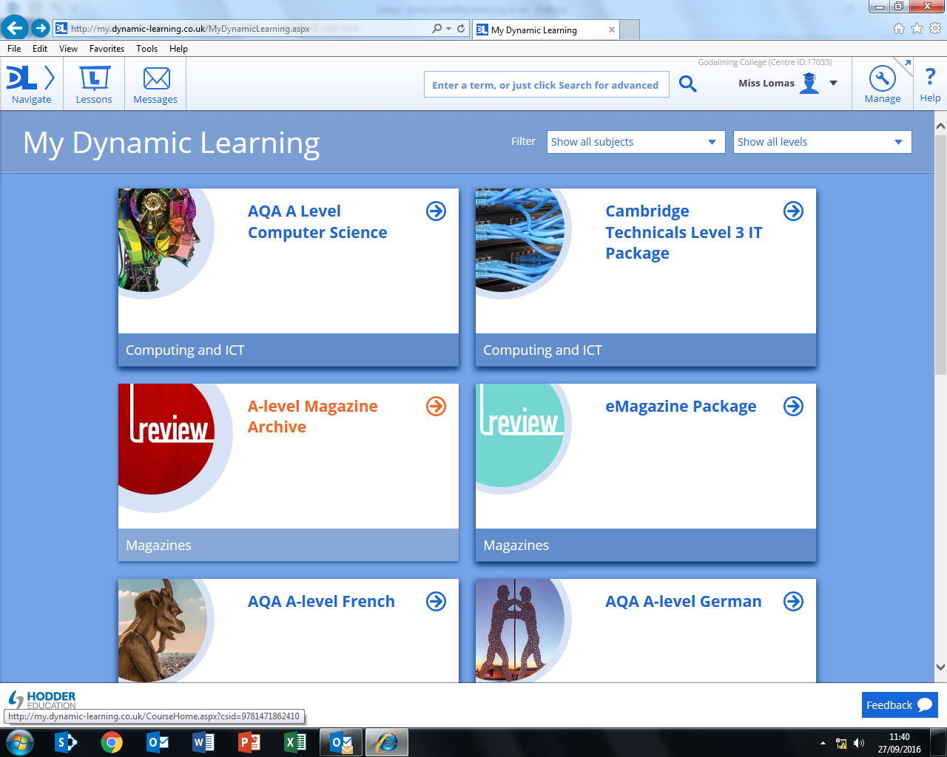

**Log-on Instructions:**

**Student access to the Dynamic Learning A-level Magazine Archive Website**

Login to Godalming Online, select Links and scroll down to ILC Library.

Select Websites/Subscriptions/Links button and scroll down to Dynamic Learning in the website list.

**Click on the Dynamic Learning link:** <http://my.dynamic-learning.co.uk/CourseHome.aspx?csid=9781471862410>

Student username is your 6 digit student number

Student password is your 6 digit date of birth

Centre ID is 17033 (you will only need to enter this once)

Tick box to accept terms and conditions (you will only need to do this once)

Select A-level Magazine Archive (top right hand side of page)

Scroll down to see the list of subject magazine archives.  The search box (advanced search advisable) is at the top of the page and you need to click on the magnifying glass symbol to search.

You can then read or print out useful articles from this website.

If you need any assistance using this website or any other College online resources, then please come to the Library Issue Desk and we will help you.