

Business

1st Year Linear

Skills Guide

This guide will help you to understand:

- What you need to do to be a successful business student
- The skills you will need to develop
- How you are assessed
- What to do when you don’t know what to do

What are study skills?

Study skills are the skills that you need to plan, organise and carry out your work effectively. They also help you to answer questions and carry out tasks which are designed to test your abilities and allow you to demonstrate your knowledge and understanding of the topics studied.

How to be a successful business student

Getting started
To help you better understand your business course and to be prepared from the very start you should:
- Familiarise yourself with the course specification (this can be printed from the course information section of your 1st Year Linear Godalming Online page).
- Set up a ring binder with dividers to sort all your work by topic (use the relevant component checklist or the course specification on Godalming Online to help you structure this).

- Purchase different coloured pens, highlighters and pencils to help with your note taking/making together with a ruler and eraser.

- Purchase a copy of the recommended text book
- Follow the department on Twitter @Business_GC to keep up with relevant business news and course information (to be a successful business student you must keep up to date with current affairs).

Time management
From the very start of your course, you should plan out the time you need to spend on homework, revision and reading each week. Getting into good study habits early on will help you to feel prepared and less stressed at exam time. It will also help you to consolidate your learning.
- Calculate how much time you have available for revision per week in hours (remember you should be carrying our 4.5 hours independent study per subject per week). Be realistic, but also make time, don’t waste time.
- Always plan your time at least one week ahead where possible, even if you haven’t had work set, there is always reading to be done.
- Always write down the nature of any homework set and the due date in your planner. You can then record it anywhere else (e.g. calendar on your phone) but ALWAYS record it in your student planner.
- Stick to your plan! If for some reason you can’t stick to your plan, make adjustments to ensure you don’t miss a deadline.
- Do not leave things until the last minute. The more time and effort you put into a piece of work, the more feedback your teacher will be able to provide.

Learning how to learn – note taking and note making
A level qualifications are a big step up from GCSE’s. When you were taking GCSE’s, your teachers probably gave you a lot of notes and you didn’t have to make them yourself. Unfortunately this is not always the case with A level subjects which is partly why they are much harder.
When studying for A-levels you are expected to take much more responsibility for your learning. One way in which we give you responsibility is to let you take and make your own notes.
During lessons we will teach Business using a variety of resources and activities, then at home it will be up to you to re-enforce and consolidate these ideas in the form of notes. This is how you learn!! At the end of the year you will have a folder full of decent notes from which you can revise for the exam(s) in June.
It’s up to you!! Your teachers will do folder checks throughout the year to ensure you are taking notes but if you’re lazy, then you will just be letting yourself down. People who have succeeded at this subject have always had a good set of notes to base their revision on.

Note taking vs note making – what is the difference?
NOTE TAKING: Summarising someone else’s thoughts, as expressed in a book or article or whilst listening to your teacher (this is what you will do in lesson).
NOTE MAKING: Organising your own facts, thoughts and learning, often in a creative, innovative way (this is what you should do outside of lesson to condense your lesson notes).
We will be asking you to do both! Part of your homework may be to take rough notes from your text book or the exam board notes on Godalming Online (NOTE TAKING!) and from your first draft, construct neater notes for your exam folder (NOTE MAKING).
There is no fool proof note taking/making plan! Everyone has their own methods. What we are trying to do is get you away from the pages and pages of “sentancy” notes you might take (or copy from the book!) to prevent your notes at the end of the year, looking like a text book. You DO NOT want your notes to look like a textbook because you WILL HAVE the textbook there with you all through the year!!!
The idea is to use the text book to learn from, NOT copy from and the following methods will help you to do that without making your homework seem like a boring exercise.
Tips for note taking in lesson
The first step to successful note taking in lesson is to listen and watch carefully. Your teachers will usually give clues as to what is important to take down. Some of the more common clues are words in bold on the teacher slides, specific reference to key terms and definitions and repetition of points. Top tips for taking notes whilst listening in lesson are:
- Make your notes brief. Never use a sentence where you can use a phrase. Never use a phrase where you can use a word. Do not try to copy everything on the slides!
- Use abbreviations and symbols, but be consistent.
- Put most notes in your own words. However, the following should be noted exactly:
Formulas Definitions Specific facts
- Use a main heading, underlined for each new major topic.
- Use indented sub headings for sub topics.
- Use a new line for each new piece of information.
- Put spaces between topics and points – try bullet points or *
- Put key words in block capitals or in a different colour to make them stand out
- Underline key terms with coloured pen to link ideas or concepts
- If you miss something the teacher says, write key words, skip a few spaces, and get the information from the teacher or the text book later.
- Don't try to use every space on the page. Leave room for coordinating your notes with the text book after the lesson (you may wish to leave a wide left or right margin to annotate your notes further later).
- Date your notes and number the pages as you go.
After lesson, you need to revisit your learning. This is when you should undertake further note making. This can be either to reduce your lesson notes to key facts and terms or to build on your lesson notes with examples from the text book or exam board notes.
Methods of note making
1. Mind map
Below is a mind map, actually explaining to somebody who has never drawn one some tips to succeed. They provide an excellent overview of a topic and also double up as an excellent memory recall device.
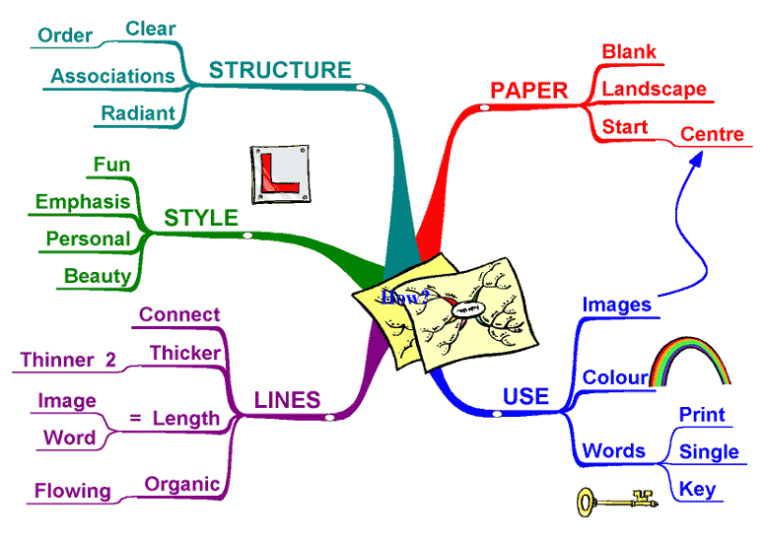
The ideas behind mind maps are word and image associations. We make associations every second of the day when we see, touch, smell, taste or hear something. What does the smell of sun tan lotion on your arm remind you of? “THE BEACH”!
The trick with mind maps is to train your mind, so that certain words and images trigger off concepts and facts you learnt in Business. Mind maps help you reinforce these associations and sub-consciously you remember the course! It’s a great way to learn.
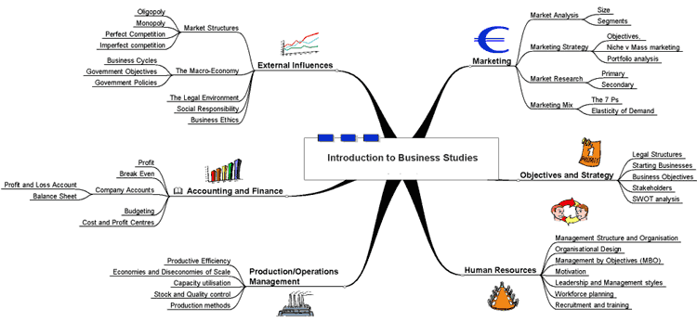
Example business mind maps:

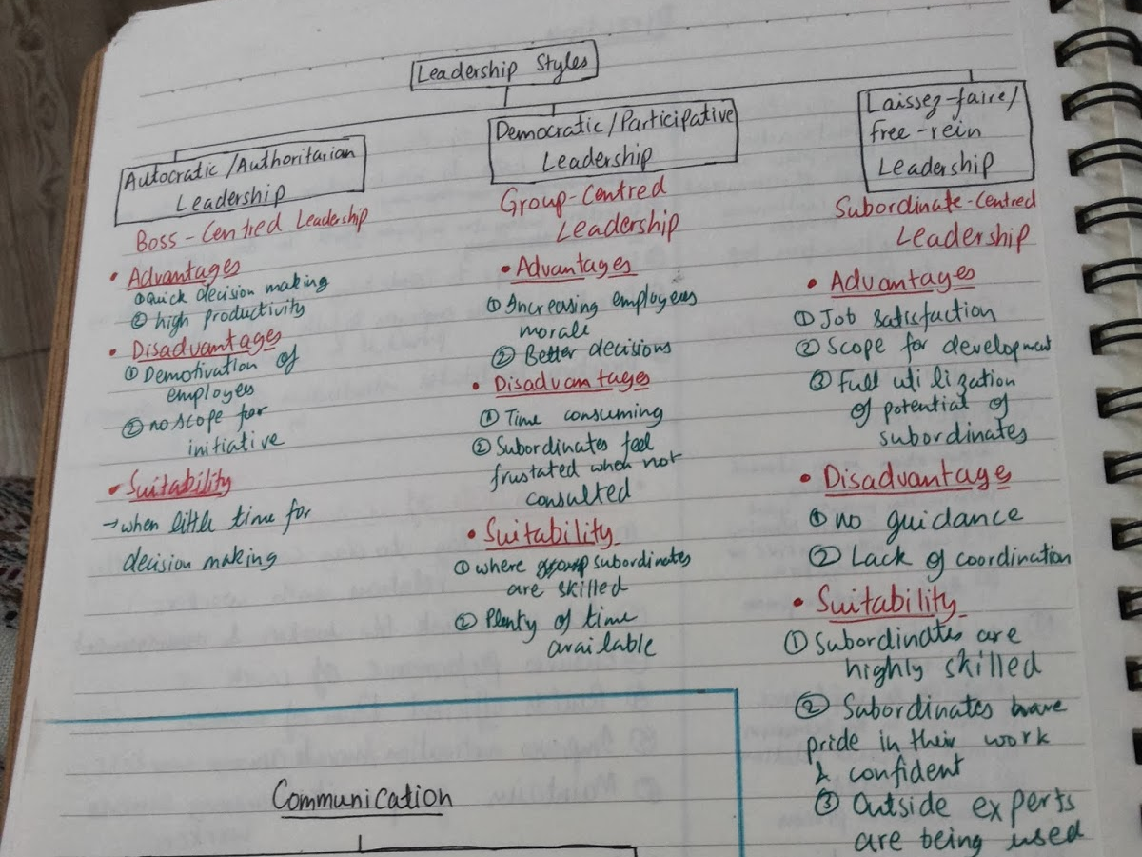
2. Grids or gridding
Below is an example of placing your notes into grids. It has the advantage that it is very easy to immediately see all the arguments or key terms that relate to a particular topic areas. They are nicely spread out and the key words are highlighted to bring them to our attention. It also forces you to relate certain aspects of the text you are reading together and helps you make connections. Doing this will help you learn the topic very comprehensively. Unfortunately sometimes it is a bit hard to come up with an all-inclusive grid for the entire text (be it a chapter or a few pages) due to a lot of different arguments. Therefore it might consist of many grids on one page, each highlighting points made.
Example: What are the benefits and drawbacks of becoming a limited company?
Becoming a limited company | ARGUMENTS FOR | ARGUMENTS AGAINST
LIABILITY | (i) Shareholders have limited liability. As a result more people are prepared to risk their money than say in a partnership. | (i) The legal procedure to set as a limited company and sell shares takes time and costs money
OWNERSHIP | (i) More capital can be raised as there is no limit to the number of shareholders. | (i) Profits have to be shared out among larger number of members

You can use either of these methods, or none at all – you will probably find your own style and way of doing things but this gives you a good head start over your peers!
The 5 Rs of note taking and note making
1. Record: During lesson, write all meaningful information legibly (note taking).
2. Reduce: After lesson write a summary of the ideas and facts using key words as cue words (note making).
3. Recite: Recite all the information in your own words without looking at teacher notes or the text book (this can be written (on cue cards) or verbal (recorded on phone))
4. Reflect: Think about your own opinions and ideas. Raise questions and record original ideas. Build in examples of real world businesses from news articles etc.
5. Review: Before your next business lesson, review your notes. Skim over the main ideas and details.
Pauk, W. (1989). How to Study in College (4th Ed.). Boston, MA: Houghton Mifflin.
How are you assessed?

Assessment objectives (AOs)
In Business, you are assessed by exams. The examiners who mark the papers are looking for particular skills to be demonstrated. We teach you these skills through the use of Assessment Objectives (AOs). All exam questions will be structured in a way that will require you to use one, some or all of these skills to meet the assessment objectives. There are 4 assessment objectives for your business course.
AO1 – Assesses knowledge AO2 – Assesses your skills of application
AO3 – Assesses your skills of analysis AO4 – Assesses your skills of evaluation
Part of being successful in the exam is knowing which objectives the questions is assessing, you therefore need to learn the different command words for each of the AOs. This will help you to structure your answer accordingly.
Assessment objective command words
AO | Explanation of AO | Command words | Example questions
AO1 | Demonstrate knowledge of terms, concepts, theories, methods and models to show an understanding of how individual and organisation are affected by and response to business issues.  This type of question requires short, concise answers and recall of material that you have memorised. | State  Define  Identify  Name  Label  Suggest  Describe  Outline  Categorise  Summarise  What is meant | Identify two of the main components of a business plan. [2]  Describe the financial incentives that a large retail store might use to motivate its employees. [6]  State the different between fixed and variable costs. [2]  What is meant by the term added value? [1]
AO2 | Apply knowledge and understanding to various business contexts to show how individuals and organisations are affected by and respond to issues.  You must make sure that you relate your answer to the case study and provide reasoning or some reference to theory. | Apply/Use  Demonstrate  Calculate  Illustrate  Select  Show  Adapt  With reference to | Adapt the diagram to show what will happen to the price of sports clothing as the general level of income rises in the UK. [2]  With reference to the cash-flow forecast identify the problem facing Darnton’s Shoes. [2]  Calculate the total fixed cost for Iestyn's business during his first year of trading. [2]

AO3 | Analyse issues within business, showing an understanding of the impact on individuals and organisations of external and internal influences.  You will need to demonstrate that you can break down information and understand the implications of what you have been presented with.  You will need to identify causes and effects and interrelationships.  You may be required to analyse data, use ratio analysis or use appropriate theories to investigate the question. | Analyse  Assess  Compare/Contrast  Explain (explain why)  Characterise  Develop  Distinguish  Examine  Debate  Deduce  Why | Explain the possible benefits and drawbacks of each chosen source of finance. [4]  Analyse how Aldi and Lidl can take advantage of economies of scale as their businesses continue to grow. [8]  Assess the usefulness of this prediction to the company. [6]  Explain the importance of workforce planning to Tata Steel. [6]
AO4 | Evaluate quantitative and qualitative information to make informed judgements and propose evidence-based solutions to business issues.  These types of questions will normally require you to provide full and detailed arguments ‘for’ and ‘against’ to show your depth of understanding.  You will be required to show judgement in weighing up the relative importance of different points or sides of an argument, in order to reach a conclusion.  Often with these type of questions, there is no ‘right’ answer, examiners are more interested in the quality of your argument and whether you have actually made a judgment. | Discuss  Decide  Recommend  Conclude  Evaluate  Argue  Justify  Consider  To what extent  Do you agree  Advise | To what extent do you agree with the view that a business plan will guarantee the success of a business venture? [8]  To what extent do you agree with the view that having a varied product portfolio and an extensive distribution network (place) will guarantee long-term success for Sarah Bunton's Luxury Chocolates? [12]  With reference to the cash-flow forecast propose three possible solutions to solve the financial problem that faces Darnton’s Shoes. [3]  Evaluate the view that the most successful supermarket in the UK is always going to be the one with the cheapest prices. [10]

As you can see from the table, there is a wide range of command words. Learn them! That way, you will know exactly what type of a question you are dealing with in the exam.
What is the difference between analysis and evaluation?
- Analysis assesses the causes and consequences of an issue and explains the likely impact and reaction of the firm.
- Evaluation builds on analysis and involves you weighing up options and coming to a (justified) view on what the firm should do.
How are marks allocated?
How the marks are allocated will vary from question to question which again is why it important to make sure you know the question command words so you can make sure you are answering the question fully and therefore giving yourself the opportunity to get the highest marks possible.
You can see from the table below, although the command word in the question tells you this is an AO3 question, AO1and AO2 are also being assessed. You do not need to address them separately in your answer, this should happen naturally as part of your analysis. You will become familiar with the marking grids and how marks are allocated throughout the course of the year.
1 | - Why do supermarket chains, such as ASDA, segment their markets? [6]
Band | AO1 | AO2 | AO3
Band | 2 marks | 2 marks | 2 marks
2 | 2 marks  Clear and correct identification of at least two reasons why supermarket chains segment their markets. | 2 marks  Good explanation of a range of reasons why supermarket chains, such as Asda, segment their markets.  Clear reference to Asda or supermarket chains like ASDA  Clear development and explanation. | 2 marks  Full analysis of why supermarket chains, such as Asda, segment their markets.  A clear understanding of the impact of market segmentation.  There is direct and clear reference to supermarkets.
1 | 1 mark  Identifies only one reason why supermarket chains segment their markets. | 1 mark  Limited reasons explained.  Explanations may not be clear. | 1 mark  Limited analysis and lack of understanding of the impact of market segmentation.
0 | 0 marks  No identification of reasons. | 0 marks  No explanation of reasons. | 0 marks  No analysis or understanding of why supermarket chains segment their markets and no understanding of the impact of segmentation.

You should always be aiming to reach the highest mark band. In the example above, this is band 2. For questions where there are more marks available, this will be band 3.

What to do when you don’t know what to do – developing resilience

It is important to remember, that intelligence is not fixed, it is something you can develop. It’s a potential that you can cultivate through education instruction.
What is learning?
- Understanding things that you did not know before?
- Learning from your mistakes?
- Coming out of a lesson more informed that when you went in?
Learning is a challenge. A challenge is set so that we can achieve something. It’s a target. It requires effort. The challenge may be tough, but how do we feel when we get to the end? Skills are needed to master a challenge, these are resilience and resourcefulness.
Resilience = if we accept that there are things that we don’t know (and therefore things that we need to learn) and we have the skills to find and use information to solve problems, we are developing resilience.
It’s great not to know!
- It’s ok to be criticised if you don’t meet the target.
- If you’ve not met the target, you need to know so that you can improve your work.
- Without this understanding there is no progress.
- To accept this and see it as a challenge  not a poor result  is to develop resilience.
Rise to the challenge
- Set targets
- Try to meet them
- Review your progress regularly and reset those targets to keep your progress steady.
- Understand that it is okay to make mistakes! We learn from mistakes. If you know the answer straight away, how much learning has taken place?
How do you rise to the challenge?
Resourcefulness
- SMART targets
- Using teacher feedback
- Independent learning (adopt the BRAIN, BOOK, BUDDY, BOSS approach)
- A positive attitude and desire to improve (this is essential)
Recommended sources of information to help you be independent
- Course textbooks
Decide where the best source of information might be and use it.
Organise the information that you have found
Use our guidance to plan and structure your answers
- Godalming Online
- Recommended internet sites
- Independent Learning Centre
- Broadsheet newspapers
- News from TV, radio, online and the department Twitter account @Business_GC
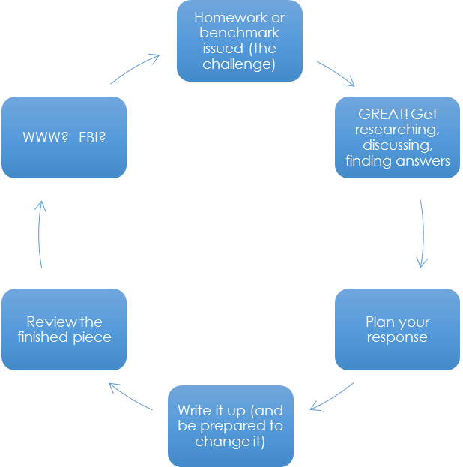

Let’s relate this approach to your studies

Remember: what to do when you don’t know that to do…?
BRAIN, BOOK, BUDDY BOSS!
Skills week class activities

Note taking activity
- Think about how you are going to set out your page. (You may wish to use the Cornell note taking system https://www.youtube.com/watch?v=WtW9IyE04OQ)
- Watch the following video about ‘We don’t like money in business’ as a class.
https://www.youtube.com/watch?v=1ssxAiNLrP4
- Whilst watching the video, use the space below to take notes and do your best to adopt the note taking techniques mentioned on pages 4 and 5).
________________________________________________________________________________________________________________________________________________________________________________________________________________________________________________________________________________________________________________________________________________________________________________________________________________________________________________________________________________________________________________________________________________________________________________________________________________________________________________________________________________________________________________________________________________________________________________________________________________________________________________________________________________________________________________________________________________________________________________________________________________________________________________________________________________________________________________________________________________________________________________________________________________________________________________________________________________________________________________________________________________________________________________________________________________________________________________________________________________________________________________________________________________________________________________________________________________________________________________________________________________________________________________________________________________________________________________________________________________________________________________________________________________________________________________________________________________________________________________________________________________________________________________________________________________________________
Note making activity
Use the space below to now review the notes you took whilst watching the video and test out a note making technique mentioned earlier (e.g. mind map, gridding etc.) or a technique of your choice.
You may wish to use a text book if you need to improve the notes you took whilst watching the video. Remember, you should be trying to condense notes into key facts and terms, making links between key concepts.

Past paper question activity
For the following questions, identify what you would have to do (i.e. AO1 – knowledge, AO2 – application, AO3 – analysis, AO4 – evaluation)

1. 

Answer:

2. 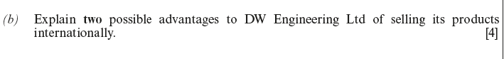
Answer:

3.
Answer:


4.
Answer:

5.
Answer:
6.
Answer:
7.

Answer:

What is application (AO2)? Activity
- When you have a question that requires application you must make sure that you relate your answer to the case study and provide reasoning or some reference to theory.
- Using the businesses name from the case does not necessarily mean that you are answering in context.
- You will need to make your knowledge of business terms, ideas and concepts relevant to the case study. You need to make reference to specific details from the case material.
Below you have some possible answers to a question from a past paper:
“Explain the benefits of an effective training programme to a business such as …?”
- Increases efficiency and productivity: enables the service they provide to be improved.
- Ensures that employees have the necessary skills and attributes to carry out their jobs.
- Increases the motivation and job satisfaction of staff: Reduced absenteeism and labour turnover.
- Can identify employee’s potential to make an even better contribution to the business.
- May reduce costs in the long run – accidents, injuries, recruitment costs.
- Can make staff more flexible and better able to cope with change.
- Better quality output both in relation to products and service.
- Can improve the image of the business.
- Attract good quality people to work for them.
Your teacher will show you a range of different case studies.
Have a go at writing an answer to the question (using the bullet points above) using specific details from the case study (i.e. application).

What is analysis (AO3) activity?
Analysis assesses the causes and consequences of an issue and explains the likely impact and reaction of the firm.
Good analysis involves developing arguments. For each point or argument you raise, you will need to analyse it.
In other words, explain what you mean. A good way to develop your arguments is to discuss your points in a ‘chain’, using at least three connectives.
Connectives are words such as “therefore….” and “as a result….is likely to happen”, and “because ……”. Never assume the examiner will understand what you mean. It is up to you to explain yourself. This is absolutely critical.
To remember to use at least three connectives in your analysis you could adopt the ‘BLT’ (Because, Leading to and Therefore) strategy:
Point | Because…  (Why is that likely to happen) | Leading to….  (What are the impacts of this?) | Therefore….  (Further discussion of the impact e.g. the knock on effects… HOW will the business do something, HOW will the impact affect the business in the short / long term etc.)

You need to look for the implications (the knock-on effects) of the points you raise for the business in the case study.
Before thinking about analysis from a ‘business’ perspective, let’s look at analysing some topics you may be more familiar with.
In pairs, use the hand out with arrows to follow the chain format and analyse the topics your teacher presents on the board.
What is evaluation (AO4) activity?
Evaluation progresses on naturally from analysis and involves you providing full and detailed arguments ‘for’ and ‘against’ a topic or question (ensuring that your arguments are balanced and not one sided) and then making a judgement.
Analysis will always form part of your answer to an evaluation question. A thorough, balanced analysis, based on excellent subject knowledge, leads to good judgements and decisions.
Evaluation means to judge or to make a decision. And to justify why that judgements or decision has been made.
This could be a conclusion to a question or some form of choice being made.
It stands to reason you need to have a good understanding of topics before you can do this. This is why evaluation questions have the highest marks.
Carry out the evaluation activities with the class. You may wish to use the format below to record your ideas and ensure you have a balanced argument
Topic
Arguments For  1. | Arguments Against  1.
Conclusion

Exemplar work
Below you will see extracts from exemplar past papers to demonstrate the difference between an A grade and an E grade answer. You may not understand the content but try to identify the key differences between the two answers.
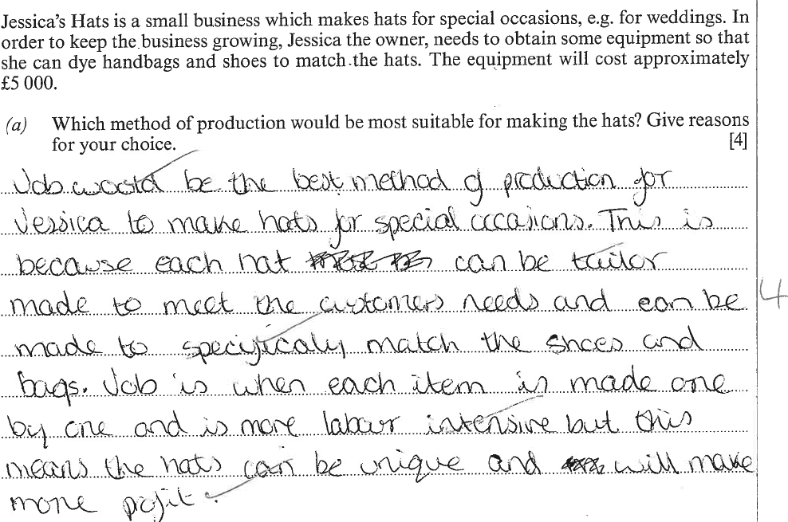
A grade paper answer (4/4 marks awarded)

E grade paper answer (0/4 marks awarded)
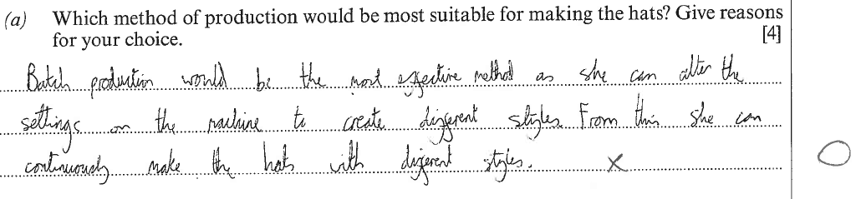

A grade paper answer (5/6 marks awarded)


E grade paper answer (3/6 marks awarded)

Marking activity
Read the following questions and answers and then using the mark schemes on the following pages, allocate marks to each AO and give each answer an overall mark.
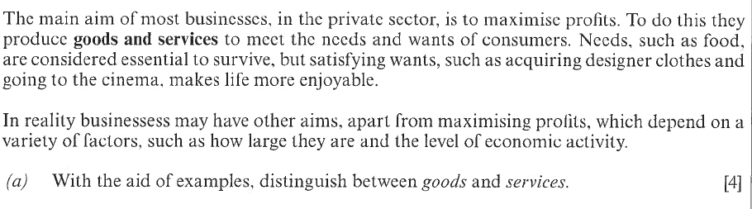
Question 1

Answer 1

AO1:

AO2:

Total
Marks:

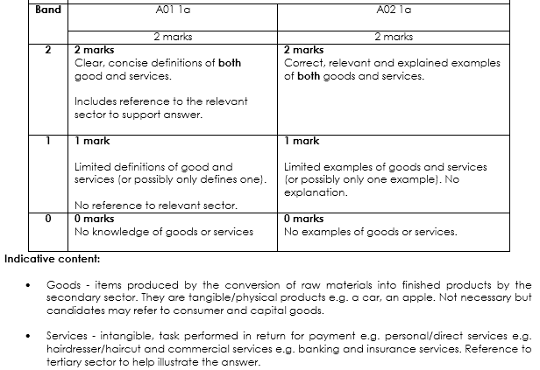
Mark scheme

Question 2
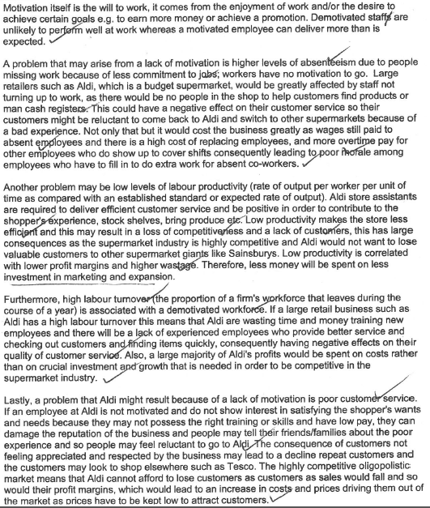
Describe the problems that a large retailer such as Aldi might face as a result of a lack of motivation amongst employees. [10 marks]
Answer 2

AO1:

AO2:

Total
Marks:

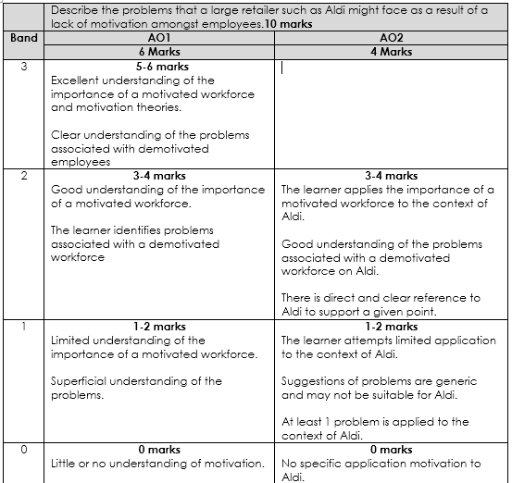
Mark scheme
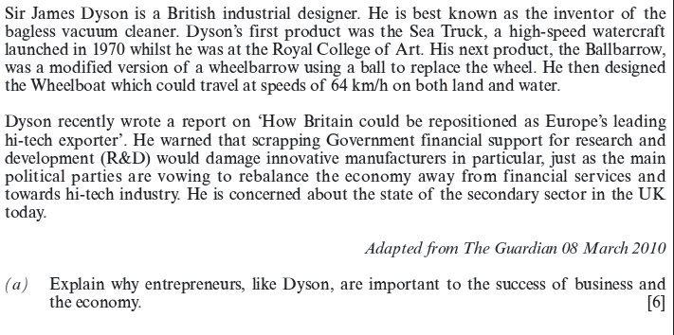
Question 3


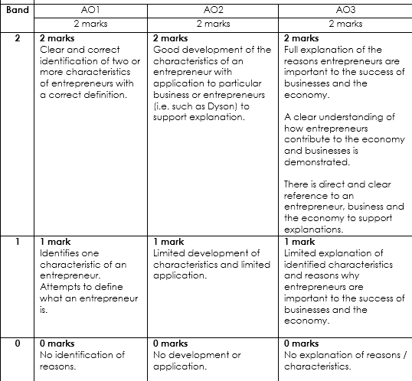
Answer 3: Mark scheme:
AO1:

AO2:

AO3:

Total
Marks:

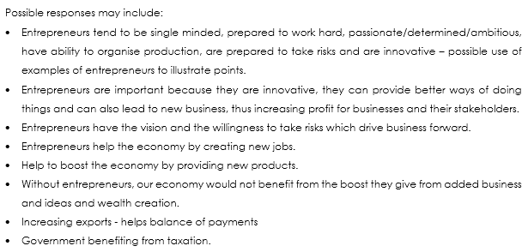
For the following question, rather than giving it a mark (as you would need to be familiar with the topic), using different coloured highlighters identify which areas of the question address AO1, AO3 and AO4 criteria. The marking grid is over the page for your information.
Question 4
To what extent is quality a major competitive issue in service businesses? [15 marks]
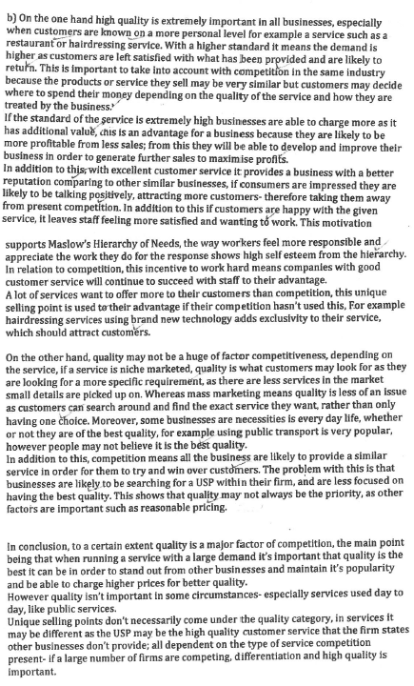
Answer 4

AO1: 2

AO3: 6

AO4: 6

Total
Marks: 14

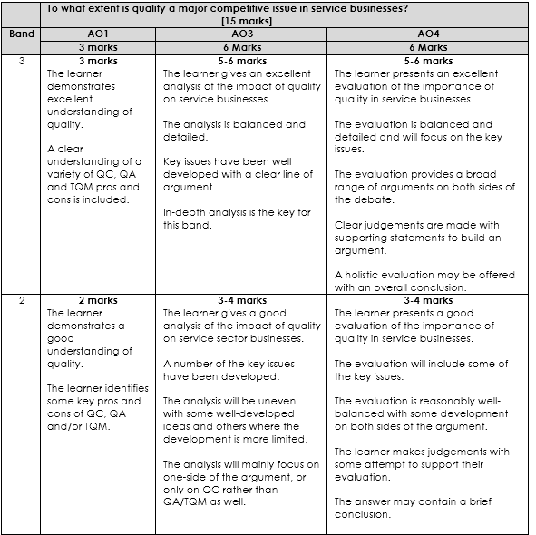
Mark grid

