Sources of Finance – Activity

Ensure that you are confident about the variety and types of finance available to a firm.
This Activity is fairly straightforward but will assess your understanding of which sources of finance are appropriate and why. You will need to make judgments, therefore, and support those judgements. In each case, assume the business has carried out the necessary market research and has planned the move appropriately.

Task:
You will be given a variety of different business scenarios. You must decide what type of finance the business in question should go for and why. Of course, there could be more than one appropriate source of finance - you could decide on a combination but again, ensure that you explain why you have decided on this route.

The Cases:

Case 1
A medium-sized engineering firm with an annual turnover of £2.5 million has decided to install a new piece of machinery to help improve its productivity. The equipment needs to be housed in a new building to be constructed on the site. The forecast cost of the building is £150,000 and the equipment £400,000.

Case 2
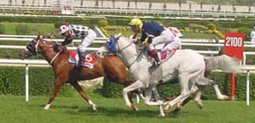
An individual has been made redundant after 20 years with a major organisation and has received a lump sum redundancy payment of £70,000. The individual is planning to set up a bookmakers and has identified a suitable premises valued at £180,000 near to a major town centre shopping precinct.
Image: Would a gamble on the horses be the best way of raising the money? Copyright: Zoban Raftik

Case 3
A large plc is planning on moving a major part of its production facility to Cornwall. It has identified a site near a former chalk pit that is now not used. The estimated cost of the facility is £4.5 million.

Case 4
A local Do It Yourself (DIY) store has experienced problems with acquiring goods from its suppliers because it has been an erratic payer of its bills with them. The reasons it has experienced these problems is that it has contracts to supply building materials to a number of local firms all of whom only pay the bills for their orders every 3 months.

Case 5
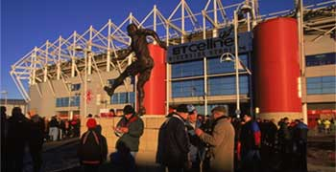
A rugby club is anticipating turning fully professional after the team secured promotion to the Zurich premiership. To take its place in the league, the league committee have insisted that it also improves facilities at the ground. It has been estimated that the cost of these two measures will be £550,000.
Image: The cost of promotion in any sport can be high - how much to improve facilities at a stadium and where does the finance come from? Title: Statue of Wilf Mannion. Copyright: Getty Images, available from Education Image Gallery

Case 6
A major UK plc is planning the takeover of a rival business. The move has been investigated by the Competition Commission and permission has been granted. The current share price of the rival firm is 260p and the firm has made an offer of 340p per share. The current market capitalisation of the target firm is £4.5 billion.

Case 7
A small partnership business has developed a new piece of software that would massively improve the efficiency of personnel management processes at large sized business organisations of all kinds. The software has massive potential but at present is not commercially viable because of lack of funds. The partners are contemplating their next move.

Case 8
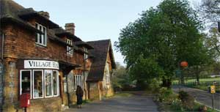
A small newsagent in a rural village centre has decided to purchase a new freezer cabinet and oven/roasting unit to provide hot meals for village workers and for students at the secondary school which serves the surrounding area which is located half a mile from the village centre. The cost of the units is £3,500.
Image: How can the local village shop raise the necessary finance for this project? Copyright: Peter Doney

Case 9
A large charity organisation has followed a consultancy programme on streamlining its records. The consultants have suggested investing into a software package that will provide a sophisticated database programme that will do all the things that the charity will require for the next 10 years. The cost of the software package is £65,000.

Case 10
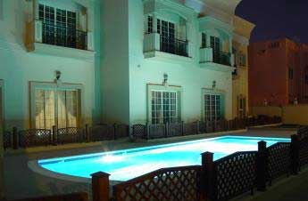
Following the construction of a new housing estate on the outskirts of a major city, a group of 10 ambitious young professionals has decided to try to exploit the type of resident moving into the area by setting up a gym and health centre on earmarked land within the development. The building has been bought by the group for £800,000 but needs to be furnished and fitted out for the purpose intended. The cost of the bar, restaurant and gym facilities is estimated at £95,000 but the other major cost is the swimming pool, spa and sauna area. This could be utilised on a separate project to the fitness centre as the local council want to secure use for local school children and elderly residents - this being part of the purchase arrangements associated with the new housing development.
Image: The construction of a new swimming pool - where would the best source of finance for such a project come from? Copyright: Paul Scott

