**How the internet is reinventing the Christmas commercial**

By Jamie RobertsonBBC World News

* 10 December 2015
* From the section [Business](http://www.bbc.co.uk/news/business)

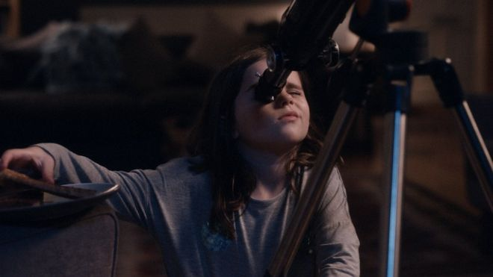 Lewis - aiming at social media

**The internet is reinventing the ChristmasTV commercial, making it more creative, more ambitious - and arguably more self-regarding.**

Advertising plays a central role at Christmas, and for over 100 years has extended its reach from posters to radio, TV and now online.

Successfully making that last leap has become the holy grail of Christmas advertising.

"The strategy among the retailers now is to get the ad into a prime time spot," says Neil Saunders, managing director of retail research agency Conlumino.

"From then on TV becomes less important as the message goes off into social media, where there is less cost and the reach can be phenomenal, far greater than TV."

**Benchmark**

So, let's look at how that works with one of the most famous, the John Lewis ManOnTheMoon commercial.

In early November it launched the ad, telling the story of a small child who sees a lonely old man through a telescope living on the moon, and sends him a Christmas present by balloon.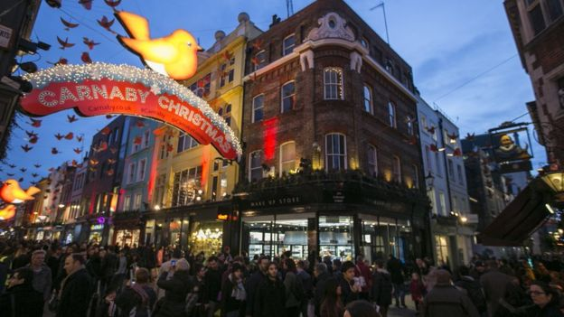is growing

Conventional wisdom might assume that the campaign should spark interest in the retailer - John Lewis - but there's barely a mention of the name.

Instead the aim seems to be to spark interest in the ad itself.

To this end John Lewis actually advertised the advertisement with a 10 second teaser commercial a week before it went live, and fired up social media interest with the #ManOnTheMoon hashtag.

Three hours after the advert was aired, #ManOnTheMoon was trending with 40,000 tweets.

And it doesn't stop there. Of the £7m spent on the campaign, John Lewis spent only £1m on the ad itself, which is just the tip of a merchandising iceberg.

**App tie-up**

There's an app offering moon-related information. There's a tie-in with a game that can be played on mobiles, sending your presents to the moon by balloon, though at this point Christmas sentimentality is abandoned in favour of eluding surface to air missiles.

Then there's a link-in with ManOnTheMoon telescopes, pyjamas, bedding, mugs and so on.

"The key to the John Lewis ad is that people no longer watch real-time television," says Jacques de Cock of the London School of Marketing.

"They defer their watching to Netflix or YouTube, and to capitalise on this market advertisers have to make their ads into social phenomena.

The reality is that companies are having to make contact with a customer whose habits are dictated not by TV but by the internet.

For instance, view the new Harvey Nichols commercial and the last frame has a "Shop Now" button to take you straight to the store.

You can't do that on TV.

But the customer is doing a lot more than just clicking and buying Uncle Cedric's Christmas socks on Amazon.

He or she is researching, comparing prices and browsing online, before either clicking or physically marching into the store and demanding the socks over the counter.

**Online influence**

According to Forrester Research, by 2020, 53% of retail sales across Europe will be influenced one way or another by the online world.

So it is not important to an advertiser by what mechanism the money is spent. What matters is where the customer makes up his or her mind - and that space is increasingly a digital one.

All of which shapes the way ads are made.

Sainsbury's advert "Mog's Christmas Calamity" written by the writer and illustrator Judith Kerr runs for a full three and a half minutes. The traditional TV ad break spot could never support that on a regular basis - but the internet can.

Lifting time restrictions allows for a great deal more creativity. For instance, the Mulberry Christmas commercial turns the gift of a red bag into a parody of the Nativity, attended by shepherds and Wise Men, which is witty both visually and verbally ("It is a thing of wonder" extols one of the Wise Men).

And there are other opportunities to add nuances to your brand.

Click on the end of the Sainsbury's commercial and up come links to Judith Kerr's book, the making of the commercial, Save the Children, competitions, recipes and of course Sainsbury's produce.

**The new rock and roll**

"We love working for retail," says James Murphy, chief executive of adam&eveDDB, which made the John Lewis ad.

"Retail is the new rock and roll in advertising. It is a great shop window for your creativity and for your effectiveness."

Some might argue the industry is taking itself a teensy weensy bit too seriously. The Burberry Christmas commercial, borrowing its theme from the play/movie Billy Elliot, rolls its own credits at the end.

Bizarrely, the prize for the most viewed ad this Christmas goes to the German supermarket chain Edeka which has been shared 2.39 million times online, leaving John Lewis (1.3 million) and Sainsbury (917,000) trailing in its wake.

It tells a tear-jerking tale, that some might find in questionable taste, of an old man abandoned by his family at Christmas, until, by faking his own death he manages to bring them round the table for Christmas dinner.

Edeka doesn't have an international retail operation. Yet the ad appears on YouTube with English subtitles, suggesting the commercial is as interested in its own brilliance as it is in trying to sell a product.

Supermarket chain Aldi tried to puncture this sort of self-indulgence by making a parody of John Lewis's ManOnTheMoon ad with the frail old gentleman debating whether he should buy a cheaper telescope at Aldi.

But it raises the question - does any of this actually increase sales? to boost Christmas sSpencer

Marks and Spencer tried to tap into this market in 2014, with its Magic and Sparkle TV commercial showing fairies carrying out gratuitous acts of generosity.

The fairies gathered 42,000 Twitter followers and the campaign was hailed as the most imaginative social media event of the year.

But it didn't work in terms of sales and Christmas turnover slumped.

**Still effective**

"The campaign is only successful if you have the right product at the right price," says Neil Saunders.

"People may want to come to the shop, but if they can't find what they want they won't buy."

This year M&S has avoided story-telling and instead opted for what is little more than a glitzy montage of its wares.

However, Robert Jones head of new thinking at agency Wolff Olins argues the campaign was still effective.

"It may not have worked in terms of Christmas sales - but this is part of a long term strategy to create an image. You can't change the way people see you in a single year." Children's author Judith Kerr has writ

So is the John Lewis ad working?

On the big discount day, Black Friday, sales were up 4.8% on last year. But it is worth noting that whatever the long term effect, the only John Lewis item featured in the ad - a telescope - had sold out online five hours after the ad went live.