EXPLAIN THEORY OVERVIEW (including research carried out by theorist)  Herzberg was an American psychologist who conducted research in the 1950’s, questioning 200 engineers and 200 accountants about the aspects of their jobs that led to job satisfaction or dissatisfaction. The results of his survey suggested that there were factors that were commonly identified as sources of satisfaction, an factors that were regularly identified as sources of dissatisfaction. There are two sets of factors that are important for motivation workers – motivators and hygiene factors.  Hygiene factors – Working conditions, pay status, health and safety, relationships with managers and colleagues. For basic job satisfaction to be in place, all of the basic hygiene factors need to be available otherwise this will lead to workers being dissatisfied and therefore unable to be motivated.  Motivators – Responsibility, a sense of achievement, interesting tasks, recognition of effort, the chance of promotion, training and development. Once all of the hygiene factors have been achieved, you can gain job satisfaction. Increasing their motivators is lead to job satisfaction. |  | DIAGRAM / IMAGE LINKED TO THEORY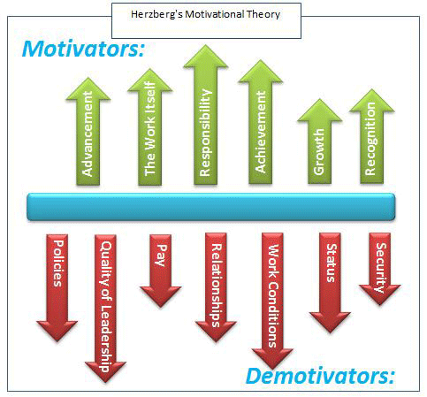
LINKS TO WHICH FINANCIAL AND NON-FINANCIAL METHODS OF MOTIVATION? (e.g. job rotation, team working, bonuses etc)  Job enrichment (variety of tasks): non-financial  Regular training (develop and carry out jobs effectively): non-financial  Good working conditions: non-financial  Competitive salaries: financial  Working policies that are fair: non-financial  Recognition of hard work: non-financial | STRENGTHS, WEAKNESSES AND CRITICISMS OF THE THEORY?  Weaknesses: Only focused on engineers and accountants and using different working groups of workers would have produced different results / It may not be possible to ‘enrich’ some jobs, especially those requiring low level skills or where workers are not interested in responsibility or promotion  Strengths: Identifying that there are factors that in general will motivate and demotivate groups of employees / Herzberg's model can be used to identify broad issues that need to be addressed or mitigated in general.
SIMILARITIES / DIFFERENCES TO OTHER THEORIES?  It is similar to Maslow’s theory: The lower levels of Maslow’s hierarchy and Herzberg’s hygiene factors and between the higher levels of Maslow’s hierarchy and Herzberg’s motivators.  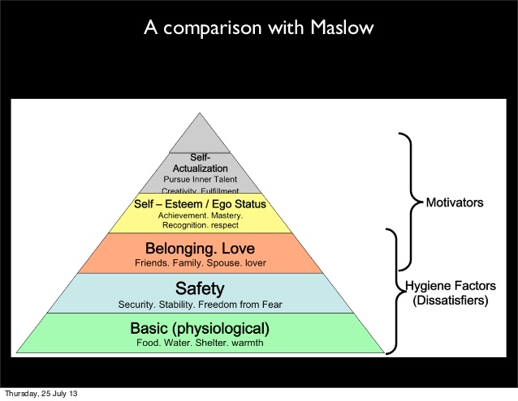 | RELEVANCE TODAY? (Including types of work situation / examples of organisations it best applies to)  Many people who understand the theory believe that it is as relevant today as it was when it was published in the 1950’s. This is due to the lack of change in work force motivators and hygiene factors. However, the theory doesn’t always apply to lower skilled jobs due to the lack of potential achievement and challenge.

