EXPLAIN THEORY OVERVIEW (including research carried out by theorist)  The expectancy theory suggests that motivation is dependent on the extent to which an individual believes they will succeed in achieving the reward on offer. If an employee is confident that the chances of success are high, they are more likely to be highly motivated. The theory has three components: valence, instrumentality and expectancy. These all relate to an individual person’s beliefs rather than to any objective reality. Valence: an individual will undertake a task if they believe that they will receive a worthwhile reward, for example, receiving a raise or bonus at the end of the task. Instrumentality: an individual needs to believe that a particular action is likely to lead to a particular result, for example, if they finish the task they would be likely to receive a promotion. Expectancy: an individual’s belief in the likelihood of them being able to achieve the target that has been set for them, for example, making a target to get a certain amount of sales and believing that you will be able to achieve this target making you more motivated. |  | DIAGRAM / IMAGE LINKED TO THEORY  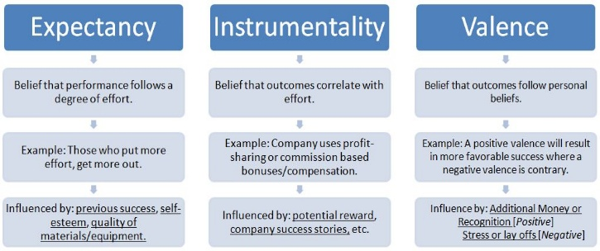
LINKS TO WHICH FINANCIAL AND NON-FINANCIAL METHODS OF MOTIVATION? (e.g. job rotation, team working, bonuses etc)  Pay rises  Set targets  Bonuses | STRENGTHS, WEAKNESSES AND CRITICISMS OF THE THEORY?  Strengths: Focusing on expectations allows the theory to account for differences in choices between people despite the actual amount of effort necessary to achieve rewards and the actual value of rewards.  Weaknesses: perceptions about effort, performance and the value of rewards are difficult to quantify so comparisons between different choices or people using the expectancy theory framework may not be accurate.
SIMILARITIES / DIFFERENCES TO OTHER THEORIES?  Focuses on both financial and non-financial methods of motivation. | RELEVANCE TODAY? (including types of work situation / examples of organisations it best applies to)  It would best apply to big businesses who do not wish to lo9se money raising employees’ salaries or handing out unnecessary promotions and motivate staff as the theory includes both financial and non-financial motives.

