EXPLAIN THEORY OVERVIEW (including research carried out by theorist)  Maslow, who is an American psychologist, put forward his theory of motivation in the year 1954. He came up with the idea that all human begins have the same types of needs that could be put into a ‘hierarchy pyramid structure (the diagram on the right) The main one of these, the psychological needs, are those that are essential for human survival and that have to be satisfied before any other needs can be addressed. The last level of needs, self-accusation focuses on the want to fulfil individual potential by self-criticism in order to improve. But Maslow was not writing specifically about the workplace, but his theory has a number of business applications. |  | 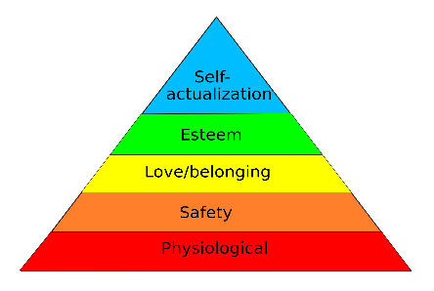  DIAGRAM / IMAGE LINKED TO THEORY
LINKS TO WHICH FINANCIAL AND NON-FINANCIAL METHODS OF MOTIVATION? (e.g. job rotation, team working, bonuses etc)  . Maslow focuses on financial physiological needs such as wages which is on the base level  . He also focuses on non-financial motivators such as safety, love and belonging, esteem and self-accusation.  . job enrichment  . good health and safety checks  . a non-autocratic manager who makes each employee feel valued which goes under the love and belonging section of the pyramid  . Team working would make the employee feel valued by the company, which would go under the love/belonging section of the pyramid.  . Appraisals would mean an employee could do some self-accusation.  . Bonuses may satisfy the physiological needs of the employee and give them a financial incentive to work harder  . Birthday recognition may help make an employee feel a sense of belonging.  . Staff discount may make an employee feel more valued  . a full time contract and good job security can make an employee feel more safe in their company.  . Employee of the month/ year etc. can make an employee feel more part of the team increasing motivation. | STRENGTHS, WEAKNESSES AND CRITICISMS OF THE THEORY?  - This theory provides a useful summary of human needs, which can be used in product design, product positioning, pricing (e.g. need for power & status), and retail outlets’ designs.  - It can also helps marketers to focus there advertising appeals on specific needs shared by a large segment of their target market.  - Physiological needs are arguable the most important needs for an employee and this would need to be addressed first before any other needs on the pyramid were.  - The major problem with Maslow's hierarchy-of-needs theory is that it cannot be tested empirically – there is no actual way to measure precisely how satisfied one level of need must be before the next higher need becomes operative. It is far to complex to actually measure as it would change fro m person to person.  - The model is far too simplistic:  - The same product or service can satisfy many needs at once.  - The model doesn’t have empirical support for the rank-ordering of the needs.  - The model is too culture-bound: it doesn’t have validity across different cultures and the assumptions of the hierarchy may be restricted to Western cultures and values. As Maslow was an American- backing up this point further.  - Changes for each worker- some might not want to be in a team and only have financial incentives e.g. to buy a car and not actually care about job satisfaction or the other parts Maslow’s pyramid.
SIMILARITIES / DIFFERENCES TO OTHER THEORIES?  - It combines many aspects of other people’s theories into his e.g. financial and non-financial motivators.  - The love and belonging bit of Maslow’s pyramid links with what Mayo said about how staff are treated will affect their motivation. Although Mayo did not cover financial motivators which Maslow did under the ‘physiological’ section of the pyramid.  - Some of Herzberg’s motivators also link with what Maslow was saying. For example responsibility links with Maslow’s self-accusation bit on the pyramid. Also Herzberg’s hygiene factors like poor working conditions and lack of job security link with the section of Maslow’s pyramid labelled ‘safety’ Although Herzberg only has two main factors as Maslow has five.  - Finally vroom’s theory of Valence ties in with Maslow’s physiological section on the pyramid. As Vroom says that the employee will undertake the task if they believe there will be a worthwhile reward at the end, like how under Maslow workers will be motivated under physiological needs e.g. money. | RELEVANCE TODAY? (including types of work situation / examples of organisations it best applies to)  - Product design, product positioning, pricing (e.g. need for power & status), and retail outlets’ designs.  - Advertising  - Clothing shops  - Factory workers – to increase their productivity if they are more motivated.

