EXPLAIN THEORY OVERVIEW (including research carried out by theorist)  - Maslow is an American psychologist who put forward his theory of motivation in 1954.  - He suggested that all human beings have the same type of needs that can be organised into a hierarchy.  - The most basic need is physiological, essential for human survival e.g food and water.  - Followed by safety – employees want to be able to predict their future and to be free from danger e.g. jobs security and pension scheme.  - Love and belonging- being part of a group and giving and relieving love and friendship.  - Esteem – feeling good about achievements e.g. positive communication from management and bonuses.  - Self-actualisation- achieving you potential and personal growth and fulfilment.  - His theory has a number of business implications. |  | DIAGRAM / IMAGE LINKED TO THEORY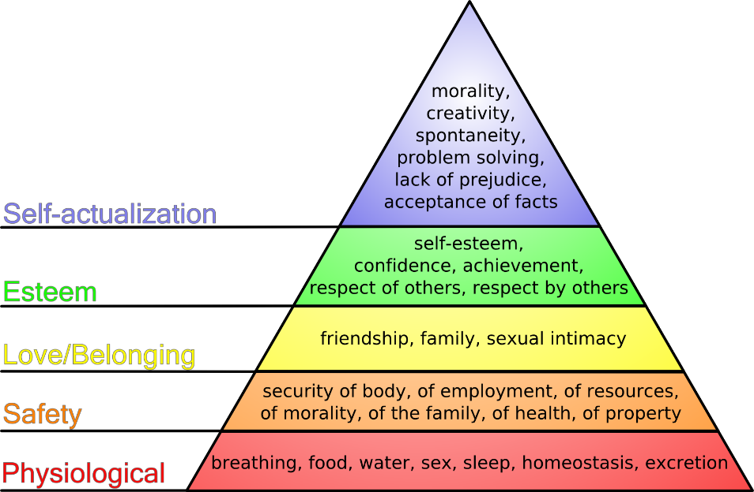
LINKS TO WHICH FINANCIAL AND NON-FINANCIAL METHODS OF MOTIVATION? (e.g. job rotation, team working, bonuses etc)  Non-financial because it focuses on the well-being and needs of workers. Only the first level focuses on money because you need that to buy food and shelter. | STRENGTHS, WEAKNESSES AND CRITICISMS OF THE THEORY?  - Some workers may be more interested in individual status an promotion rather than belonging to a group  - Workers may not use the workplace to satisfy all of their needs. They may only work for financial reasons.  - Each level of needs is dependent on the levels below- if someone loses their job the whole system collapses as the need to feed becomes the most important again.  - It will be expensive for a business to satisfy needs of the employees up to self-actualisation  - It make workers loyal to the business because they feel cares and valued. This means they be more motivated and more productive.  - If there is more of a structure then the employees will have an aim of what they want to achieve and communication will be improved between people in the business .
SIMILARITIES / DIFFERENCES TO OTHER THEORIES?  Vroom- the top level of the hierarchy focuses on achievement and fulfilling your potential. Vrooms theory focuses on what people this they can achieve and the reward they get from that. They are similar because they both focus on achievement and working your way up the hierarchy.  Taylor- only similar at the bottom of the hierarchy because you need money to buy food and shelter. Different because Maslow mainly focuses on the wellbeing of the person at work and not only the financial reward of working. | RELEVANCE TODAY? (including types of work situation / examples of organisations it best applies to)  - Physiological- Kellogg's offers competitive salaries. This gives people the means to acquire the basic needs for living. The Kellogg's Cornflex flexible benefits programme allows employees to choose those benefits that suit them.  - Safety needs – Kellogg's values the safety of all employees. The company is committed to providing a safe and healthy work environment to prevent accidents.  - Social needs – These are associated with a feeling of belonging. Kellogg’s operates weekly group 'huddles'. These provide informal opportunities for employees to receive and request information on any part of the business, including sales data and company products.  - Self-actualisation – Kellogg's provides employees with the opportunity to take on challenging and stimulating responsibilities. For example, the business provides the opportunity for individuals to take ownership of projects. This enables them to develop and improve.

