EXPLAIN THEORY OVERVIEW (including research carried out by theorist)  His theory was based on teamwork – they had the idea that work is all based on a group activity and the ‘team spirit’ created by a cooperative work environment. Workers may group together informally, producing their own personal set of rules which can have an influence on behaviour. Managers getting involved in the workforce and recognising their contributions can boost morale and therefore lead to an increase in productivity – known as the Hawthorne Effect. He felt social rewards such as teamwork and effective communications were more important than financial rewards. |  | 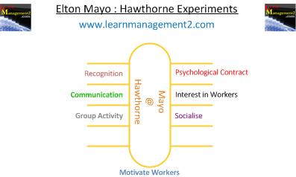  DIAGRAM / IMAGE LINKED TO THEORY
LINKS TO WHICH FINANCIAL AND NON-FINANCIAL METHODS OF MOTIVATION? (e.g. job rotation, team working, bonuses etc) | STRENGTHS, WEAKNESSES AND CRITICISMS OF THE THEORY?  Strengths:  The method allows clear identification of the concerns of the workers.  It solves productivity issues in a sustainable and long term basis, if it is properly and accurately modeled.  Criticisms:  Mayo’s experiments have been criticised for not being scientific- only small groups of workers were used and subsequent experiments failed to confirm his results.  Workers may not share management interests in increasing productivity and may expect more than recognition for doing so.
SIMILARITIES / DIFFERENCES TO OTHER THEORIES?  Similarities:  Differences:  Taylor- Taylor though financial rewards was the best way to motivate employees e.g higher salaries. However, Mayo, thought non-financial reasons such as good teamwork was the key to motivation of employees. | RELEVANCE TODAY? (including types of work situation / examples of organisations it best applies to)  Tesco:  Communication- At Tesco the Mayo theory is seen to be operating throughout the company. Communication is an extremely important factor in motivating employees. This may be through 1-to-1 discussions with managers, through the company intranet or newsletters or through more formal structures such as appraisals.  Training & development- In 2009 Tesco appointed 3,000 managers 80% internally. As well as an annual career discussion with every employee, the company also emphasizes the development of the whole person and has implemented a system of 360 degree feedback.  Personal development plans- All Tesco employees have a Personal Development Plan which they build through their 360 degree feedback and other tools

