**Capital-labour substitution at Ford**



15th October 2015

The Ford Motor Company has recently spent £1.7bn on upgrading its largest European plant in Valencia, Spain with the latest robotics and hi-tech engineering.

Capital has been substituted for labour in many areas of the production line, for example, checking bodywork for blemishes and checking for annoying rattles, and workers have been redeployed elsewhere in the business, especially into specialist roles such as repairing blemishes and tiny errors. Ford's aim is to reduce average costs, at the same time as boosting the quality of the finished cars. A novel introduction to the assembly line has been ostrich feathers, which are being used to dust cars before they are painted.

You can [read more about the factory on the BBC News website](http://www.bbc.co.uk/news/business-34454071), and on the same page you can take a virtual tour of the factory.

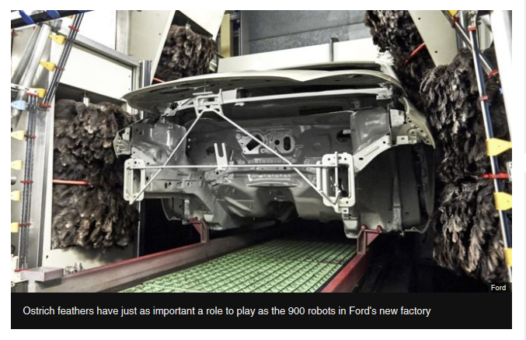

**Questions: (Use the above information and the BBC News website)**

1. **Ford operates a lean production system at its Spanish factory. What does this mean?**

(4 marks)

1. **How might companies like Ford use technology to improve quality throughout the production process?** (6 marks)
2. **Evaluate the decision to spend £1.7bn on upgrading the Ford Valencia plant?**

(15 marks)