Innovation

Backdrop: Tesco launch a £1bn campaign to re-vitalise their UK stores; to give back to their customers. Fewer opening of new stores, more staff in existing stores, better value.

How would you innovate?

The two videos below visit the same store in Germany. The first in 2008 introduces new ideas. The second (unrelated) visit gives feedback on how these have been received, plus new ideas.

Supermarket 2008

<http://news.bbc.co.uk/1/hi/technology/7476672.stm>

Supermarket 2011

<http://www.bbc.co.uk/news/business-12310810>

JIT car seat construction: good for the detailing and thought that has been expended on reducing variability

<http://tlc.discovery.com/videos/understanding-manufacturing-automobile-seats.html>

# The Copenhagen wheel – where is it now?

2009 <http://news.bbc.co.uk/1/hi/sci/tech/8415379.stm>

2012 <https://www.recyclebank.com/live-green/copenhagen-wheel-makes-your-bike-electric-talks-to-your-iphone>

2012 the pre-production company? <http://senseable.mit.edu/copenhagenwheel/>

2014 now on sale: <http://www.youtube.com/watch?v=S10GMfG2NMY>

Some of these links no longer function. But the dates are of interest, as it gives an insight in to the development time, resilience required of entrepreneurs – and cash!!

The 2014 link is live and can probably be supplemented with others

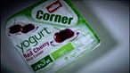[Packaging in the food industry](http://www.bbc.co.uk/learningzone/clips/packaging-in-the-food-industry/12271.html)

**Duration**: 06:41

Highlighting the importance of packaging through innovation with a report on the history of the twinpot in the yogurt market and the plastic bottle in the water market.

[packaging](http://www.bbc.co.uk/learningzone/clips/packaging), [advertising](http://www.bbc.co.uk/learningzone/clips/advertising), [added value](http://www.bbc.co.uk/learningzone/clips/added%20value), [markets](http://www.bbc.co.uk/learningzone/clips/markets), [price](http://www.bbc.co.uk/learningzone/clips/price), [marketing mix](http://www.bbc.co.uk/learningzone/clips/marketing%20mix), [Muller](http://www.bbc.co.uk/learningzone/clips/Muller), [design](http://www.bbc.co.uk/learningzone/clips/design), [risk](http://www.bbc.co.uk/learningzone/clips/risk), [innovation](http://www.bbc.co.uk/learningzone/clips/innovation), [thefoo](http://www.bbc.co.uk/learningzone/clips/thefoodsthatmakebillions)

**UPDATE 2014**: Mike Lynch Autonomy. Hewlett Packard bought the company in 2011 for £7.1bn. Shortly after HP claimed they had been misled and since then have called in the lawyers and police. Dispute continues. Meanwhile HP has written off approx. £4.5bn of the amount they paid.

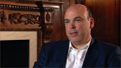[From student to UK software millionaire](http://www.bbc.co.uk/learningzone/clips/from-student-to-uk-software-millionaire/12860.html)

**Duration**: 07:18

A great story of high-tech enterprise. Cambridge students struggle to get £2,000 for start-up capital, yet eventually build the UK’s biggest software business. Customer knowledge and high-tech skills combine to develop computer recognition of fingerprints, giving a huge potential market among police forces worldwide.

[finance](http://www.bbc.co.uk/learningzone/clips/finance), [technology](http://www.bbc.co.uk/learningzone/clips/technology), [Angel investor](http://www.bbc.co.uk/learningzone/clips/Angel%20investor), [Angel funding](http://www.bbc.co.uk/learningzone/clips/Angel%20funding), [added value](http://www.bbc.co.uk/learningzone/clips/added%20value), [innovation](http://www.bbc.co.uk/learningzone/clips/innovation), [understanding customers](http://www.bbc.co.uk/learningzone/clips/understanding%20customers), [venture capital](http://www.bbc.co.uk/learningzone/clips/venture%20capital), [mentor](http://www.bbc.co.uk/learningzone/clips/mentor), [education](http://www.bbc.co.uk/learningzone/clips/education), [location](http://www.bbc.co.uk/learningzone/clips/location), [clusters](http://www.bbc.co.uk/learningzone/clips/clusters), [risk](http://www.bbc.co.uk/learningzone/clips/risk), [culture](http://www.bbc.co.uk/learningzone/clips/culture), [b](http://www.bbc.co.uk/learningzone/clips/bbc%20news)

# R& D

BMW Plant 0: the ‘secret’ plant that proves concepts and develops solutions

<http://techcrunch.com/2011/03/25/video-inside-bmws-secretive-plant-zero-rd-manufacturing-facility/>

Poka Yoke and Chuka Chuka: the latest pre-teen dolls?

<http://tlc.discovery.com/videos/understanding-manufacturing-automobile-seats.html>

[Robots move in to aiding patients recovery / recuperation (5.00min video)](http://www.tutor2u.net/blog/index.php/business-studies/comments/technological-change-robots-move-on-from-the-production-line)

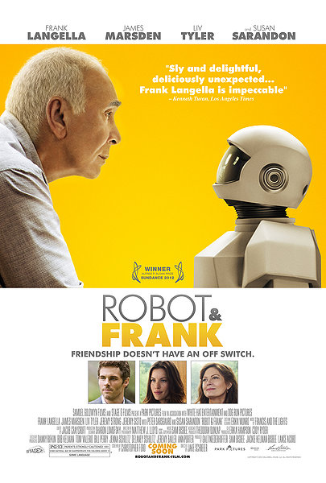

**ROBOT & FRANK**  is a buddy caper. Set in the near future, aging curmudgeon and retired jewel thief Frank (Frank Langella) lives a solitary life until his son (James Marsden) installs a caretaker robot; against he and his daughter's (Liv Tyler) wishes. The robot upends Frank's lonely life - filled only with books and a visit to his favourite librarian (Susan Sarandon) - with a strict regimen of exercise, diet and gardening. Stubborn at first, Frank soon realizes Robot has the ability to pull off the most calculated of heists. An unlikely friendship, and crime duo, is born.

[TRAILER (2.31mins)](http://www.rottentomatoes.com/m/robot_and_frank/trailers/)

[Googles Self Driving car – a collection of video](http://www.bing.com/videos/search?q=google+self+drive+car&FORM=HDRSC3)

Think about . . .

What are Google doing – manufacturing ‘shell’ or providing the software.

How are the costs recovered? Will Google licence the software to vehicle manufacturers?

Will vehicle manufacturers buy the licence or develop their own system?

Are amendments to the Law required?

Exercise:

Wolinski: Ch27 case study Automation for dishwashers, p.330

**CASE STUDY dishwashers**

Mark Scheme

**p. 330**

*(3 marks)* 1 Employees may believe that the robots will replace them on the production line. Furthermore,

as robots become more sophisticated, they are likely to be taking away the more highly skilled

jobs that pay well.

*(6 marks)* 2 Employees may support the introduction of the robots because:

The robots may be taking away the more routine, boring jobs, leaving the workers with the

more interesting roles to fulfil.

Robots can be programmed to work in difficult conditions such as high temperatures or

handling heavy loads. Using robots may improve health and safety for the employees.

The greater profitability of the business should enable it to pay higher wages to its workforce.

The employees may benefit from greater job security if the business is more profitable.

*(16 marks)* 3 The following advantages might be highlighted:

Improved quality will be a great help to Bosch, as this is one of its unique selling points. The

high quality will enable it to offer guarantees for 10 or more years without fear of excessive

compensation to customers whose dishwashers have deteriorated before the guarantee ends.

The gentler handling of components and the consequent elimination of waste, along with the

greater productivity achieved, will reduce the cost of making the dishwashers. This will allow

Bosch either to charge a more competitive price or to increase its profit margin.

Greater reliability and flexibility will enable Bosch to meet sudden increases in demand for its

dishwashers, if necessary.

Bosch will be able to fulfil its obligations to its employees by improving their working

conditions.

***Evaluation***

Which of these benefits is/are the major advantage(s) will depend on the aims of Bosch. As an organisation

with a reputation for quality, it is probable that Bosch will see improved quality as the main

benefit, although higher productivity will boost its profitability in a more clear-cut way.

©