**Plagiarism and Referencing**

Plagiarism is a form of cheating. It is dishonest to claim that somebody else's ideas or words are your own.

Being able to use information from other sources without committing plagiarism is an important academic skill. Your work must show that you

* have individually (unless you are working on a group assignment) carried out the necessary research to complete your assignment
* understand the main theories and arguments surrounding your topic and can use this information appropriately to support your own arguments
* know how to attribute the words and ideas of others using accepted referencing techniques

**Most common forms of plagiarism**

* Copy directly from another source without presenting it as a quote or providing a reference
* Use ideas from another source without providing a reference
* Use too many words from another source when paraphrasing
* Submit someone else's work or ideas as your own
* Include a diagram, image or data table from another source without providing a reference

**Good note-taking habits**

Before you begin taking notes, write down all the details that you will need to cite and reference the source appropriately in your work.

* Make a note of the web address of any websites you use for research purposes.
* Instead of copying the text, read a section or page and then write a summary of it in your own words.
* If you need to copy or paraphrase the author's words very closely, develop a method of indicating this clearly in your notes to help you remember. You could use:
  + Different coloured pens
  + "Quotation marks"
  + Coding system e.g. [quote] = a direct quote
* Adopt a similar method to clearly distinguish your own ideas from the author's.

**When to cite a reference**

Cite your source in your text and provide a full reference at the end when you:

* paraphrase
* summarise
* quote
* refer to the ideas or theories of another work in your assignments.

Use this diagram to help you decide when you need to cite:

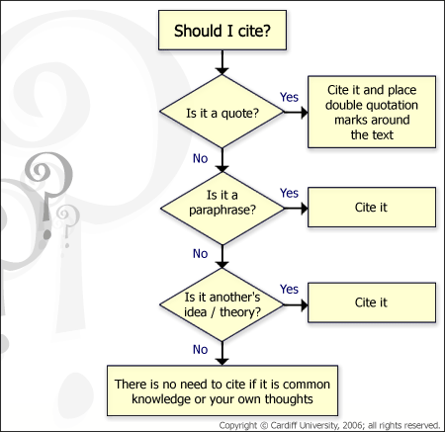

**Referencing.**

You can reference the material you use in your work using footnotes or a direct reference.

**To add a footnote to a work document:**

Select the **reference** tab at the top of the screen[1] and click on **Insert Footnote**, a small number will appear in your work and a corresponding number will appear at the bottom of the screen where you can type in the name and author of the book, website, film etc as well as any supplementary you want to include. The next time you need to reference something click **Insert Footnote** again and a second number will appear[2]

**If you want to insert a direct reference:**

Put quotes in “inverted commas” or paraphrase an idea and then add:

* The author, title and page number if your source is a book
* The author, title and issue number if your source is a magazine or newspaper
* The Web address and author if your source is a website
* The Name and broadcast date if your sources is a TV programme or film.

**And Finally!**

At the end of your assignment you need to include a **Reference List** which includes all of the sources you have used throughout the project.

This help sheet was put together using the iskills section on plagiarism on Godalming Online For more information about plagiarism visit: <http://moodle.godalming.ac.uk/learning/course/view.php?id=333&topic=2>

1. This is the 4th tab along.
2. Like this!