# Links to help with D1

## Nissan

News articles from Nissan’s company pages

<https://newsroom.nissan-global.com/releases?from=IR&lang=en-US>

Annual reports and financial data

<https://www.nissan-global.com/EN/IR/>

General info on Nissan and Globalisation

<https://www.ukessays.com/essays/education/nissans-global-strategy.php>

<http://fortune.com/video/2017/01/11/nissan-ceo-carlos-ghosn-trade-globalization/>

<http://www.bbc.co.uk/news/av/business-20782296/nissan-investment-vote-of-confidence>

Statistics and data

<https://www.statista.com/statistics/316786/global-market-share-of-the-leading-automakers/>

<https://www.statista.com/statistics/271608/global-vehicle-sales-of-automobile-manufacturers/>

<https://www.statista.com/statistics/267830/brand-values-of-the-top-10-most-valuable-car-brands/>

<http://www.quest-trendmagazine.com/en/automobile-industry/internationalization/market-shares-automobile-manufacturers.html>

<http://www.quest-trendmagazine.com/en/automobile-industry/internationalization/changes-in-market-shares-of-automakers.html>

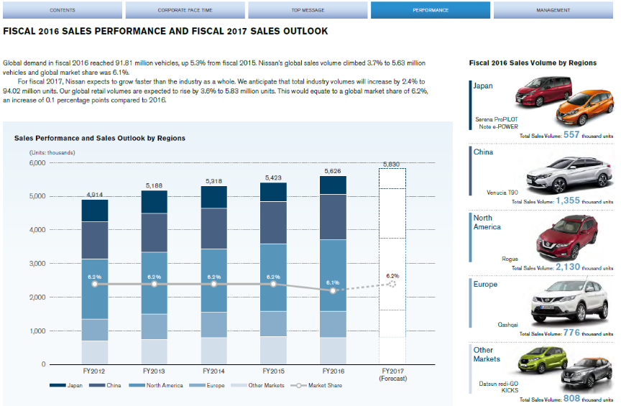

<https://www.nissan-global.com/EN/DOCUMENT/PDF/AR/2017/AR17_E_All.pdf>