**[Bowles and Gintis: The Correspondence Principle](https://revisesociology.com/2017/07/04/correspondence-principle-bowles-gintis/)**

Posted on [July 4, 2017](https://revisesociology.com/2017/07/04/correspondence-principle-bowles-gintis/) by [Karl Thompson](https://revisesociology.com/author/notsoclevermonkeys/)

Marxists sociologists Bowles and Gintis (1976) argue that the main function of education in capitalist societies is the reproduction of labour power.They see the education system as being subservient to and performing functions for the Bourgeoisie, the capitalist class who own the means of production: the Bourgeoisie require a workforce that is hardworking, accepts authority, and who won’t kick up a fuss if they are exploited, and the main function of school in capitalist societies is to indoctrinate children into these norms and values. The education system does this through the hidden curriculum – which consists of the things pupils learn through the experience of attending school, rather than the stated education objectives in the ‘formal curriculum’.

**Bowles and Gintis: the correspondence principle**

The correspondence theory is the idea that the norms and values pupils learn in school correspond to the norms and values which will make it easy for future capitalist employers to exploit them at work.

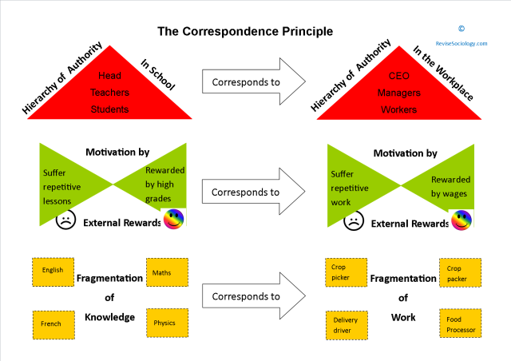

Bowles and Gintis say that ‘work casts a long shadow over school’.There are four ways in which the norms and values of school correspond to the required norms and values of work in capitalist society:

**One – It helps to produce a subservient workforce of uncritical, passive and docile workers**

In a study based on 237 members of the senior year of a New York high school, Bowles and Gintis found that the grades awarded related more to personality traits rather than academic ability: low grades were related to creativity, aggressiveness and independence, while higher grades were related to perseverance, consistency and punctuality. The education system was creating an unimaginative and unquestioning workforce through rewarding such traits.

**Two – encouraging an acceptance of hierarchy and authority**

Schools are hierarchical organisations – pupils have little say over what they learn, or how the school day is organised, and in day to day life, pupils are expected to obey the authority of the teachers. Later on at work, workers are expected to obey the authority of managers.

**Three – motivation by External Rewards**

This is where pupils are taught to be motivated by the qualifications they will receive at the end of school, rather than the ‘joy of learning’ itself, while at work, workers are motivated by the wage packet at the end of the month rather than ‘the joy of working’ itself.

***This is probably the most important aspect of the correspondence principle:***

In Marxist theory, if people have control over it,  work is actually enjoyable: many people engage in ‘work’ as part of their hobbies: if left to their own devices, people will naturally engage in work because it gives them a sense of satisfaction: as an example think of a car-fanatic who will happily spend hours putting together a car engine, or the whole car itself in his garage, or an allotment owner who will do the same when ‘growing their own’ – if people control the whole process of work, and can ‘see themselves’ in it, they will happily work, even for no pay.

However, work in capitalists societies becomes alienating and exploitative – Capitalists require workers to be like machines, working as part of a ‘production line’ for example, because this means production is more efficient and their profits are thus greater – so rather than individuals or small groups of individuals each setting up their own garages to make cars, or small scale farms growing food for a few dozen people, work becomes larger scale, organised into massive factories, and workers become part of the ‘machine’ of production, where the worker has no control, and work is repetitive and dull. In this industrial-capitalist system of work, workers have no intrinsic motivation to work, they need to be motivated externally, by wages.

Because this is such an unnatural and miserable situation, there needs to be a long process of convincing people this is normal – which is where school comes in – school is about learning to put up with boring lessons, and the motivation for this is at the end – through the qualifications.

Thus capitalism requires school to teach people to not be inquisitive, to just ‘learn what I tell you to learn’ and put up with boredom, to work hard now (study) in order to achieve the grades at the end of the year… there is no reward in education for those ‘doing their own thing’, because this is not what future employers require.

**Four – the fragmentation of subjects at school**

Learning at school is fragmented into different subjects, split up into maths, English, history, sciences, with lessons lasting only 45 minutes to an hour. Knowledge is thus fragmented into different academic subjects, rather than being holistic’. This corresponds to the fragmentation of the workforce in later life – workers specialise in particular tasks in the office or the factory, without having an appreciation of the whole. This fragmentation makes workers easier to control because they are divided, which makes it more difficult for them to unite and challenge their exploitative conditions.

**Evaluations of Bowles and Gintis’ Correspondence Principle**

Ken Robinson’s TED talk about schools killing creativity (look it up!) seems to offer broad support for the idea that school doesn’t reward creative thinking. https://www.ted.com/talks/ken_robinson_says_schools_kill_creativity

However, on balance, much of this theory seems out of date – relevant maybe to the 1970s, when there were more factory jobs, but not so relevant to today’s more child-centred and entrepreneurial society.

**Briefly summarise the argument made by Bowles and Gintis below:**

**What issues would a functionalist have with this?**

**What can be seen as positive about this approach?**

**What is negative about this approach?**