**Godalming College**

Booklet Checked by: _____________

Grade: U/S 1 2 3

Comment: __________________________________________________________________________________________________________________________________________________________

**Sociology Department**

ROLES, RESPONSIBILITIES AND RELATIONSHIPS WITHIN THE FAMILY

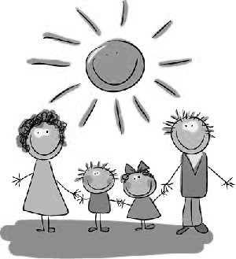

**PAPER 2 Workbook 3**

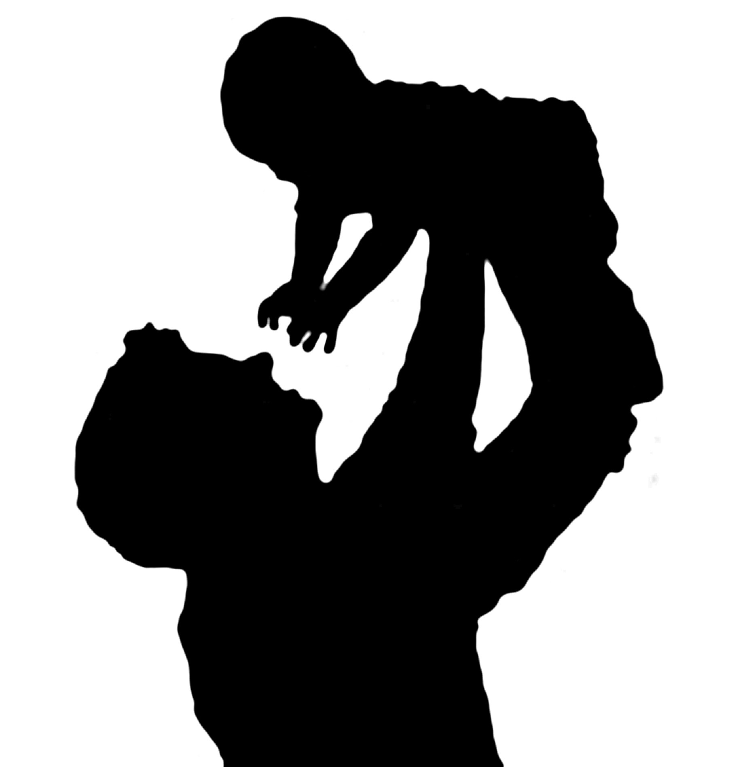Family Roles

|  |  |  |
| --- | --- | --- |
| Name: | Set: | Group: |

**The AQA Specification:**

**A LEVEL SPEC**

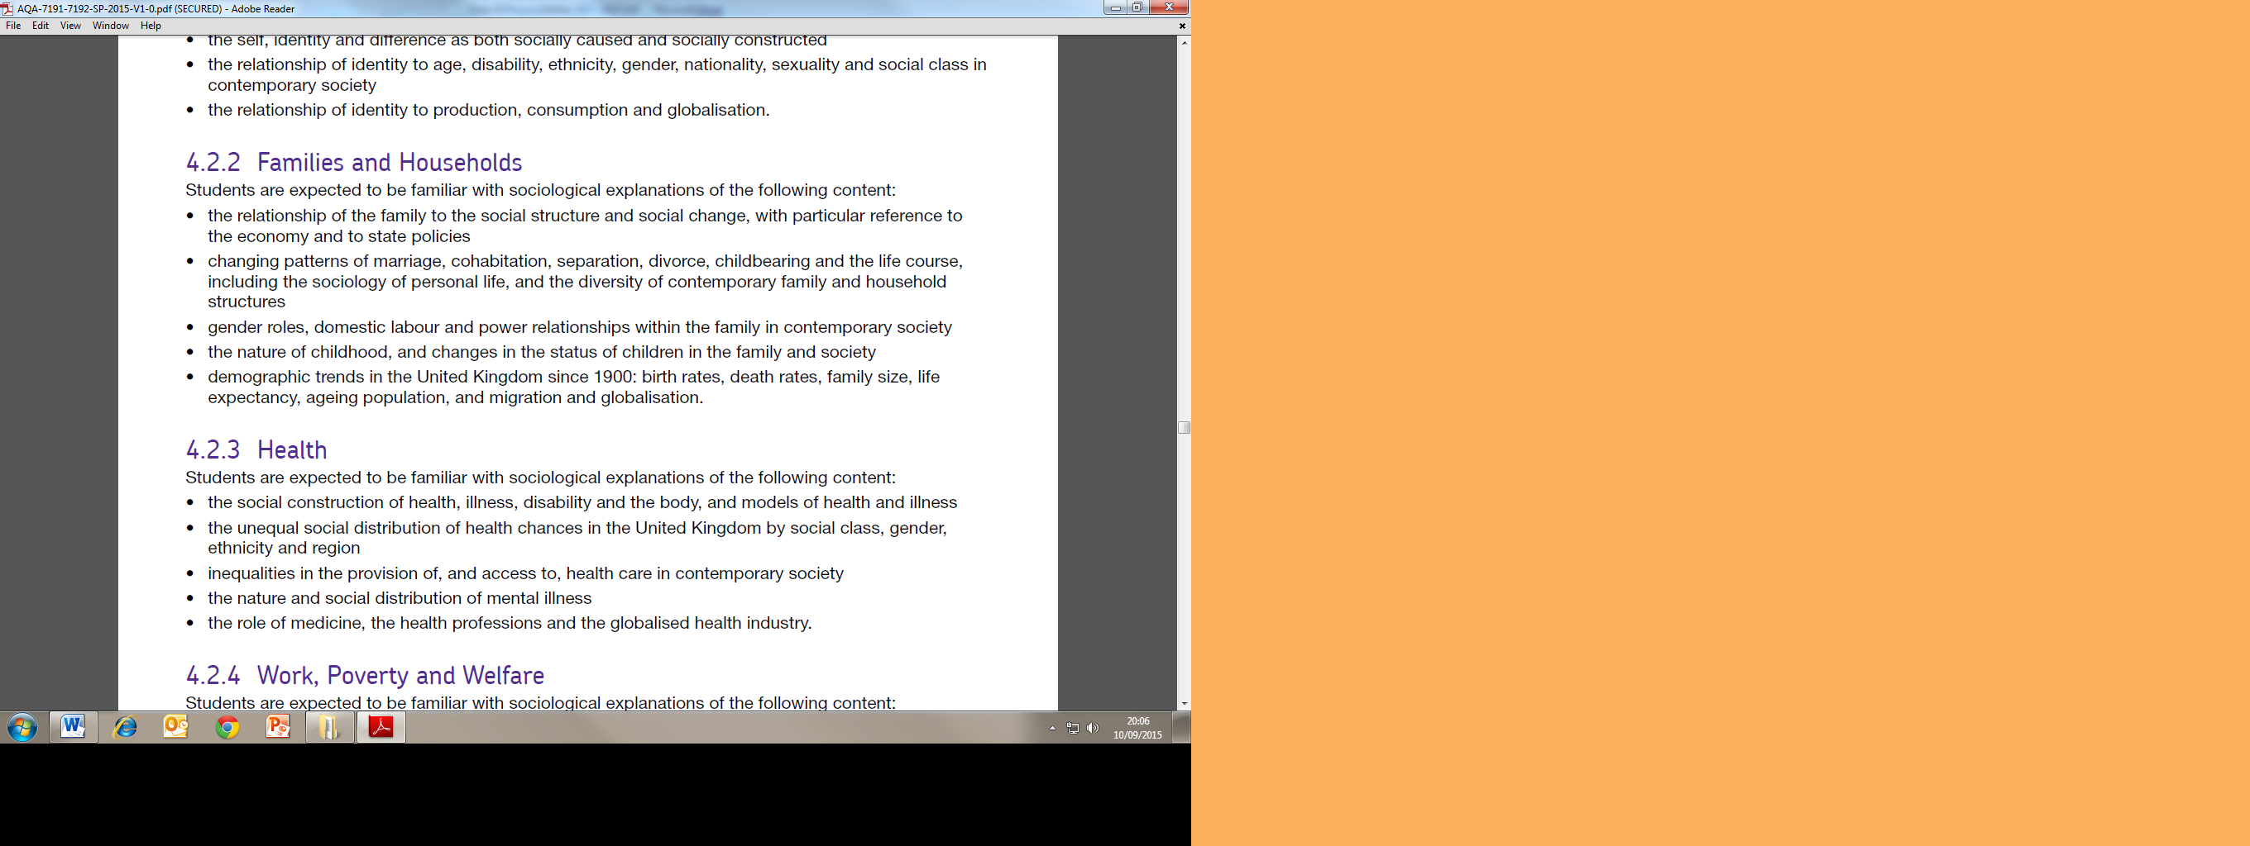This booklet will give an overview of the ways in which the nature of the family has changed over time and the debate about the changing roles within it..

It is imperative that you are fully aware and clear of the debates within this workbook, and how each of the main perspectives position within these debates.

All the key terms you need to know feature at the end of this workbook. We recommend that you maintain your own key studies summaries, as covered within class, to aid your revision.

**SECTION 1 CONJUGAL ROLES**

**What are conjugal roles?**

**CONJUGAL (or marital) ROLES** are the different roles taken by husband and wife within a marriage

several sociologists have engaged in a debate regarding conjugal roles and how they may have been shaped or altered by socio-economic change. There are a number of basic positions on how these roles have changed over the last 40 years:

1. An **equal partnership** has come into the family - some even alleging that a "new man" may be found prepared to fully engage with responsibilities for domestic tasks, child-rearing, etc. (*the key question here is why is no-one married or going out with one*?!)
2. The partnership between men and women in the family is **no more equal** than it ever was - the new man is essentially an ideological construction - this argument is particularly associated with feminist approaches.
3. A further position argues that the partnership between men and women has become **less equal**. As women have increasingly taken on an economic role as wage earners they have also maintained their role in homecare / childcare. This is known as the **dual burden hypothesis or triple shift** (this is also associated with feminist approaches)
4. The last argument, from a postmodern argument, is that the roles between men and women are now based on choice, which can lead to variety in how conjugal roles are formed, such the mother going back to work and the husband looking after the children.

After reading the three positions outlined above, consider which position you most agree with. Explain your answer using the space as fully as possible below:

________________________________________________________________________________________________________________________________________________________________________________________________________________________________________________________________________________________________________________________________________________________________________________________________________________________________________________________________________________________________________________________________________________________________________________________________________________________________________________________________________________________________________________________________________________________________________________________________________________________________________________________________________________________________________________________________________________________________________________________________________________________________________________________________________________________________________________________________________________________________________________________________________________________________________________

**Perspectives on conjugal roles – SUMMARY SHEET**

**Varieties of functionalism**

**The “biological imperative”.** Earlier functionalists (Parsons, Murdock) have tended tosee the sexual division of labour in the home as biologically inevitable. Women are seen as naturally suited to the caring and emotional roles, which Parsons terms the ‘expressive role’.

**Cultural Change and its critics** Later sociologists who might also be seen as functionalist (Young and Willmott, etc.) have tended to see the growth of greater equality between men and women as culturally determined and inevitable – this is sometimes described as a “march of progress” – inevitable and necessary

However, New Right theorists, whilst agreeing that such changes are occurring, see them as destabilising and against the best interests of those involved – a return to an earlier functionalist position

**Liberal feminists**

**Meaningful change.** Liberal Feministsbelieve women have made real progress in terms of equality within the family and particularly in education and the economy. They generally believe that men are adapting to change and, although they culturally lag behind women in terms of attitudes and behaviour, the future is likely to bring further movement towards domestic and economic equality. But it may not be quick enough. See Oakley

**Marxist feminists**

**Capitalism and domestic labour.** Marxist feminists argue that the housewife role serves the needs of capitalism and maintains the present workforce and reproduces future labour-power, all at low cost.

**Radical feminists**

**Men as the problem.** They believe that the housewife role is created by patriarchy and geared to the service of men and their interests. The family is the main source of men’s oppression of women and the root to gender inequality in society. This is expressed in the fact that women are expected to do most of the unpaid labour of housework and childcare. They argue men use the threat of domestic violence to keep women subordinate to their will. See Duncombe and Marsden, Bernard

**Postmodernists**

**The problem of generalisation and meaning.** They believe that the nature of postmodern society means that relationships between people are based far more on individual choice. If a woman wishes to be a housewife she can, if not she need not, but it will be a matter of individuals exercising choice over their own lives.

## The Conjugal Role Debate

## Arguments and evidence to support the view that there is greater equality in conjugal roles

**ELIZABETH BOTT - Family and Social Networks (1957, revised 1971).**

A key study used by Young and Willmott, Bott distinguished between two polar types of conjugal role relationship, segregated and joint.

**Joint**

**Segregated**

In the segregated case, men and women have a clear differentiation of tasks, and a considerable number of separate interests and activities. In the joint relationship, many tasks are carried out together with a minimum of task differentiation and separation of interests.

Bott noted that in all families, there was a basic division of labour in which the man was primarily responsible for supporting the family financially, and the woman was primarily responsible for housework and childcare. Her study reviewed the 'considerable variation in detail' on this basic theme.

If family members maintain ties with a network of friends or neighbours who know one another and interact apart from the family members, members of these networks can exert pressure on family members to conform to traditional role. When members of close-knit networks marry and still participate in network activities after marriage, they will be likely to develop more segrergated traditional roles in marriage.

Bott offered three hypotheses:

* *The Class Principle*. Working class with less formal education were generally more likely to have traditional segregated roles
* *The Composition Principle*. Where networks were strong (women with strong links to female kin, neighbours, friends; men with strong local links to work colleagues, etc) segregated roles were more likely
* *The Residential Principle*. The more geographical mobility the greater likelihood of joint conjugal roles, as local extended families and friendship groups are split up.

**THE KEY STUDY**

## The Symmetrical Family – Michael Young and Peter Willmott (1973)

Young and Willmott’s study has set the debate for succeeding sociological work, and is based on their earlier detailed case study on changing families (in Bethnal Green in London), a large scale survey based on structured interviews with 1,928 contemporary families (in Greater London and the outer metropolitan area) and the historical and other material provided by other theorists (secondary data).

They see the family as moving through 4 main stages as follows

**Stage 1 – the pre-industrial family**

The family is a unit of production: the husband, the wife, and unmarried children work as a team, typically in the area of agriculture. This type of family gradually disappeared with industrialisation but a small number survive today, the best examples being some farming families.

**Stage 2 – The early industrial / the asymmetrical family**

From the Industrial Revolution, the family ceased to be a unit of production as individual members **went out to work** as wage earners. Before the Welfare State the family would extend its network to include extended kin (older generation, cousins, etc), providing insurance against insecurity and hardship. This extension was largely conducted by women. The key tie was between a mother and her married daughter, while in comparison the **conjugal bond** (between the husband and wife) was relatively weak. Families were often headed by a female, but this was likely to be because of higher mortality rates for men rather than desertion, separation or divorce.

This type of family saw decline through the 20th Century but it is still found in some low income, long established working class areas. Its survival was documented in Young and Wilmott’s famous study ‘**Family and Kinship in East London**’. This was conducted in the 1950s. They found that two out of three married people had parents living within 2 or 3 miles or their residence. There was also a close tie between female relatives. Over 50% of the married women in the sample had seen their mothers during the previous day. There was also a constant exchange of services such as washing, shopping and babysitting, between female relatives.

Although many aspects of the stage 2 family were present in Bethnal Green, there were also indications of a shift toward what they called stage 3, with fathers increasingly involved in active parenting of children and spending leisure time with the family rather than with work colleagues.

**Stage 3 – the symmetrical family**

This family is characterised by the separation of the nuclear family form the extended family. Ties between female kin and female neighbours weaken and the father spends non-work time in the family.

Life is largely home centred, particularly when children are young, leisure is mainly home based (e.g., watching television). The conjugal bond is strong, the husband and wife increasingly share their work. Conjugal roles are symmetrical – not identical but in some sense equal (e.g., women may retain primary responsibility for child care, but there is a division of chores and responsibilities within the household to ensure its smooth running. Decisions are often shared

Reasons for the rise in the symmetrical family:

1. Reduced need for kinship based mutual aid.
2. Increasing geographical mobility
3. Reduction in the number of children in the family allows women to work.
4. Husbands drawn into the home with increasing comfort, better amenities, and a greater range of home entertainment.

Young and Willmott found that the home centred symmetrical family was more typical of the working class. Members of the working class are less fully work centred and focus is centred on family life. The nature of work is therefore central to family life.

**Stage 4 – beyond the symmetrical family?**

Applying this principle of Stratified Diffusion in 1973, Young and Willmott examine the family life of managing directors, who are work-centred, leisure activities are less home-centred and are less likely to involve their wives. The family was increasingly asymmetrical and showed similarities to some of the patterns in Stage 2.

Young and Willmott suggest that changes in technology and the reduction in routine work may result in stage 4 families becoming more common. People may become more work-centred and less home-centred, and they predicted that the asymmetrical family represents the next major development.

**ANTHEA HOLME - Housing and Young Families in East London - 1985**

**Holme** took another look at Young and Willmott's patch a decade later studying 50 Bethnal Green families. Shefound that a link had developed between conjugal roles and social networks. Bethnal Green husbands were noticeably home-centred, although the area had moved more slowly toward this than Woodford - an outlying estate. Wives' expectations on the sharing of tasks were often rather low, although tasks were more likely to be shared when the wife returned to work after having children. The mother/daughter bond seemed to have weakened - when asked who they would turn to for advice and help, wives mentioned husbands as often as their mothers.

|  |
| --- |
| **Summarise Young and Willmot’s findings below** |

**Arguments and evidence against the rise of joint conjugal roles and the symmetrical family**

**Ann Oakley - Housewife**

**Oakley** dismissed the idea that marriages are increasingly equal partnerships. She argued that sociological studies of "equality" in marriage have often started from the assumption that cooking, cleaning and childcare are somehow inherently women's responsibilities and that any intervention in these spheres by men is seen as a major breakdown of conventional patterns. While couples do things "jointly" this does not necessarily mean that they do things equally. Also, mutuality in some aspects of the relationship may not extend to others - e.g., couples may entertain or visit friends together but that in itself is no guarantee that childcare or housework is shared.

*"As long as the blame is laid on the woman's head for an empty larder or a dirty house, it is not meaningful to talk about marriage as a "joint or "equal" partnership. The same holds of parenthood. So long as mothers, not fathers, are judged by their children's appearance and behaviour, symmetry remains a myth.”*

**FRAN ANSLEY**

The Marxist feminist **Fran Ansley** (1972) adapted Parsons’ view of the family as functioning to stabilise adult personalities and turned it into a Marxist idea. She sees the ‘function’ of the family (particularly the wife) as being an ‘***emotional safety-valve’*** absorbing the husbands frustrations created by the capitalist system. By doing this, the wife helps keep capitalism stable - this explanation sees society in conflict rather than consensus as evident in Parsons’ explanation.

**Jessie Bernard - The Future of the Family**

**Bernard** argues that the benefits of a marriage to husband and wife are radically different. She points to the beneficial effects of marriage for men. Compared to single men, married men are likely to have successful careers, high income, high status occupations; their mental and physical health is significantly better and they are likely to lead longer and happier lives. **Bernard** sees that it is the wife "*willing to devote her life to taking care of him, providing, even enforcing the regularity and security of a well-ordered home*", who produces these beneficial results for her husband.

Compared with their husbands, wives suffer stress, anxiety and depression; they suffer these complaints more than single women. Single women are healthier than their married counterparts.

***"In truth, being a housewife makes women sick****."*

**JEAN DUNCOMBE & DENNIS MARSDEN (1995)**

**Duncombe and Marsden** argue that with married women increasingly taking on paid employment they end up doing what they call the ***triple shift*** – having completed paid employment they not only have to the housework but also do the emotional work of care and nurturing.

**A R HOTHSCHILD (2013)**

Hothschild argued that women tend to work in jobs which involve emotional labour – somewhat as an extension of their domestic role.

**FIRESTONE (1971)**

As a radical feminist, Firestone argues extreme inequality has occurred between men and women in both the personal and public spheres. The source of patriarchy lies in biological differences between men and women, women’s ability to give birth results in biological dominance and women are subject to the support of men at a time of their life when they are dependent.

Q What problems can you identify with feminist arguments regarding domestic roles?

**Catherine Hakim’s criticism of the feminist argument**

**CATHERINE HAKIM - Preference theory**

Hakim emphasises that women make active individual choices regarding their employment, and are not simply the product of socialisation/canalisation.

Partly because of the impact of feminism and the development of anti-discriminatory legislation, women are now free to choose their relationship to the domestic sphere, but will often choose traditional roles because they would prefer to do so.

She argues there are three types of women:

1. **Adaptive women** – combining paid employment and family work without prioritising one or the other – Hakim says around 2/3 of all women in the labour market?
2. **Work-centred women** – fit their life around their work - a minority according to Hakim (20%)
3. **Home-centred women** – only engaged in paid employment thorough a shortage of money. May still be well-qualified and even attracted to higher education (middle class marriage market! - again 20%?)

*Hakim’s work raises important issues – we can clearly see when people choose unconventional domestic arrangements (househusbands, child free women etc) but when people actively and deliberately choose what appear to be conventional roles, their freedom to do so may not be apparent.*

Q. What issues might you raise with Hakim’s hypothesis and statistics?

**Areas of Contention – you will also be required to add your own study to each of these areas**

1. **Domestic Labour (see Webb p.322-326)**

**JONATHAN GERSHUNY – the relationship between paid work and domestic work**

Jonathan Gershuny found that wives who worked full time did less domestic tasks.

* Wives who did not go to work did 83% of the housework and wives who worked part time did 82%
* Wives who worked full time did 73% of the housework, the longer the wife had been in paid work the more likely the husband was to help out.

He explains this trend towards greater equality in terms of a gradual change in social values.

Role models are also important: couples whose parents had a more equal relationship were more likely to share housework equally themselves

**Silver and Schor - the commercialisation of housework**

Silver and Schor (1993) argued that roles have become more symmetrical because of two principal factors:

1. Housework has become more ‘commercialised’ In a society of consumers, there are may products which make housework easier, the things that housewives previously had to produce are now readily available
2. Women are also working in paid employment with the responsibilities that entails sharing roles is necessary

**THE FUTURE FOUNDATION _ Household Chores**

According to the survey conducted by the Future Foundation ("Complicated Lives", 2000) based on a sample of 1,000 UK adults.

Housework:

* + Men now average 50 minutes / day.
  + Women in paid employment average 90 minutes / day.
  + 60% of men claimed to do more housework than their father.
  + 75% women claimed to do less housework than their mother.

In 1960, women averaged 110 minutes / day and men 10 minutes / day.

1. **Money and power within the Household (see Browne p.327-328)**

**ONS - Househusbands and Official Statistics**

In 2011, according to the Office for National Statistics, 62,000 men in the UK were classified as economically inactive and looking after their family or home. This was a considerable increase on the 21,000 men recorded in 1996.

This correlates to figures internationally. In the USA in 2013 Kramer, using the American Census Bureau’s Current Population Survey found over the previous ten years that the percentage of house dads increased to 3.5%, or 550,000 dads. In the ’70s, only 280,000 men were staying at home, representing only 2% of the families analysed.

**ONS - Women in Paid Employment**

In a study published in 2013 the Office For National Statistics noted the rise in percentage of women aged 16 to 64 in paid employment (67% of women – up from 53% in 1971) and a fall in the percentage of men (76% down from 92% in 1971).

**DUNNE – gender scripts**

Dunne (1999) argues that the division of labour continues because of ‘gender scripts’ - the expectations and norms that set out the different expectations of men and women in heterosexual couples

Because they had been free of these traditional gender scripts, her research into same-sex lesbian couples found them more likely to

* Describe their relationship as equal, share housework and childcare equally and view childcare positively
* Give equal importance to each partner’s career

**CAROL SMART – same sex households**

Smart (2007) found that some gay and lesbian couples attached no particular importance as to who controlled the money as a sign of inequality in a relationship

Smart felt that same-sex couples did not enter relationships with the same “historical, gendered, heterosexual baggage of cultural meanings around money” that saw it as a source of power.

**JEFFREY WEEKS – same sex households**

Weeks (2001) identified a “c*o-independence*” model in gay and lesbian househlds sharing some money for household expenses whilst retaining separate accounts for independent spending

**VOGLER – cohabiting couples**

Vogler found that cohabiting couples were less likely to pool money than traditional married couples and yet were more likely to share tasks equally – from this it is not clear that money is always a clear indicator of equality in other areas

**PAHL - MONEY AND MARRIAGE**

Pahl points out that even pooling money is not in itself equal – it is also relevant to ask who spends and directs this pooled money

In the majority of households studied by Pahl(1989) men were dominant in financial decision-making and this was related to their earning power. Husbands were more likely to dominate financial decision-making where the wife did not have a job - but that minority of wives who did dominate decision-making were usually in paid employment. For very poor couples, where neither partner was in employment, husbands were often dominant in decision-making; although wives might actual directly control the money.

**EDGELL – Decision making for middle class couples**

Studying decision-making in the family, **Edgell** (1980) found that, although decisions might seem evenly balanced, more important and less frequent decisions tended to be husband-dominated.

|  |  |  |  |
| --- | --- | --- | --- |
| Decision area | Perceived importance | Frequency | Decision-maker (majority pattern) |
| Moving | Very important | Infrequent | Husband |
| Finance | Very important | Infrequent | Husband |
| Car | Important | Infrequent | Husband |
| House | Very important | Infrequent | Husband and wife |
| Children's education | Very important | Infrequent | Husband and wife |
| Holidays | Important | Infrequent | Husband and wife |
| Weekends | Not important | Frequent | Husband and wife |
| Other leisure activities | Not important | Frequent | Husband and wife |
| Furniture | Not important | Infrequent | Husband and wife |
| Interior decorations | Not important | Infrequent | Wife |
| Food and other domestic spending | Not important | Frequent | Wife |
| Children's clothes | Not important | Frequent | Wife |

1. **Parenting and equality**

**DERMOTT – Intimate Fatherhood**

The relationship between men and their children has been of particular concern to sociologists in recent years. The shift away from an exclusively *“breadwinner”* ideal for fathers has signalled what Dermott has referred to as the rise of *intimate* fatherhood – with an attempt to develop a more effective work/family balance and greater involvement with children. This was based on *25*

semi-structured interviews with fathers with at least one child of *primary* school age.

However, this study might be criticised for the very small size of the sample used. The interviews were also conducted with *working class* men. This is significant in that it mirrors the social class group focused on by Young and Willmott’s study, but may also represent a group with a greater capacity to engage in this active model of fathering, especially given the very long working hours of the UK compared with continental workforces.

**THOMPSON – The decline of the breadwinner role**

Thompson’s survey (2005) found that only *39%* of the fathers surveyed felt that the breadwinner role was the most important aspect of fatherhood. Further, *80%* of the fathers surveyed said that they would be happy to stay at home to care for children. However, 65% of those studied felt that women were “naturally” better at childcare.

**MARY BOULTON - Fatherhood**

Boulton demonstrated that, whilst fathers may well help with specific childcare tasks , it is usually mothers who take on the responsibility for the well-being and security of the child (“*On Being a Mother*”, 1983)

Fewer than 20% of husbands in her study had a major role in childcare

**FERRI & SMITH – Fathers and childcare**

Ferri and Smith (1996) found that fathers took responsibility for childcare in fewer than 4% of households

**DEX & WARD – Dads’ involvement with children**

Dex and Ward’s study in 2007 contrasted relatively high levels of involvement with responsibility for 3 year olds

78% of fathers actively played with their children but only 1% would take responsibility for a sick child

**BRAUN, VINCENT & BALL - Fathers as Carers**

Braun, Vincent and Ball in 2011 found that of 70 families they studied, in only three of them was the father the main carer

Most men were “background fathers” – primary responsibility to partner rather than child, with a “provider ideology”, i.e., their principal role to provide for the family rather than actively participae in parenting on a day-to-day basis

By contrast, women’s roles in “intensive mothering” were supported by media stereotypes

**EOC – Dads on Dads**

The Equal Opportunities Commission (Dads on Dads, 2002) in their survey whilst fathers play a range of roles in contemporary families most still saw themselves as primarily breadwinners. The key factor in shaping domestic roles for the EOC was women’s lower average pay.They found four principal styles in parenting

1. **Enforcer dad –** not involved with the day-today care of children. What is important is being a role model and setting clear rules as to what is important. These were often older dads.
2. **Entertainer dad –** plays with the children whilst his partner gets on with domestic chores
3. **Useful dad –** helps out, but led by the mother in terms of what needs doing
4. **Fully involved dad –** equally involved with running the home and the family at least for some of the time. Mother’s and father’s roles are interchangeable.

**See also material on Domestic Violence and other sources in previous booklet and in Browne p.330-332**

**GLOSSARY**

|  |
| --- |
| **JOINT CONJUGAL ROLES** |
| **SEGREGATED CONJUGAL ROLES** |
| **DUAL BURDEN** |
| **TRIPLE SHIFT** |
| **DOMESTIC LABOUR** |
| **BIOLOGICAL IMPERATIVE** |
| **PRINCIPLE OF STRATIFIED DIFFUSION** |
| **SYMMETRICAL FAMILY** |
| **MARCH OF PROGRESS** |
| **EMOTION WORK** |
| **PREFERENCE THEORY** |
| **COMMERCIALISATION** |
| **GENDER SCRIPTS** |
| **INTIMATE FATHERHOOD** |
|  |
|  |
|  |
|  |

**Exam questions**

**10 mark outline questions**

Outline and explain **two** changes in society which may have contributed to women’s changing roles within families. *(10 marks)*

**10 mark apply questions**

*Item A: Domestic violence accounts for up to a quarter of all recorded violent crime. Victims are more likely to be female and offenders males: domestic violence is linked to gender roles in patriarchal society. However, not all women are equally likely to suffer domestic violence. Victims- both male and female- are more likely to belong to disadvantaged social groups and live under difficult circumstances.*

Applying material from Item A, analyse two reasons for patterns of domestic violence (10 marks)

**20 mark questions**

**Example 1**

*In contemporary Britain, families are often thought to be more “symmetrical”, whereby the relationship between married or cohabiting couples has become less patriarchal, or male-dominated, and much more an equally balanced partnership.*

*Both partners share household chores, childcare and decision-making, and both partners are more likely to be involved in paid employment.*

Applying material from **Item B** and your knowledge, evaluate the view that contemporary families have become a partnership of equals. (20 marks)

**Example 2**

*Research by feminist sociologists such as Oakley showed that gender roles were unequal in many families, with women taking the greatest share of housework and childcare. Some sociologists argued that this was because these roles were ‘natural’. However, it is now claimed that there is a growing equality between partners, with domestic tasks being shared more equally.*

Applying material from Item B and your knowledge, evaluate the contribution of feminists to our understanding of the family (20 marks)

**Example 3**

*Some sociologists claim that many changes in society have benefitted women and their roles within the family. For example, they argue that both the increasing number of women in the workforce and the growing acceptance of equality between the sexes have led to the roles of men and women within the family becoming more similar. Other sociologists argue that family roles continue to reflect the unequal positions of men and women in society.*

Applying material from Item B and your knowledge, evaluate the view that families remain largely patriarchal structures that disadvantage women (20 marks)

**PREPARING THE ESSAY ON ROLES AND RELATIONSHIPS**

One way in which you might lay out an essay for this topic would be to pick the three main areas and investigate the evidence and arguments for each in turn

|  |  |  |  |  |
| --- | --- | --- | --- | --- |
| **Introduction**  Unpack the question and key terms  Outline the debate | |  | |  |
| 1. Domestic Labour |  | |  | |
| 1. Parenting |  | |  | |
| 1. Money & Decision Making |  | |  | |
| Conclusion  Are roles more equal?  How could we tell?  What problems arise when trying to prove it? | |  | |  |