**Godalming College**

Booklet Checked by: _____________

Grade: U/S 1 2 3

Comment: _______________________________________________________________________________________________________________________________________________________

**Sociology Department**

**SAMPLING**

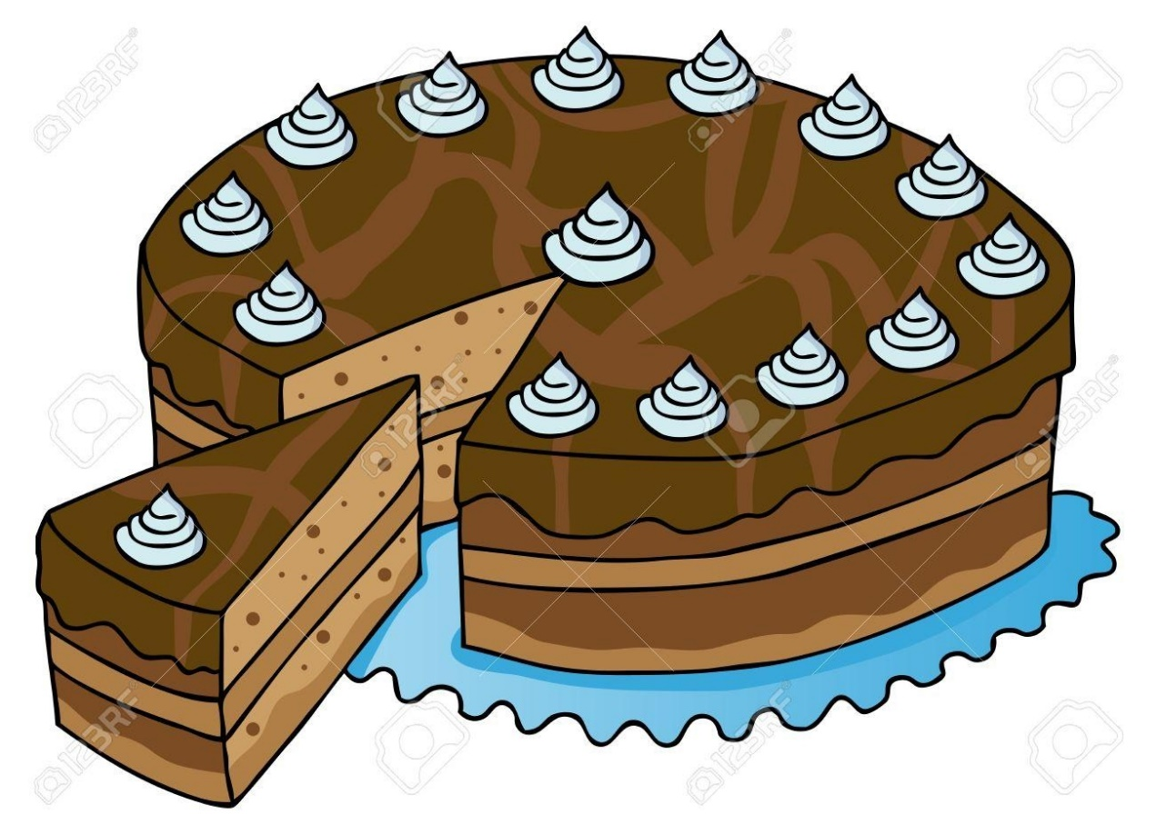

**RESEARCH METHODS**

|  |  |  |
| --- | --- | --- |
| Name: | Set: | Group: |





**Aims**

As you can see from the specification above, Sampling is marginal to the content of Sociology A level – however, it is an important part of the language of methods, relates closely to theoretical issues and is necessary to grasp and build on the concepts of **representativeness** and **generalisability**

This booklet is therefore only intended as a very quick guide to sampling techniques. It will revise some with which you will be familiar, and some which are a little more obscure

By the end of this module you should have

* Considered sampling strategies employed by sociologists and other researchers
* Considered the advantages and disadvantages of different sampling strategies
* Considered how sampling techniques may be more or less appropriate when combined with particular methods

**Exam questions?**

Outline and explain two problems with the use of random sampling in sociological research (10 marks)

Outline and explain two reasons why sociologists might use non-random sampling in their research. (10 marks)

**Key terms in sampling**

|  |
| --- |
| Sample |
| Sampling frame |
| Universe |
| Population |
| Snowball sampling |
| Opportunity sampling |
| Random |
| Quasi-random sampling |
| Stratified Random Sampling |
| Self-selected sample |
| Practical reason |
| Methodological reason |
| Representativeness |
| Reliability |
| Validity |
| Generalisability |

#### The sampling process

**(a) Using a sampling frame**

|  |  |  |
| --- | --- | --- |
|  | **UNIVERSE OR POPULATION** |  |
|  | The target group to be studied |  |
|  | **↓** |  |
|  | SAMPLING FRAME |  |
|  | A collection of names, a list, a roll, etc. which is in some sense representative of the target population |  |
|  | **↓** |  |
|  | **SAMPLE** |  |
|  | The group selected from the sampling frame to be studied by the researcher |  |

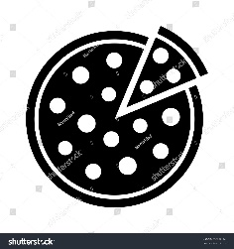Representativeness will depend upon the relationship between these different levels, i.e., how closely related the frame is to the target population (e.g., if one were using a telephone book, would the absence of non-telephone users or users of alternative telephone systems be significant to the whole population, or might double counting occur where a household had more than one line or might it be significantly out of date?), and how closely related the sample is to the frame (this would be dependent primarily upon the technique used, the size of the sample and the accuracy of the process).

**(b)Not using a sampling frame**

e.g., Snowball sampling

Researcher

Here, representativeness will depend upon the willingness of respondents not only to respond themselves, but to facilitate other contacts for the researcher. This approach is far less systematic than (a) and may well introduce a range of hidden but potentially very influential biases.

# Summary Notes on Sampling in Sociology

## RANDOM SAMPLING

Uses a sampling frame

May use computer generated tables or draw lots

“**Every item or person has as much chance of selection as every other”**

## QUASI-RANDOM OR SYSTEMATIC SAMPLING

Uses a sampling frame sampling every nth entry in the frame e.g., takes every 5th or 10th entry on a list (so not truly random)

Often used in small scale studies because

## STRATIFIED RANDOM SAMPLING

Uses a sampling frame

Divides the sampling frame into sub-sets to replicate characteristics within the survey population e.g.,

Often the most accurate form of sampling but may be difficult and time-consuming when applied to complex populations.

Thought to be the most appropriate for detailed sociological studies because

## CLUSTER OR MULTI-STAGE SAMPLING

Uses a sampling frame

Uses a smaller geographical area to represent a larger geographical area

Often used in political opinion polls because

## QUOTA SAMPLING

Uses no sampling frame

Attempts to select a certain number of people to fit certain categories

Often used by market researchers because

## SNOWBALL OR OPPORTUNITY SAMPLING



Uses no sampling frame

Relies upon "networking" individuals through other individuals slowly accumulating a sample

Not representative but sometimes the only form of sampling available (e.g., studies of hidden deviance) because

## SELF-SELECTED SAMPLES

Respondents select themselves choosing to participate in a particular study as **volunteers**.

Often used in psychological or other experiments where the active cooperation of respondents is required on ethical grounds.

Very likely to be unrepresentative because



NB to describe a sample as self-selected is often felt to be a sufficient criticism in itself to disregard the findings of particular studies.

## PURPOSIVE SAMPLING

* No sampling frame
* Sampling which uses only relevant members of the population based on their knowledge or experience as determined by the researcher.
* Unlikely to be representative of any wider population.
* Similar to quota sampling but based on more complex range of variables rather than external appearance

## THEORETICAL SAMPLING

* No sampling frame
* Used in inductive research - “***Grounded Theory***” in which theories **emerge** from empirical research rather than the other way around
* Data is collected on the basis of preceding work and sample is slowly accumulated
* Process of data collection continues until point when no new categories can be identified and instances of variation emerge - **theoretical saturation**
* Similar to snowball sampling but based on research interests not contacts

## MULTI-PHASE SAMPLING

Uses a series of sampling frames related to each other

May involve a variety of sampling techniques

Used in detailed case studies using a range of methods because

# ActivitIES

# 1. Using the list of topics below outline which of the types of sampling listed above, in your opinion, could be appropriate to each piece of research?

|  |  |  |
| --- | --- | --- |
| Research topic | Type of sampling | Reasons |
| 1.Ph.D. research on men's experience of housework |  |  |
| 2.A journalist's account of a local biker gang |  |  |
| 3.Market research on customer satisfaction with South Western Railways |  |  |
| 4.Content Analysis of a range of national newspapers for sexist bias |  |  |

**2. Why would interpretivists not insist on the use of representative samples in sociological research?**

**Why do positivists believe in the importance of representative sampling?**

**3**. A lengthy questionnaire is sent out to a random sample of households in a given area asking detailed questions about the domestic relations of its respondents. The survey has a low response rate.

Suggest some reasons why people may not have responded to the questionnaire, why the researchers may have had doubts about some of the replies they did receive, and suggest ways in which the response rate might be improved.