**Godalming College**

Booklet Checked by: _____________

Grade: U/S 1 2 3

Comment: _______________________________________________________________________________________________________________________________________________________

**Sociology Department**

OBSERVATION TECHNIQUES

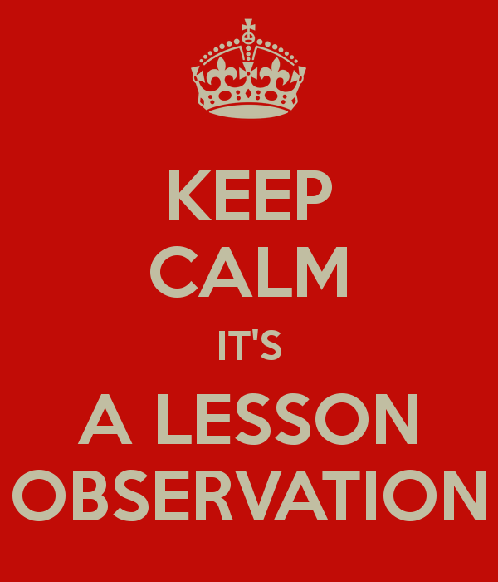

WORKBOOK 6 - RESEARCH METHODS FOR PAPERS 1 AND3

|  |  |  |
| --- | --- | --- |
| Name: | Set: | Group: |

**What the specification says:**

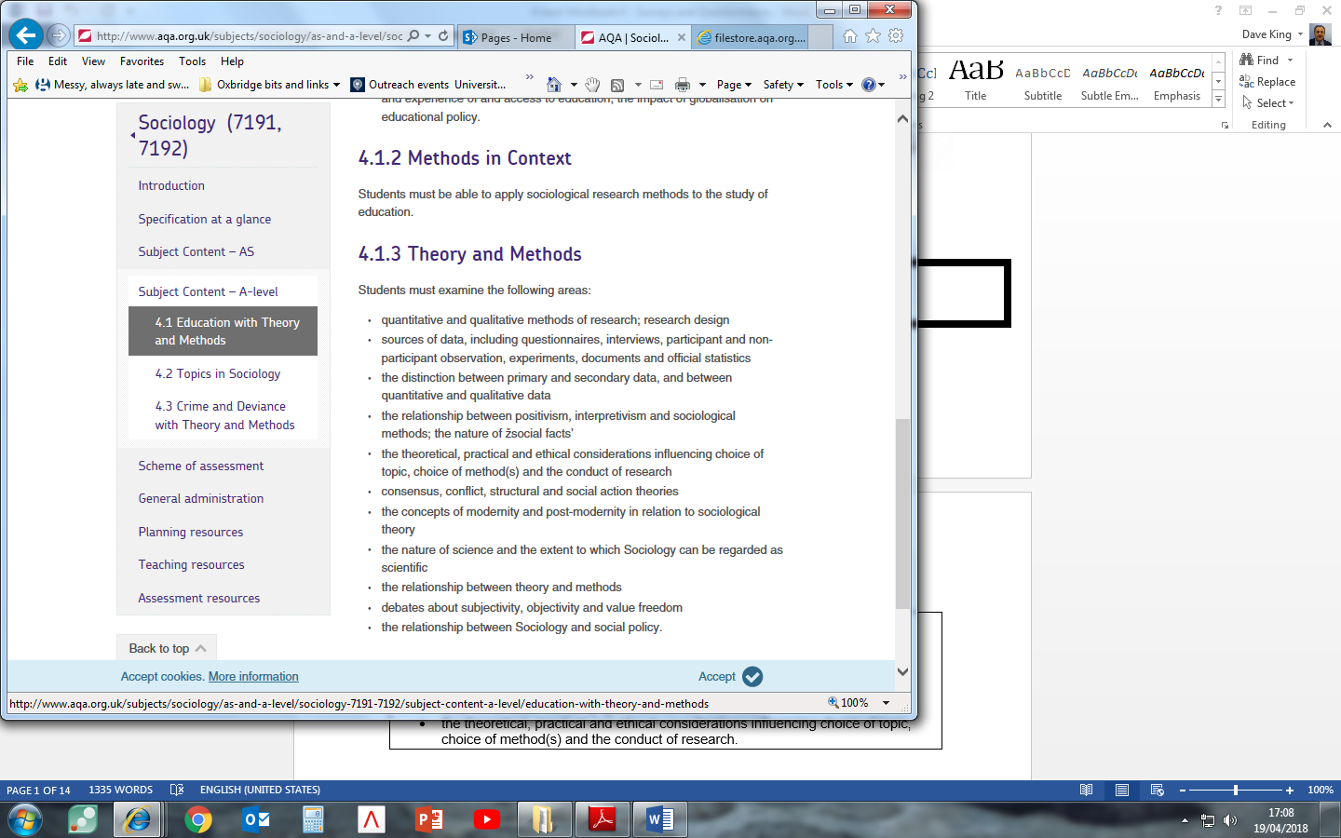

**OBSERVATION**

Perhaps the most obvious way to ‘do sociology’ is to watch people going about their everyday activities: We might observe people in exactly the same way that bird-watchers observe birds and then attempt to describe and explain their social behaviour. However, in some ways sociological observers face similar problems to bird-watchers. For example, if birds are aware of the presence of an observer they are likely to fly away and, similarly, people's behaviour can be affected if they are aware of being ‘watched’. Because of this the researcher usually has to join in, to some extent, with the group being studied.

Some sociologists in some situations may be able to conduct non-participant, or direct observation where they do not participate at all and are a ‘fly on the wall’. This may be possible at large events where many people are present so that the sociologist can easily blend in, or from behind a two-way mirror for example. Some sociologists, however, as you will see later, believe that we can only really understand human behaviour if we join in with it, thus discovering what it actually feels like to be that sort of person.

To wrap up this brief introduction, we can distinguish between two different types of observation**: Participant observation** and **non-participant observation**. In this booklet, we will mainly, but not exclusively, focus on participant observation. In particular, we will examine some useful examples where this method has been used, and explore the advantages and disadvantages that come with using this method.

**PARTICIPANT OBSERVATION**

This approach was first developed outside sociologyby anthropologists who study the variety of different societies and cultures in the world. In the early part of this century they began to live in the societies they were interested in. One of the most famous examples of this approach is Bronislaw Malinowski's research in the South Pacific Trobriand Islands where he lived during the First World War. Later in the 1920's and 1930's in America sociologists in Chicago borrowed this approach and applied it to their city. They studied the lives of different groups including tramps, members of criminal gangs and the rich.

In America in the 1950s and 1960s interactionism grew in importance as a dominant sociological perspective. Sociologists became increasingly interested in ‘getting inside the heads’ of their subjects. Participant observation gave researchers a method to view the world through the *eyes* of other people. Rather than testing hypotheses against evidence and searching for the causes of social events, the idea was that ***verstehen***(an understanding developed through empathy or close identification) and qualitative research are what sociology should be about.

For example, in his famous book, *Asylums*, Erving Goffman worked in a psychiatric hospital and carried out participant observation byparticipating in the lives of the patients and talking to them.

**The Stages of Participant Observation**

The stages of participant observation can be summed up in terms of *getting in*, *staying in*, and *getting out* of the group concerned. Let’s have a look at these issues before we examine a case study that illustrates the method of participant observation well.

**Getting In**

Joining a group raises several questions about the researcher’s role. The researcher may adopt an **overt role**, whereby he declares his true identity to the group and the fact that he or she is doing research. Alternatively, the researcher may choose to adopt a **covert role** (concealing his or her role as a researcher), or a cover story (partially declaring his or her role as a researcher, but concealing elements of it. James Patrick’s study A Glasgow Gang Observed (1973) offers an example of this. James Patrick was a teacher at an approved school in Scotland. He took up the invitation by Tim - a sixteen-year-old juvenile offender - to come and see for himself 'whit the score wis' in the 'Young team' (a Glasgow street gang of which Tim was leader).

Patrick, posing as Tim's friend from the approved school, took up this challenge. Having been briefed by Tim on the appropriate style of dress and considering himself aware of the local dialect and slang (an assumption which was to prove his first mistake), Patrick met and joined the gang.

To participate successfully, especially when adopting a covert role, the researcher would need to share some of the characteristics of the group, such as gender, age or ethnicity.

**Staying In**

The observer has to develop a role which will involve gaining the trust and cooperation of those observed, to enable continued participation in and observation of the group. Initially, this will involve learning, listening and getting a sense of what is going on. In Whyte’s study entitled *Street Corner Society* (1955), the main informant Doc plainly advised Whyte to ‘keep your eyes and ears open but keep your mouth shut’. Problems when staying in the group can arise when taking extensive notes, which might be seen as disruptive. Another question concerns how far you wish to immerse yourself within the group without either losing the trust of the group or your objectivity as a researcher (see box on ‘going native’). Staying in might also mean engaging in activities you disagree with. James Patrick, in his study on gangs in Glasgow, found the level of violence so abhorrent that he decided to stop his covert observation sooner than initially planned. In his study, Whyte did some ‘personating’ – illegally voting twice in an election – as this was common practice in the group he was studying.

**Getting Out**

Getting out of the group involves issues as such leaving the group without damaging relationships, becoming sufficiently detached to write an impartial and accurate account, and making sure members of the group cannot be identified. There may be possible reprisals against the researcher if criminal activities are involved. For instance, when Patrick’s study was published, he faced threats to his personal safety.

|  |
| --- |
| **‘Going Native’ –** The personal involvement which participant observation demands can reduce objectivity. An observer can identify so strongly with the group that the behaviour of its members is invariably seen in a positive light. In rare cases, this identification is carried to its extreme – observers ‘go native’, join the group and never return to their former lives |

**Types of Participant Observation: Overt and Covert Research**

**Overt Role**

|  |  |  |
| --- | --- | --- |
| Advantages | Disadvantages | Examples |
|  |  |  |

**Covert Role**

|  |  |  |
| --- | --- | --- |
| Advantages | Disadvantages | Examples |
|  |  |  |

**Sudhir Venkatesh: *Gang Leader for a Day* (2009)**

**Background –** In 1989 Sudhir Venkatesh, a graduate student at the University of Chicago, entered the Lake Park housing project armed only with a questionnaire and a desire to learn more about the lives of the people who lived in ‘The Projects’ (the general name given to Public Housing provision across the USA). He was almost immediately surrounded by a group of young black men he later came to understand belonged to the Black Kings – a well-organized gang that controlled a significant part of the drug trade in a territory dominated by the Robert Taylor Homes – one of the largest public housing projects in the world and home to a wide variety of some of the very poorest Chicago blacks.

During this initial encounter (and period of incarceration as a virtual prisoner of the gang), Venkatesh got to ask only one of his questions – ‘How does it feel to be black and poor?’ – before being forced by his ‘captors’ into the realization that to make sense of this question it was pointless to ask it; to understand what it was like ‘to be black and poor’ he had to experience what it was like to be both of these things – and to do this he needed access to the lives of the people in the Projects. He had, in other words, to live the lives they led (or as close to such an experience as it was possible for ‘an outsider’ to have).

To this end Venkatesh spent around 7 years in his study, producing a vivid description of the lives and relationships of the black residents, gang members and non-members alike, of Robert Taylor Homes. The study of a way of life of a group of people, which often involves an attempt to see the world from their point of view, is referred to as an **ethnography**.

Venkatesh revealed a complex mix of subculture (the Black Kings were a highly organized gang with a clear hierarchy, recruitment rituals, and socialization processes) and culture – the gang were embedded in the day-to-day life of the Projects. Although their primary purpose was to make money through selling drugs (mainly crack cocaine), they also performed a range of secondary functions within their territory – from the provision of protection for Project residents from other gangs, through the organization of social activities (such as Basketball games), to policing the Projects (involving things like the provision of shelter for ‘the homeless’).

**Activity:** Watch the video ‘Gang Leader for a Day’ (https://www.youtube.com/watch?v=yRq1AhFAN-4) and answer the following questions relating largely to practical, ethical and theoretical issues

|  |
| --- |
| 1. What was the context and aim of the research? 2. Why might the question ‘How does it feel to be black and poor?’ in his initial encounter have gotten Venkatesh into difficulties? What are the ethical issues with such a question? 3. How did Venkatesh solve the practical difficulty of gaining access? 4. At an early stage in the research JT seems to have used the idea that Venkatesh was “writing his life story” as a way of justifying Venkatesh’s presence in the Projects. Whether or not JT actually believed this is what Venkatesh was actually doing is not made clear, although Venkatesh does make passing reference to it at various points. Can you identity any ethical issues with this? 5. What is the advantage of spending seven years to study a group? What does it say about the validity of the data? 6. The individuals in the field were aware of Venkatesh’s status as a researcher. Explain how the known presence of the researcher might have an effect of the validity of the data. |

**Activity:** Using the following list, note at the side whether the point would be classified as a Practical Ethical or Theoretical issue (PET) and a + for it being a positive evaluation point and a X for a negative evaluation point

|  |  |  |
| --- | --- | --- |
| **Evaluation of observational methods** | **PET** | **+ or X** |
| Allows respondents to talk for themselves – does not impose a “researcher-led” structure on answers |  |  |
| May produce a more valid picture of social reality than some other techniques |  |  |
| Allows a fluidity in the research process that is not possible with most positivistic approaches |  |  |
| Much information is based on first-hand information (primary data) |  |  |
| Allows access to groups that other techniques could not |  |  |
| Within the group a range of possibilities can occur, e.g., “observer as participant” or “participant as observer” |  |  |
| Can be a useful source of hypotheses for further research |  |  |
| Can lead the researcher into problematic situations |  |  |
| Too much involvement can produce a subjective analysis (‘going native’) |  |  |
| Usually deals with small groups so generalisations are difficult to establish |  |  |
| Researcher’s presence may disturb the normal patterns of group interaction |  |  |
| Undercover (covert) participant observation can be considered ‘unethical’ and can threaten the project if found out |  |  |
| Difficult to record data – memory/selective issues |  |  |
| High level of researcher skills required |  |  |
| Comparisons are problematic due to lack of reliability |  |  |
| Time consuming |  |  |
| Access to restricted groups can be limited due to researcher’s characteristics – the attitudes of possible subjects |  |  |

**PET of PARTICIPANT OBSERVATION**

|  |  |  |  |  |  |
| --- | --- | --- | --- | --- | --- |
| **Define the**  **method** |  | | | | |
| **Example(s)** |  | | | | |
| **Circle correct** | **Quantitative** | **Qualitative** | **Positivist** | **Realist** | **Interpretivist** |
|  | **Strengths** | | **Weaknesses** | | |
| **Practical** |  | |  | | |
| **Ethical** |  | |  | | |
| **Theoretical** |  | |  | | |

**NON-PARTICIPANT OBSERVATION**

In the case of non-participant observation, the researcher need not participate to observe people’s behaviour. A non-participant observer is like a birdwatcher in a hide, observing people without joining in. For example, a researcher may secretly observe children’s behaviour in a school playground from an upstairs room in the school. They may use a *behaviour schedule* – a checklist of activities which are noted when they occur. This is also called STRUCTURED OBSERVATION whereby particular behaviours or activities are recorded which allows for the observation data to be coded (counted using categories) to determine the number of times something happens.

Compared to the aforementioned method of participant observation, non-participant observation has a number of advantages and disadvantages.

|  |  |
| --- | --- |
| **Advantages** | **Disadvantages** |
|  |  |

**Activity:** Watch the video on street life (<https://www.youtube.com/watch?v=Y-s0pIHTac4>)

|  |
| --- |
| 1. Describe the most important things that are going. 2. Why might non-participant observation be a useful approach for studying street life? 3. What theoretical and ethical issues might arise from this approach? |

|  |
| --- |
| **Case Study: ‘WHY KIDS KILL’ Dispatches- Glasgow shown on Channel 4 28.01.2008** |

The study wanted to find out the scale of violence in areas where gang violence was common. Dispatches have been asking kids about their experiences of the ‘teenage wars on our streets and possible solutions.’ It provides a good counterpoint to other studies on gang life explored in this booklet that use covert and overt participant observation (James Patrick’s ‘A Glasgow Gang Observed’ and Sudhir Venkatesh’s study ‘Gang Leader for a Day’).

|  |
| --- |
| Which methods are used by the investigators? |
| How many youths were included in the main body of the research? |
| What sorts of questions were asked? |

This research is not sociological in the ‘traditional’ sense; nonetheless, it helps us understand some of the practical, ethical and theoretical issues with **non-participant observation.**

The study contained **overt** **non-participant observation** with the use of filming the youths when questioned were asked

|  |
| --- |
| What data did this provide? |
| What were the benefits of using this method? |
| What problems could with using this method? |

The study also contained **covert non-participant observation** with the use of CCTV evidence

|  |
| --- |
| What data did this provide? |
| What were the benefits of using this method? |
| What problems could with using this method? |

**PET of NON PARTICIPANT/STRUCTURED OBSERVATION**

|  |  |  |  |  |  |
| --- | --- | --- | --- | --- | --- |
| **Define the**  **method** |  | | | | |
| **Example(s)** |  | | | | |
| **Circle correct** | **Quantitative** | **Qualitative** | **Positivist** | **Realist** | **Interpretivist** |
|  | **Strengths** | | **Weaknesses** | | |
| **Practical** |  | |  | | |
| **Ethical** |  | |  | | |
| **Theoretical** |  | |  | | |

**Exam Practice:**

**10 mark questions**

Outline and explain two reasons why sociologists choose to use structured observation [10]

Outline and explain two problems with participant observation [10]

Outline and explain two reasons why sociologists would choose to use participant observation in their research [10]

Outline and explain two advantages that some sociologists see in using participant observation in their research [10]

Outline and explain two reasons why interpretivist sociologists choose to use ethnographic method [10]

**20 mark questions (these would include an item)**

*Using the material in Item C and your own knowledge...*

... Evaluate the advantages of the use of covert methods in sociological research [20]

... Evaluate the usefulness of using observation technique in sociological research [20]

... Evaluate the advantages of using non participant observation in sociological research [20]

**Methods in Context – Investigating the ways in which classroom interactions reinforce traditional gender identities.**

|  |
| --- |
| **Item B**  **Investigating the ways in which classroom interactions reinforce traditional gender identities.**  Some sociologists have pointed to the ease with which traditional gender identities can be reinforced in classroom interaction. Verbal abuse and other more subtle processes such as the ‘male gaze’ can have an impact on gender identity. Sociologists have found that some male teachers may even collude with male pupils in ‘putting down’ girls.  Sociologists may use non-participant observation to investigate the ways in which classroom interactions reinforce traditional gender identities. Observing classroom behaviour first hand enables researchers to see what actually goes on rather than getting a verbal account after the event. There is also the potential for greater insight through direct experience of classroom interaction. However, it is very difficult for the observer to avoid being noticed and this can affect the behaviour of teachers and of pupils. |

Applying material from **Item B** and your knowledge of research methods, evaluate the strengths and limitations of using non-participant observation for the study of the ways in which classroom interactions reinforce traditional gender identities. **[20 marks]**

**Proposed plan:**

|  |
| --- |
| **Introduction – WWWE**   * **W**hat? – What is the method in the question? Define and apply detail about the method. * **W**ho? – Who would use it? (Positivist, Interpretivist, Realist) * **W**hy? – Why would they use it? – Relating to the context in the question – in this case classroom interactions reinforce traditional gender identities * **E**valuate – Who wouldn’t use it? Why? |
| **Main body**   * Aim for at least **3 strengths and 3 weakness.** * Consider and include all elements of **PERVERT** within your response. * Refer back to the **context** (in this case classroom interactions reinforce traditional gender identities) |
| **Conclusion**   * **Summarise strengths and weaknesses** (in relation to the **context**) * Would an **alternative method** be more suitable? Apply **methodological approaches** to this response (Positivism, Interpretivism and Realism) |