**Godalming College**

Booklet Checked by: _____________

Grade: U/S 1 2 3

Comment: _______________________________________________________________________________________________________________________________________________________

**Sociology Department**

EXPERIMENTS

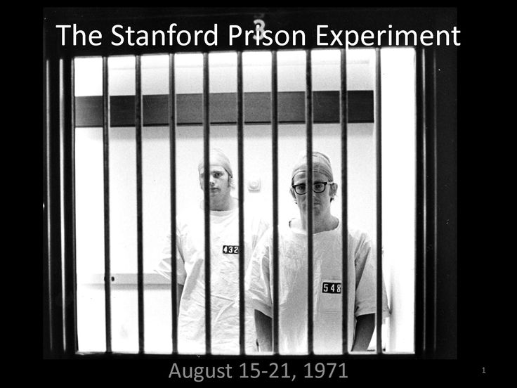

|  |  |  |
| --- | --- | --- |
| **Name:** | **Set:** | **Group:** |

WORKBOOK 7 - RESEARCH METHODS FOR PAPERS 1 AND3

**What the specification says**

|  |
| --- |
| AQA Specification  Research Methods  Students must examine the following areas:   * sources of data, including **experiments,** **laboratory** and **field experiments** * the theoretical, practical and ethical considerations influencing choice of topic, choice of method(s) and the conduct of research. |

**EXPERIMENTS**

Experiments may be divided into two main types: **Laboratory experiments** (common in natural sciences**)** and **field experiments** (more common in Sociology but especially in Psychology). Let’s begin with laboratory experiments below.

**Laboratory Experiments**

The experiment is the main means of conducting research in the natural sciences. In natural sciences, experiments are used to test a **hypothesis** in laboratory conditions in which all **variables** or causes are under the control of the researcher. By manipulating variables and studying and measuring the results, the researcher tries to test a hypothesis by isolating the cause of some phenomenon under investigation (such as, why pigs get fat).

The researcher will take two groups that are alike in every way: one is the **control group** and the other is the **experimental group**. The researcher will then alter some factor (the independent variable) in the experimental group to see whether the variable being investigated (the dependent variable) changes, compared to in the **control group** (for example, alter heat in pigsties to see whether this affects pigs getting fat). If nothing changes in the **experimental group**, then that variable can be dismissed as a cause of the thing being investigated, and other variables can be tested. Through this experimental method, the researcher can eventually arrive at an explanation for the issue being investigated that has been tested against evidence, since any difference between the groups after the experiment can only be because of the experimental variable, as the two groups were otherwise identical before the experiment

Laboratory experiments in the natural sciences have a number of advantages:

* they enable scientists to test their hypotheses in controlled conditions.
* they make it easy to isolate and manipulate variables to determine the causes of events.
* they are repeatable (replicable) and therefore able to be checked by other researchers.
* they enable comparisons to be made with other similar experimental research.

**HOWEVER,** several problems exist when it comes to using the experimental method in Sociology. The key disadvantages are:

* in the social sciences, and sociology in particular, it is often difficult to isolate a single cause of a social issue like crime, or underachievement in school, and it is extremely difficult to isolate variables for testing. For example, crime and low achievement in school are the result of a range of causes.
* Experiments need to treat one group differently from another similar group and compare results. However, this poses ethical problems on sociologists, as it may have negative effects on the experimental group
* People may object to being experimented on, and if they are deceived and don’t realise they’re involved in an experiment – for example, to avoid the **Hawthorne Effect** – then the researcher will not have obtained the informed consent required in order to be acting ethically.

|  |
| --- |
| **The Hawthorne Effect –** Sociologists want to study people in their normal social context, but the laboratory and experimental conditions are artificial situations. People, unlike chemicals and many animals, can and do know what is going on in an experiment. The knowledge that an experiment is taking place, even if it is not fully understood, may mean people behave differently from their usual, everyday behaviour. They may deliberately sabotage the experiment, or ‘play up’ for the researcher. The very presence of the observer may become the principal independent variable in social scientific experiments. The classic example of this is known as the Hawthorne Effect. |

**Using p.109-110 of the Webb textbook outline the advantages and disadvantages of laboratory experiments below:**

|  |  |
| --- | --- |
| **Advantages** | **Disadvantages** |
|  |  |

**Field Experiments**

Field experiments are conducted in normal social situations, such as the classroom, the factory and the street corner. They are conducted in the real world under normal social conditions, but following similar procedures to the laboratory experiment. One advantage over laboratory experiments is the fact that field experiments are not ‘artificial’, which increases their validity. This is especially the case when the subjects (e.g. in a classroom) do not know that an experiment is taking place. Unlike laboratory experiments, however, they do not allow the researcher to control all the important variables, making them difficult to replicate.

Other disadvantages of field experiments are similar to laboratory experiments. These might involve the researcher misleading research participants, changing their behaviour through the Hawthorne effect or failing to gain their informed consent. The research might also have negative consequences for the participants.

Field experiments have been mainly carried out by interpretivists, who are interested in how meanings and labels, like ‘bright’ or ‘mentally ill’, get attached to people, and how others react to them. This is illustrated in the work of Rosenthal and Jacobson, which is examined below.

|  |
| --- |
| **Example – Rosenthal and Jacobson (1968). *Pygmalion in the Classroom*** |

**Activity**: Watch the video entitled ‘The Pygmalion Effect and the Power of Positive Expectations (<https://www.youtube.com/watch?v=hTghEXKNj7g>) and answer the following questions:

|  |
| --- |
| 1. What was the hypothesis of Rosenthal and Jacobson’s study? 2. How did the researchers go about with the study? 3. What was the outcome of the study? 4. What is the ‘pygmalion effect’? 5. What are the four factors in the classroom that contribute to the self-fulfilling prophecy? 6. What external factors/variables might you wish to take into account alongside teachers’ influence in creating student success/failure? 7. What may be some ethical issues relating to the study? |

**The Comparative method**

There is another experimental approach known as the comparative method where the approach is carried out only in the mind of the sociologist. It is a ‘thought’ experiment and does not involve actual people. Just like laboratory and field experiments its aim is to determine cause and effect. It works as follows:

1. Identify two groups of people who are very alike, but vary in one respect e.g. Durkheim in his study of suicide hypothesised (predicted) groups with higher levels of integration (Catholics) would have lower rates of suicide than Protestants who had lower levels of social integration.

2. Then compare the two groups and find differences. Durkheim’s hypothesis was supported by official statistics that found that Catholics had lower levels of suicide.

|  |  |
| --- | --- |
| Positives | Negatives |
| Avoids artificiality- does not use ‘real’ people who may change their behaviour because of the experiment. | Researcher has less control over variables- cannot determine whether other issues have caused the event. |
| No ethical issues because not dealing with people | Can be affected by the subjectivity of the researcher |
| Can study historical events |  |

**PET: LAB EXPERIMENTS**

|  |  |  |  |  |  |
| --- | --- | --- | --- | --- | --- |
| **Define the**  **method** |  | | | | |
| **Example(s)** |  | | | | |
| **Circle correct** | **Quantitative** | **Qualitative** | **Positivist** | **Realist** | **Interpretivist** |
|  | **Strengths** | | **Weaknesses** | | |
| **Practical** |  | |  | | |
| **Ethical** |  | |  | | |
| **Theoretical** |  | |  | | |

**PET: FIELD EXPERIMENTS**

|  |  |  |  |  |  |
| --- | --- | --- | --- | --- | --- |
| **Define the**  **method** |  | | | | |
| **Example(s)** |  | | | | |
| **Circle correct** | **Quantitative** | **Qualitative** | **Positivist** | **Realist** | **Interpretivist** |
|  | **Strengths** | | **Weaknesses** | | |
| **Practical** |  | |  | | |
| **Ethical** |  | |  | | |
| **Theoretical** |  | |  | | |

**Exam Practice:**

**10 mark questions**

Outline and explain two advantages of using the comparative method [10]

Outline and explain two reasons why sociologists might want to use a field experiment [10]

Outline and explain two reasons why a sociologist would be reluctant to use experiments as a research method. [10]

Outline and explain two ethical issues with laboratory experiments. [10]

Outline and explain two reasons why positivist sociologists may like to use experimental methods in research [10]

**20 mark questions**

*Using the material in Item C and your own knowledge...*

... Evaluate the theoretical issues of using experiments in sociological research [20]

... Evaluate the problems of using laboratory experiments in sociological research [20]

**Methods in Context – using experiments to study teachers’ labelling of pupils**

**Item B - Using experiments to study teachers’ labelling of pupils**

Some sociologists argue that even though teachers have a professional duty to treat all pupils fairly, they often give negative labels to pupils based on the pupils’ social class, gender and ethnicity. Pupils may respond to these labels in a variety of ways, including forming anti-social subcultures.

Sociologists may use experiments to investigate teachers’ labelling of pupils. One problem is that laboratory experiments are not naturalistic and this can affect the way teachers and pupils act. With covert field experiments, however, the real purpose of the research is not known and this may help to overcome the Hawthorne Effect. Another issue is whether a particular statement or action on the part of a teacher is actually an example of unfairly attaching a label to a pupil. This is very much open to interpretation by researchers.

Applying material from **item B** and your knowledge of research methods, evaluate the strengths and limitations of using experiments to study teachers’ labelling of pupils **[20 Marks].**

**Proposed plan:**

|  |
| --- |
| **Introduction – WWWE**   * **W**hat? – What is the method in the question? Define and apply detail about the method. * **W**ho? – Who would use it? (Positivist, Interpretivist, Realist) * **W**hy? – Why would they use it? – Relating to the context in the question * **E**valuate – Who wouldn’t use it? Why? |
| **Main body**   * Aim for at least **3 strengths and 3 weakness.** * Consider and include all elements of **PERVERT** within your response. * Refer back to the **context** |
| **Conclusion**   * **Summarise strengths and weaknesses** (in relation to the **context**) * Would an **alternative method** be more suitable? Apply **methodological approaches** to this response (Positivism, Interpretivism and Realism) |