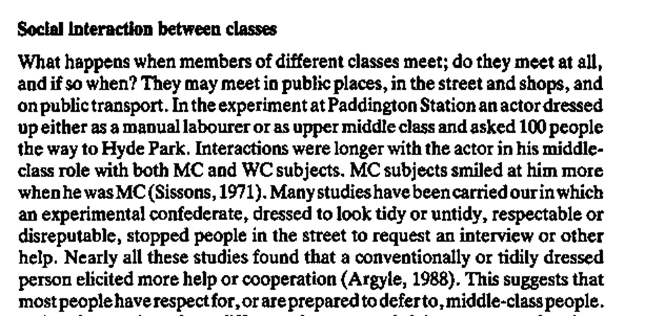

ITEM from AQA old series

*Individuals’ life chances are linked to their ethnicity. For example, in Britain, members of black ethnic groups are more likely to experience unemployment, low pay and poor housing than are members of the white majority ethnic group. It is claimed that such disadvantages are the product of discrimination.*

*One way in which sociologists have tried to demonstrate this claim is by the use of actor tests (also called situation tests). In these, actors of different ethnic backgrounds are used. The actors are matched in terms of characteristics such as age and gender, and in terms of their ‘cover story’. For example, if applying for a job, each actor would claim to have similar qualifications and experience.*

*Then, if for instance the white candidate is regularly chosen over an otherwise seemingly identical black candidate, this may demonstrate that discrimination is responsible for ethnic differences in life chances such as rates of unemployment.*

An example of this method in action:

Other possible issues that might be explored in this fashion:

Advantages of this method:

Disadvantages of this method: