**Godalming College**

Booklet Checked by: _____________

Grade: U/S 1 2 3

Comment: _______________________________________________________________________________________________________________________________________________________

**Sociology Department**

**Why are there gender based differences in Education?**

**-The Gender Gap in achievement- why do girls outperform boys?**

**- Gender and subject choice – why do boys and girls choose different subjects?**



**WORKBOOK 3**

**SOCIOLOGY OF EDUCATION (Paper 1)**

|  |  |  |
| --- | --- | --- |
| Name: | Set: | Group: |

AQA Specification

**Students are expected to be familiar with sociological explanations of the following content:**

* Differential educational achievement of social groups by social class, gender and ethnicity in contemporary society
* Relationships and processes within schools, with particular reference to teacher/pupil relationships, pupil identities and subcultures, the hidden curriculum, and the organisation of teaching and learning

**Learning objectives**

Tick the boxes when you feel confident you have a high level of understanding of the following:

|  |  |
| --- | --- |
| **Objective** | **Tick if met** |
| Be able to describe the pattern of gender differences in educational achievement |  |
| Understand the difference between internal and external factors affecting achievement, providing detailed examples of each and evidence to support explanations |  |
| Be able to evaluate and analyse the role of different external and internal factors, both separately and combined, providing research and evidence to support points |  |
| Be able to discuss the relationship between gender and class (and ethnicity) |  |
| To be able to evaluate the significance of gender identity in explaining subject choice and achievement |  |

**GENDER: SOME KEY CONCEPTS**

**What do we mean by “gender”? How does it differ from “sex”?**

**What forms our gender identity?**

Gender Identity

**What are gender roles?**

**Define and give examples for:**

|  |  |
| --- | --- |
| **Hegemonic femininity** | **Hegemonic masculinity** |
| **Definition:** | **Definition:** |
| **Examples:** | **Examples:** |

|  |
| --- |
| **Gender and Achievement** |

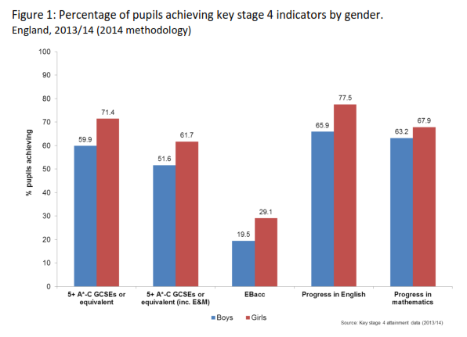

Girls are on the right of each pair of bars

**Activity:** Looking at the table above andpage 51 of the Webb textbook. Explain in your own words what the differences are in the achievement of boys and girls in education.

**What reasons could there be for this?** (You may be able to apply some internal reasons you learnt about in class and education, to the issue of gender)

|  |  |
| --- | --- |
| **Internal** | **External** |
|  |  |

**THE FACTS**

* Girls do better at every stage in the National Curriculum Tests
* Girls are more successful than boys in most GCSE subjects (although boys are catching up)
* In 2013 66% of girls got 5 A*-C grades at GCSE and 54% of boys. This is particularly apparent in English GCSE with 70% of girls getting A*-C compared to 54% of boys
* Girls also get a higher proportion of A grades than boys
* They are also more likely to get 2:1 or First degree grades
* A higher proportion of females stay on in sixth form and post 18 education

What questions would a sociologist be interested in posing to find out about these issues?

**So does this mean complete equality has been achieved for all girls in the education system?**

Not necessarily.

* Many girls are still underachieving. There is a difference between the achievement of middle class and working class girls.
* Middle class boys outperform working class girls. Girls eligible for free school meals also underperform compared to both boys and girls not eligible for free school meals
* Girls and boys also tend to choose different subjects – arts for girls and science for boys
* Girls also achieve fewer high grade A levels than boys with the same GCSE results
* Women with similar qualifications to men have less employment opportunities than men

**But what about boys?**

* Overall however boys tend to achieve less in the education. This is particularly apparent for working class boys and specifically those eligible for free school meals
* We should however remember that boys are still doing well in the system, and continuing to improve their results each year

We must remember that class, gender and ethnicity cannot be looked at in isolation. Middle class, white students, regardless of gender, tend to fare better in the education system overall.

|  |
| --- |
| **External explanations for the gender gap.**  **External reasons why girls are doing better**  **External reasons why boys underachieve** |

|  |
| --- |
| **Why are girls outperforming boys?**  **External explanations** |

|  |  |
| --- | --- |
| **Reason** | **Study/Evidence** |
| **The Impact of the women’s movement and Feminism** |  |
| **The Family** |  |
| **Changes in the Position of Women in employment** |  |
| **Girls ambition** |  |
| **Maturity** |  |

|  |
| --- |
| **Identity, Class and Achievement**  **CLASSWORK** |

Girls from working class backgrounds will achieve less GCSEs than girls from middle class backgrounds. Using your knowledge of ***Archer et al*** (2010) and the **Webb** textbook (p.**55-56**), explain in more detail the reasons identified that explain why working class girls are less successful in the education system.

|  |  |
| --- | --- |
| **Symbolic capital** |  |
| **Hyper-heterosexual feminine identities** |  |
| **Boyfriends** |  |
| **Being ‘loud’** |  |
| **Working class girls’ dilemma** |  |
| **Successful working class girls** |  |
| **Why are boys underachieving?**  **External explanations** | |

|  |  |
| --- | --- |
| **Globalisation and declining traditional male employment opportunities** |  |
| **Male identity crisis** |  |
| **Hegemonic masculinity** |  |
| **Over estimation of ability** |  |

|  |
| --- |
| **Why are girls outperforming boys?**  **Internal Factors** |

|  |  |
| --- | --- |
| **Labelling and the self-fulfilling prophecy** |  |
| **Equal Opportunity Policies** |  |
| **Positive role models in school** |  |
| **Challenging gender stereotypes** |  |
| **Marketization** |  |

|  |
| --- |
| **Why are boys underachieving?**  **Internal Factors** |

|  |  |
| --- | --- |
| **Labelling and the Self Fulfilling Prophecy** |  |
| **Anti-School Subcultures** |  |
| **Feminisation of the Curriculum** |  |
| **Lack of male role models** |  |

**What do Feminists think of girls’ apparent achievements in school?**

**Liberal Feminists**

They believe that equality can be achieved gradually, through changes in the law and policies. They take a positive view and celebrate the progress made so far by girls in the education system. They believe that the progress is ongoing however and that continuing to implement more equal opportunities polices and positive role models will continue to encourage equality and girls achievements.

**Radical Feminists**

While they can see that girls are achieving well in the education system, they argue that education remains a patriarchal system, which is shown in the following ways…

* Girls are sexually harassed at school
* Education continues to stereotype career options and subject choices
* Male teachers are still more likely to become heads of secondary schools (in which heads are paid more than primary)
* Women are under-represented in many areas of learning – for example female contributions to history and science.
* Some argue that due to the patriarchal nature of education, girls could be achieving more than they currently are

|  |
| --- |
| **Evaluation of External and Internal factors**   * **Jackson et al** (2010) argue that educational policy has ignored girls in recent years. They argue that focusing on ways to raise boys achievements can have negative consequences on girls, by ignoring problems such as peer pressure and demands for femininity that affect girls. * Feminists argue that there is a ‘panic’ about boys failing as the ‘norm’ tends to believe that it should be boys who achieve better than girls. **Ringrose** (2013) argues that it reflects a fear that underachieving working class boys will grow up to becoming a threat to society. * **Osler** (2006) also argues that the focus on boys underachieving has led to a neglect of girls. She states that girl’s disengagement from school is often quieter and therefore missed. * **Read** (2008) believes that school is not becoming feminized and that female teachers were just as in tune with the kind of discipline boys need * **Jones** (2006) notes that while schools are often female dominated, male teachers are often more likely to be Headteachers, particularly of secondary schools – with men having a 1 in 4 chance of becoming a head and females a 1 in 13 * You cannot separate gender from class and ethnicity. Girls and boys from the same class often get similar results. Girls from the highest class are much more likely to achieve five good GCSEs than those from the lowest. * Male-female differences in A level language examination results are small * The relationships between physical and intellectual maturity are uncertain * Gender differences in examination results cannot be explained only by the presence or absence of coursework. * Psycho-biological explanations tend to be offered as total explanations, but seem to falter when the changing historical pattern of educational success is taken into account |

**Activity: Summarise the four most significant factors (that you think are most important) from the preceding list. Explain why these are particularly important.**

**1.**

**2.**

**3.**

**4.**

|  |
| --- |
| **Gender and Subject Choice: Why do girls and boys choose different subjects?** |

Identify below subjects which could be regarded as traditionally “male” or “female”.

|  |  |  |  |  |  |
| --- | --- | --- | --- | --- | --- |
| ***Subject*** | ***m/f*** | ***Subject*** | ***m/f*** | ***Subject*** | ***m/f*** |
| *Physics* |  | *Art* |  | *English* |  |
| *Sociology* |  | *French* |  | *Mathematics* |  |
| *Psychology* |  | *Biology* |  | *History* |  |
| *Home Economics* |  | *Chemistry* |  | *Food Technology* |  |

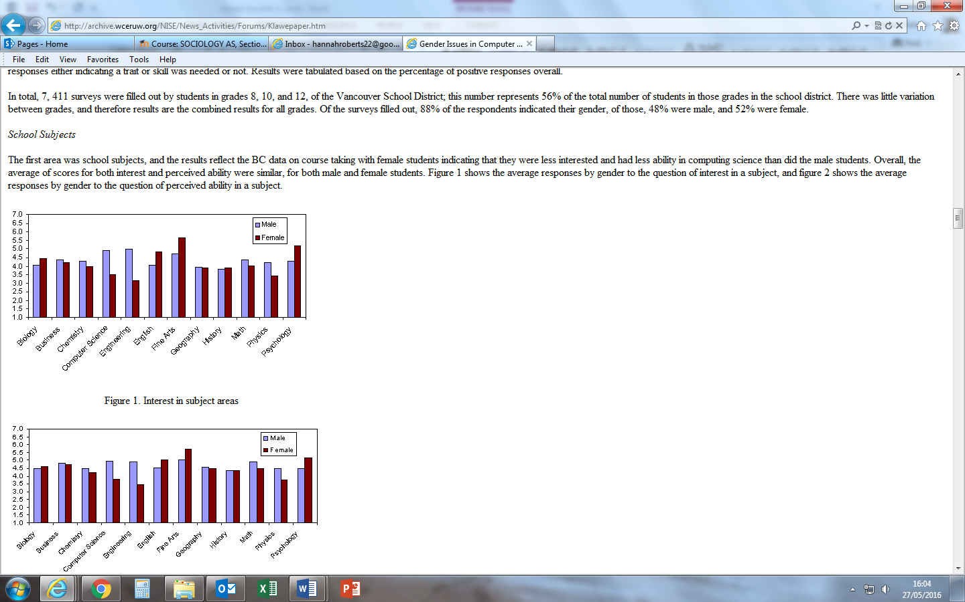

Figure 2. Interest in subject areas

1. What factors do you think make a subject masculine or feminine?
2. How has the creation of the National Curriculum affected this issue?

Using your own knowledge and experience, try to identify at least two external and two internal reasons for these differences

|  |
| --- |
| **External**  **1)**  **2)** |
| **Internal**  **1)**  **2)** |

***See also Browne pages 73-75 for a better discussion of these and other key factors***

**Two case studies**

**1. Alison Kelly and the gendering of science**

Kelly identifies science as masculine – she emphasised the following reasons

1. **Packaging** - Science is often presented with a masculine bias, examples in textbooks, illustrations, etc.
2. **Behaviour** - Boys often dominate equipment or materials in the science laboratory – they will grab at equipment and try to exercise control

As a result of the work of Kelly and others specific initiatives were introduced to encourage girls’ take up of traditionally male subjects e.g., the ***Girls into Science and Technology*** initiative (GIST)

Q Why might there have been so much less emphasis on similar initiatives to encourage boys to take up traditionally female subjects?

**2. Glenys Lobban, Lesley Best and Reading Schemes**

**Glenys Lobban** "Data Report on British Reading Schemes", TES 01/03/74) noted the way in which "toys" (in this case, books) represent a readily-available source of sex-role socialisation for males and females. Lobban, in particular, has done a great deal of work in relation to reading schemes and sex role representations which has shown how rigidly traditional forms of gender stereotyped behaviour are ingrained in our culture. She carried out a content analysis in the 1970s of young children’s schoolbooks and found that from a study of 179 stories in 6 reading schemes; only 35 stories had heroines compared to 71 that had heroes. Girls and women were almost exclusively portrayed in traditional domestic roles and it was nearly always the men and boys who took the lead in non-domestic tasks.

At the time, when girls seemed disadvantaged in the education system, this was an important finding.

**Lesley Best** in 1992 still found, in spite of changing patterns of achievement and educational reform, that 75% of reading schemes had stereotypical roles for males and females. Men were portrayed in 69 different occupations whereas women were portrayed in only 18. By this point, girls were already surpassing boys’ achievements.

More recent work has demonstrated even more fundamental differences. **Oakhill and Petrides** (2007) highlight the greater difficulty that boys have with reading at all, and that their interest in content is far more significant than for girls. It is as if boys need to be coaxed to read at all! (See Browne, p 72)

Q. Does your experience of boys’ and girls’ reading support these findings?

|  |  |
| --- | --- |
| **Explaining Gendered Subject Choice**  **External Factors** | |
| **Gendered Socialisation**  Subject choice stems from primary and secondary socialization. Boys and girls may be encouraged to play with different toys and do different activities in the home. | Best (1993) found that gendered stereotyping occurred in children’s books, with women being more likely to be featured in domestic roles. |
| **Biological differences**  Some neurological differences seem evident. Experiments investigating the brain activities of male and female babies suggested that females have genetically determined linguistic advantages giving them advantages in language-based subjects | The relative improvement in female GCSE results was associated with the introduction of coursework-based assessments which had been absent from the GCE O Level examinations |
| **Gendered Career opportunities**  Employment is often gendered and jobs are thought of as being ‘male’ and ‘female’. Women’s jobs are often domesticated, involve child-care and care work or secretarial/clerical. This is often correlated with the kind of subjects preferred by girls. | Over half of all women’s employment falls within four categories; clerical, secretarial, personal services and cleaning/domestic work.  Women are more likely to seek part time work due to child caring responsibilities. |

|  |  |
| --- | --- |
| **Explaining gendered Subject choices**  **Internal factors** | |
| **Gender domains**  Tasks and activities are often gendered and seen as either male or female ‘territory. Children may be more comfortable carrying out tasks that they see as their ‘domain’. And this may be linked to subject choice. For example, Woodwork may be seen as a ‘male domain’ | Browne and Ross (1991) state that child’s beliefs about gender domains are shaped by primary socialization. Murphey (1991) argues that boys and girls pay attention to different aspects of the same task. Girls focus on how people feel and boys focus on how things work. |
| **Gendered Subject Images**  The ‘Image’ of a subject affects who will choose it. Linked to gender domains, some subjects are seen as ‘boys’ and some ‘girls’. | Kelly (1987) states that science is seen as a boys subject and Colley (1998) argues that computing is also seen as a boys subject. In both, the way they are taught puts females off, and machine work is seen as a ‘male domain’. Kelly states that science teachers are also more likely to be male. |
| **Peer pressure**  Students may not wish to study a subject not considered to be their ‘gender domain’ in case they are ridiculed or disapproved of by friends. | Dewar (1990) found that female students were called ‘butch’ or lesbian if they were interested in sport. Paechter’s (1998) study supported this. |

**The Influence of Feminism, the family and educational reform**

Changes in family structure and parental attitudes have been complemented by changing attitudes within the education system itself. Feminists, and teachers influenced by Feminism, have emphasised the importance of women’s rights in family, school and work place.

Key studies before girl’s marked improvement in the 1980s tended to regard girls as “invisible” in the classroom – they were left to get on with work and their experience disregarded (Michelle Stanworth and Dale Spender’s work reinforced this. Gender fair policies in education and Ofsted in particular have challenged this.

The romanticised image of married life may have been challenged by rising divorce rates which in turn may have led more women to see education and the financial independence it brings as important.

Educational reform:

1. More emphasis on **equal opportunities** issues in teacher training courses , schools, and school inspections.
2. Teaching resources were developed which aimed at avoidance of gender stereotyping.
3. **National Curriculum** (1988) GCSE Science made compulsory for all students as a result of which more female students entered for and gained A*-C grades in GCSE Science examinations.
4. Academics and teachers combined to form **GIST** [Girls into Science and Technology] and **WISE** [Women into Science and Engineering] which aimed to produce more “girl friendly” Science teaching resources and to broaden female career horizons.
5. The greater emphasis on examination results and the introduction of league tables made it increasingly necessary for schools to maximise both boys’ and girls’ examination results.

**Case Study: *Becky Francis: Boys, Girls and Achievement: Addressing the Classroom Issues [2000]***

The findings of Francis’ study encapsulate many of the above points .

* She argues girls’ improvement relative to boys can be explained by the processes affecting the social construction of femininity and masculinity. Many girls of middle and secondary school age aim to construct feminine identities which emphasise the importance of maturity and a relatively quiet and orderly approach to school life.
* Girls certainly do take considerable interest in their appearance and may choose to rebel quietly by talking at the back of the class or feigning lack of interest but, not in a way which will detract from their school studies. Their femininity is constructed in such a way that if they choose to behave sensibly and work hard this, if anything, adds to their femininity.
* No evidence is found to the effect that girls worry that evidence of intelligence and hard work may make them unattractive to boys and attitudes within female friendship groups are likely to strengthen rather than undermine girls' commitment to their school work.
* The girls in Francis’ sample express interest in a relatively wide variety of careers and in careers for which further education, higher education and a degree will be necessary

|  |
| --- |
| **School and Gender Identity**  **How does school reinforce gender identity?**  **CLASSWORK** |

A key reason why there may be a difference in why boys and girls choose different subjects, may be because school encourages and reinforces stereotypical gender identities. School may reinforce this in a number of ways. Use the **Webb** textbook p.62-64 textbook to complete the following table:

|  |  |
| --- | --- |
| **Issue** | **Study/Evidence** |
| **Double standards** |  |
| **Verbal Abuse** |  |
| **The male gaze** |  |
| **Male peer groups** |  |
| **Female Peer Groups** |  |
| **Teachers and discipline** |  |

**Some key terms:**

|  |  |
| --- | --- |
| **Sex** |  |
| **Gender** |  |
| **Patriarchy** |  |
| **Malestream** |  |
| **Invisibility** |  |
| **Gender Regime** |  |
| **Gender Domain** |  |
| **Hyper-heterosexuality** |  |
| **Globalisation** |  |
| **Feminisation of curriculum** |  |
| **Male gaze** |  |

**Additional reading**

|  |
| --- |
| **Primary Socialisation and the Gender Gap** |
| Traditionally girls may have been socialised to be relatively quiet, obedient and passive and to see their futures more in terms of marriage and motherhood rather than in terms of careers.  However more parents nowadays encourage both their sons and daughters with reading and other study activities, reducing any relative female disadvantage.  The fact that young children are most often taught to read by mainly female first school teachers and by their mothers may have led children to believe that reading was primarily a “feminine” activity which may discourage some boys from engaging with it.  This may occur especially in cases where mainly fathers are keen to encourage their sons sporting and other more active “masculine” leisure activities.  The playground games and activities girls engage in may be more likely to encourage communication skills, giving them an advantage in terms of educability  Research from Hannan (2000) shows that girls spend their leisure time differently from boys. Whereas boys tend to relate to their peers by doing, girls relate to one another by talking. This puts girls at an advantage, because school is essentially a language experience- most subjects require good levels of comprehension and writing skills.  Ann Oakley would suggest that girls are being manipulated into an identity that is more submissive than their male counterparts. Parents channel girls’ interests into typically more feminine activities.  **How does this affect schooling?**   * Children are more likely to learn to read from female adults. As a consequence reading (and the crucial communication skills it develops) becomes seen as a ”gendered” activity – more suited to girls than boys * The games children are encouraged to play, toys they are given etc differ according to gender. Girls toys and games are more likely to encourage the development of communication skills, and therefore to put them at an advantage. E.g. girls are more likely to be involved in creative, role play activities as young children whereas boys may be more likely to be involved in physical play. * Father-son relationships – fathers may be more likely to encourage their sons to get involved in sport/physical activity than “academic” work, based on their own perception of masculinity and femininity * Male role models – it could be suggested that many of the role models presented to boys in modern society are drawn from the world of sport, where educational achievement is not essential to achieve success. |

**Possible exam questions:**

**4 mark**

* Outline two reasons why girls generally achieve more highly in education than boys [4]
* Outline two reasons why boys generally underachieve more in the education system than boys [4]
* Outline two external factors that influence male underachievement in schools [4]

**6 mark**

* Outline three ways in which the government have attempted to reduce inequality in achievement of boys and girls [6]
* Outline three factors that influence girls’ subject choices [6]
* Outline three external factors that could have an impact on girls’ achieving more highly in the education system.

**10 mark**

* Outline and explain two factors inside the school that could lead to females achieving more highly in the education system [10]
* Outline and explain two ways peer groups influence the achievement of students based on gender [10]
* Outline and explain two reasons why boys and girls often choose to study different subjects [10]

Item A: Although achievement levels for both sexes have risen, boys’ examination performance has fallen behind that of girls since the 1980s. At the same time, there have been a number of major changes in wider society. These include the decline of traditional jobs in manufacturing industries, a big increase in divorce and more women in paid employment.

Applying material from the item, analyse two reasons for boys’ underachievement compared to girls [10]

**30 mark**

Item B: Sociologists have investigated a number of aspects of gender and education. Although it is clear that in most subjects, girls achieve better examination results than boys, girls’ experience of schooling in other respects may be less positive. For example, there is evidence that schooling reinforces traditional gender identities. Some sociologists argue that this disadvantages girls.

Applying material from the Item and your knowledge, evaluate the claim that although girls outperform boys in terms of achievement, the experience of schooling reinforces traditional gender identities [30]

* [Using an item] Evaluate the claim that internal factors have the biggest impact on male underachievement in the education system [20]
* [Using an item] Evaluate sociological explanations for male underachievement in the education system [30]