**ORIGINS OF PSYCHOLOGY**

**SPEC CHECK:**

Origins of psychology: Wundt, introspection and

the emergence of psychology as a science.

The history of Psychology spans a period of over 2000 years from the ancient Greeks to the present day. In the early years, Psychology did not exist as a separate discipline (subject) but instead was a branch of experimental Philosophy. Only in the last 150 years has Psychology emerged as a separate subject with its own methods of investigation and questions about the nature of human existence.

PRE-SCIENTIFIC PSYCHOLOGY.

Several important influences in the development of the modern study of Psychology emerged during the 17th century.

**Rene Descartes** (1596 - 1650) suggested that human behaviour

could be analysed and investigated on a more scientific basis.

Influenced by new discoveries about the physical structure and

functions of the human body, Descartes argued that the human

body could be seen as a machine which obeyed laws which

could be investigated and identified.

In his theory of **dualism**, he made a distinction between:

* the mind - thinking, knowing and remembering etc and
* the body - the physiological processes.

The **Empiricist** Movement which included **John Locke** argued that rather than engaging in philosophical dialogue about the nature of human existence, the way to study humanity was through the systematic and objective observation of human behaviour and experience.

The Physiologists including pioneering work by the Germans Helmholtz and Fechner. They who investigated the nature of visual perception and provided useful information about the nature of human processes.

During the early 1800s, research into the natural sciences (chemistry, physics, biology) was initiated and this research led to an interest in the behaviour of animal and humans (Such as **Darwin**). Physiologists carried out investigations into the structure and function of the nervous system and physicists found relationships between physical stimuli and the sensations they produced. However, it was not until the first psychological laboratory was founded in 1879 that psychology as a science began. Since then, psychologists have studied behaviour from many different approaches, some of which are considered in the following sections.

[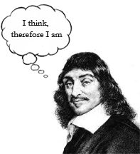](http://www.google.co.uk/url?sa=i&rct=j&q=&esrc=s&frm=1&source=images&cd=&cad=rja&uact=8&ved=0CAcQjRw&url=http://www.observation-science.com/2014/10/06/artificial-intelligence-and-thinking-machines/&ei=DjORVeSgC-KU7Abe8IioCA&psig=AFQjCNGjnpUNuDzwfGT6rSo3kq2RixgJAg&ust=1435665528763931)

THE EMERGENCE OF PSYCHOLOGY AS A SEPARATE SCIENTIFIC DISCIPLINE.

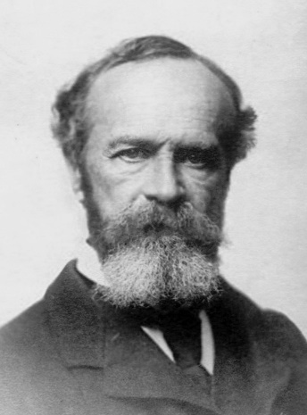**Wilhelm Wundt** is generally known as the founder of experimental psychology and the first person to be considered a ‘psychologist’. He wrote ‘Principles of Physiological Psychology’ and established the first psychology laboratory at Leipzig University, Germany in 1879.

Wundt and his co-workers studied psychology by trying to explain and understand the nature of people’s consciousness, by breaking down experiences into their basic elements. The chief method used was **introspection** (from the Latin meaning ‘looking into’), which involved monitoring and reporting on the contents of consciousness (basic sensations, thoughts and feelings) while being presented, under controlled conditions, with various sensory stimuli. For example, people were shown objects and asked to reflect *how* they were perceiving it, or presented with stimuli and asked to describe the inner process they were experiencing in response to it.

Wundt’s approach to the study of the mind became known as **Structuralism**. Borrowing the model of chemistry, they believed that by isolating these *elements* of conscious experience (like sensation and perception) they could understand how they combined to form the *compounds* of the mind, and that in doing so they might ultimately gain an understanding of the structure of the mind.

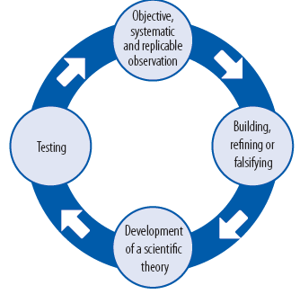This new ‘scientific’ approach to psychology was based on two major assumptions. First, all behaviour is seen as being caused (the assumption of determinism). Second, if behaviour is determined, then it should be possible to predict how human beings would behave in different conditions (the assumption of predictability).

The **scientific method** refers to the use of investigative methods that are objective, systematic and replicable. It is objective in that researchers do not let preconceived ideas or biases influence

the collection of their data, and systematic in that observations or experiments are carried out in an orderly way.

EVALUATION OF WUNDT

Wundt’s emphasis on careful conduction of investigation into the mind (using laboratory settings, standardised instructions and the same stimulus) meant his controlled studies could be replicated. As a result his influence is still seen today in making the discipline of Psychology ‘scientific’ in nature.



Wundt’s **introspection** was considered by his critics to be too subjective (based on the individuals’ interpretations). People’s feelings and emotions varied greatly from person to person, which meant it was too difficult to draw general principles on the nature of the mind.



By the very nature of thoughts and feelings they are ‘non-observable’, private experiences. Individuals can experience them, but they cannot be directly observed or measured by a researcher (in an empirical way). Critics stated that this made them unscientific.

The Emergence of Psychology: A Brief History

Psychology is a branch of Philosophy.

**Wilhelm Wundt** opens the first psychology lab in Germany. Psychology emerges as a separate discipline.

**Sigmund Freud** publishes *The Interpretation of Dreams*. The **Psychodynamic approach** is established.

**John Watson** writes *Psychology as the Behaviourist views it*. **BF Skinner** establishes the **Behaviourist approach**.

The **Humanistic approach** emerges, which rejects Psychodynamic and Behaviourist views and instead emphasises self-determination and free will. **Carl Rogers** & **Abraham Maslow** are the origins of this movement.

The **Cognitive approach** emerges - the introduction of the computer forms the basis of a representation of the mind as an information processor.

**Bandura** proposes the **Social Learning Theory** as a way of integrating ideas from the cognitive approach with traditional Behaviourist views.

**Cognitive Neuroscience** emerges – combining cognitive and biological branches of Psychology.

The **Biological approach** gains status as an important approach in psychology due to advances in technology to study brain and biological processes.

**C15th-**

**17th**

**1900s**

**1913**

**1950s**

**1960s**

**1980s**

**C21st**

**1879**

**Sample questions**

1. Explain what Wundt meant by introspection? (3 marks)
2. Which of these is a criticism of Wundt’s introspection (1 mark)
   1. It was too objective
   2. It doesn’t deal with real experiences
   3. It produced subjective data
   4. It was unscientific
3. Explain one criticism of introspection as a method of investigation (3 marks)
4. Explain the emergence of psychology as a science (4 marks)

**LEARNING APPROACH: BEHAVIOURISM**

**SPEC CHECK:**

The behaviourist approach, including classical conditioning and Pavlov’s research, operant conditioning, types of reinforcement and

Skinner’s research.



ASSUMPTIONS

* We are born a ‘blank slate’ (**tabula rasa**) and assumes all behaviour is learned from experience. They argue that all animals (including humans) learn via the same basic processes, which they refer to as *conditioning*.
* Only behaviours which are directly observable and can be scientifically measured should be studied (**empirical** methods).

CLASSICAL CONDITIONING – Learning through **association**

All animals (including humans) are born with several natural reflexes such as the reflex action of salivation when food is placed in the mouth. These reflexes are made up of a stimulus (such as food) and its naturally associated response (in this case, salivation).

Reflexes consist of an **Unconditioned Response** (UCR) which is an innate/unlearned response to a naturally occurring or **Unconditioned Stimulus** (UCS) e.g. a blast or air (UCS) causes you to blink your eye (UCR). In classical conditioning a new stimulus - response link is made by way of the following process: a **neutral stimulus** (NS) is paired with the UCS so that an individual comes to expect them together. Over a period of time, the NS produces the UCR on its own. The NS is now called a **conditioned stimulus** (CS) and the response it produces is called a **conditioned response** (CR).

PAVLOV’S RESEARCH

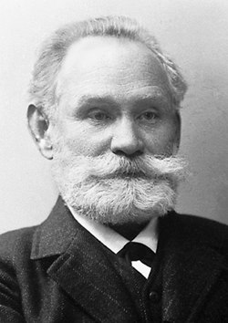

Ivan **Pavlov** is generally credited with discovering the process of classical conditioning. He was investigating the salivary response to the presentation of food in dogs, but he ran into difficulties when the dogs began to anticipate the arrival of food and begin salivating before it was presented. He realised the dogs had *learned* an association between the procedures of preparing the food and the imminent arrival of their food.

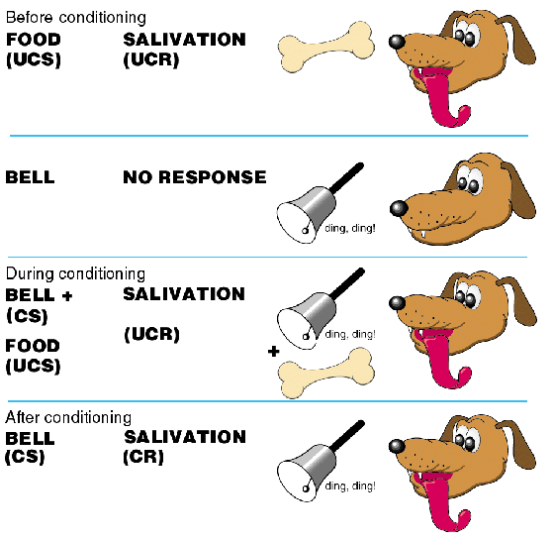Pavlov repeatedly rang a bell (NS) when the dog was being presented with the food (UCS). He called these repeated pairings the conditioning process. After several pairings, Pavlov found that when the bell alone was rung the dog would begin to salivate. The dog had learned to associate the bell with the presentation of the food.

After the conditioning process the bell was no longer a neutral stimulus instead it Pavlov referred to it as a Conditioned Stimulus (CS) producing the Conditioned Response (CR) of salivation.

Extinction - If the conditioned stimulus is repeatedly presented without the unconditioned stimulus, then after a period of time the conditioned response will disappear. E.g. If a dog learns to associate the sound of a bell with food and then the bell is rung repeatedly, but no food is presented, the dog will soon stop salivating at the sound of the bell.

Stimulus Generalisation - Generalisation is when the conditioned response to the stimulus can be generalised to other, similar stimuli. A dog who has been conditioned to salivate to the sound of a bell may well salivate to a similar sounding bell or a buzzer.

Spontaneous Recovery - After a period of extinction there can a spontaneous reappearance of the conditioned response if presented with the conditioned stimulus. E.g. Imagine the dog has learned, due to a period of extinction, that the bell no longer means food. Some weeks later a bell is rung – it may spontaneously cause the dog to salivate.



OPERANT CONDITIONING – Learning through **reinforcement**

In operant conditioning the learners’ behaviour brings about certain consequences. These consequences can shape the behaviour to either strengthen or weaken the behaviour.

**Positive Reinforcement** – a behaviour is rewarded (positive consequence) which makes the behaviour more likely to reoccur in the future.

* Receiving praise or a prize for doing a good piece of homework, means you are likely to try to another good piece of work in the future.

**Negative Reinforcement** - a behaviour means the person avoids a negative consequence which makes the behaviour more likely to reoccur in the future.

* Someone trying to quit smoking might start to experience unpleasant withdrawal symptoms and so start smoking again in order to avoid them, thereby increasing the smoking behaviour.

**Punishment** – a behaviour is met with a negative consequence which makes the behaviour less likely to occur in the future.

* A child being placed in a ‘time out’ after biting another child, means they are less likely to hit again in the future.

SKINNER’S RESEARCH

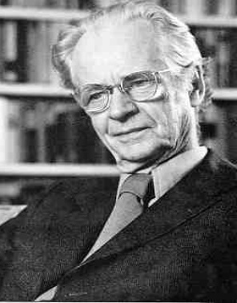

**Skinner** conducted several well controlled laboratory experiments and predominately used pigeons and rats in his experiments. For example, a pigeon is placed in a special box called a Skinner box. The pigeon first pecks randomly around the box as part of its natural exploratory behaviour. Accidentally it presses a lever within the box. Each time the lever is pressed a pellet of food appears, the food acts as a reward – a positive reinforcement. The more that the reward and the lever are paired the greater the likelihood of the behaviour being repeated.

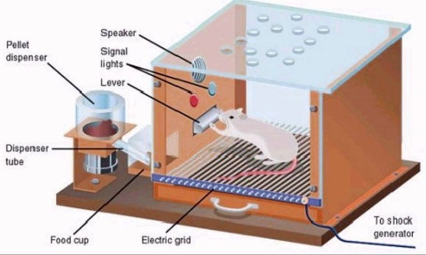In another series of experiments, a rat was put in a Skinner box with an electrified floor. If it carried out the desired behaviour, which was pressing a lever, then electricity stopped. The termination of the shock acts to remove or avoid the unpleasant experience of being electrocuted – negative reinforcement. Other rats in a Skinner box were given an electric shock after they had pressed a lever. The rats were less likely to press the lever again. This was because the consequence of pressing the lever was a punishment and so it weakened the behaviour.



*Schedules of Reinforcement*

|  |  |  |
| --- | --- | --- |
| Reinforcement Schedule | This means… | Everyday example |
| Continuous reinforcement | Each time the behaviour is performed it is reinforced | Receiving a tip from every customer you serve |
| Fixed Interval | The behaviour is reinforced after a set period of time (e.g. after 30 secs) provided the behaviour is displayed | Giving yourself a 10 min break after each 30 mins of revision. |
| Variable Interval | The behaviour is reinforced on average after a set period of time (e.g. on average every 30 secs) but at what point it is provided varies from trial to trial meaning the reward is unpredictable | A teacher sets a pop quiz on average every two weeks, but students are unsure which day the test will be. |
| Fixed Ratio | The behaviour is reinforced after a set number of times (e.g 10) the behaviour is shown | Collecting a token each time you buy a cereal so that after 5 tokens you can claim a prize |
| Variable Ratio | The behaviour is reinforced on average after a set number of times the behaviour is displayed (e.g. on average every 10 times) but the number of times required varies from trial to trial so the reward is unpredictable | Gambling on a slot machine – it is programmed to ‘pay out’ on average after a set number of ‘plays’ |

EVALUATION OF BEHAVIOURISM

 The behaviourist approach also takes a very scientific approach to studying human behaviour. They believe in studying observable and measurable behaviours and generally use well controlled laboratory methods to conduct their research. As a result, it is easier to draw conclusions about cause and effect (high internal validity) in relation to stimulus-response links and the influence of consequences of behaviour.

 Another key strength of the behaviourist approach is that as is views all behaviour as learned – it therefore assumes behaviours can also be unlearned by the same processes. As a result, it provides real life application in modifying behaviour and therefore these techniques are used in a variety of areas. For example, in teaching children positive behaviours; used in prisons to maintain order; by therapists to alter maladaptive responses such as phobias.



A weakness of the behaviourist approach is that it overlooks people’s free will. This is because it claims our behaviours are determined by learned stimulus-response associations or from learning the consequences of our actions. However, people often demonstrate unique or spontaneous behaviours, which are hard to explain using the behaviourist approach.



Much of the research into the behaviourist approach is conducted on non-human animals. This is because behaviourists claim that animals and humans learn using similar processes. However, critics argue that humans are much more complex and therefore they question the external validity of the research in explaining human behaviours.

Furthermore, the ethics of such research is also questioned as animals involved in Skinner’s research were exposed to stressful and aversive situations. This may have also influenced how they reacted to the experimental situation.

**Sample questions**

* + - 1. Outline one assumption of the behaviourist approach. (3 marks)
      2. Outline two types of reinforcement as suggested by the behaviourist approach. (4 marks)
      3. Outline the main findings of Skinner’s research. (4 marks)
      4. Outline one strength and one limitation of the behaviourist approach. (6 marks)
      5. Outline and evaluate the behaviourist approach in psychology. (16 marks)

**LEARNING APPROACH: SOCIAL LEARNING THEORY**

**SPEC CHECK:**

Social learning theory including imitation, identification, modelling, vicarious reinforcement, the role of mediational processes and Bandura’s research.

ASSUMPTIONS

* Behaviour is learned from the environment and our experiences, but also claims that we can learn indirectly from others by observing their behaviour and its consequences.
* Cognition plays an important role in learning.

SOCIAL LEARNING THEORY

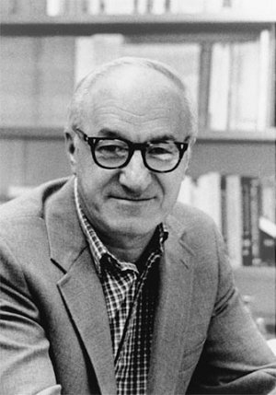Social Learning Theory was proposed by **Bandura**. He rejected Skinner’s views that direct consequences on our behaviour were sufficient to explain behaviour – instead he believed people were also interested in the potential consequences of their behaviour which can be learned indirectly (or vicariously) by watching and learning from other people. It also viewed the cognitive processes involved in learning as being important too.

He claimed that we watch people significant to us (e.g parents, friends, celebrities). He called them **role models**. If the role model’s behaviour is positively reinforced, then this acts a **vicarious (indirect) reinforcement** for the observer. The observer learns the potential consequences of such behaviour and as a result is likely to **imitate** the behaviour themselves to receive the same reinforcement. Observation and subsequent imitation of the behaviour is referred to as **modelling**. Likewise, if the model’s behaviour is punished then it acts as a vicarious (indirect) punishment for the observer and is likely to make it less likely the observer will imitate the behaviour.

Bandura also claimed that imitation is also dependent on the observer’s **identification** with the role model. For example, if they view themselves as similar (e.g. in gender, ethnicity etc) or view the model as having higher status (e.g. more expertise, a celebrity) to which they aspire they are more likely to identify with the model and therefore imitate their behaviour.

*Mediational processes*: Bandura also highlighted the importance of the cognitive aspects of imitation. Firstly, attention to the behaviour and its consequences; retention in order to recall the behaviour and its consequences; the observer’s motivation to perform the behaviour (which is largely influenced by the consequence of the behaviour they observed) and also their perception of their motor reproduction skills – they are only likely to imitate the behaviour if they believe they can reproduce the same behaviour.



BANDURA ET AL’S RESEARCH (1961)

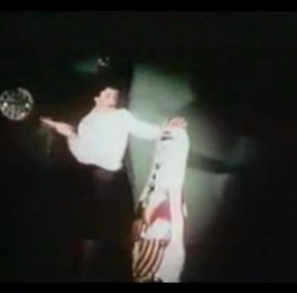Procedure: The participants were 4 year children - 36 boys and 36 girls. They either watched an aggressive model - an adult behaving aggressively towards a **bobo doll** (a doll with a rounded bottom so it does not topple over) by punching and hitting it with a hammer, OR a non-aggressive model. The children were then taken to a room which contained brand new toys and were told that they weren’t allowed to play with these (this was done to create a sense of frustration). They were then moved to another room with other toys, including a hammer and a bobo doll. Their behaviour was observed through a one-way mirror.

Findings:

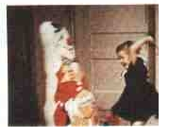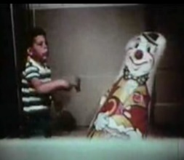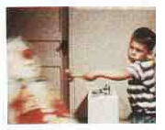

* Children in the aggressive model condition reproduced a good deal of physical and verbal aggressive behaviour resembling that of the model (Children who observed the non-aggressive model exhibited virtually no aggression towards the Bobo doll).
* Boys showed higher levels of aggression than the girls.
* Both boys and girls were more likely to imitate the model’s aggressive behaviour if the model they had observed was the same gender as them.

This research supports the claims that we learn behaviour, such as aggression, from observing the behaviours of others and that this is even more likely if we strongly identify with the role model.



Bandura + Walters’ (1963)carried out a follow-up study.

Procedure: The children were shown videos of an adult behaving aggressively towards a Bobo doll. There were 3 conditions:

-One group of children saw adult kick and punch bobo doll with no consequences (Control group).

-Another group of children saw the same aggressive behaviour performed by the adult model but this time the model was rewarded by another adult for the aggressive behaviour by being told ‘well done’.

-In the final group the children saw the same aggressive behaviour, but this time the model was punished by another adult who warned him not to be aggressive in the future.

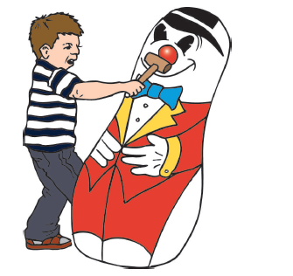Findings: Children exposed to the model rewarded were most likely to imitate the aggressive acts, followed by the no consequences condition whereas the children in the model punished condition were least likely to imitate the aggressive behaviour.

This research supports the claim that we learn behaviour by observing the consequences of others’ behaviour – the idea of vicarious reinforcement.

EVALUATION OF SOCIAL LEARNING THEORY

|  |  |
| --- | --- |
|  | An important strength of the Social Learning Theory is that it accounts for cognitive factors in the learning process. Neither classical nor operant conditioning alone are sufficient to explain the learning of human behaviours. Therefore, Social Learning can provide a more comprehensive explanation of learning, especially of novel behaviours (e.g. starting smoking). |
|  | http://www.tucrs.utulsa.edu/images/smiley.jpgSocial Learning theory also helps us to understand why there are cultural variations in human behaviour. This is because the role models we are exposed to are specific to our culture. This means that the cultural norms are perpetuated through the continuous observation and imitation of behaviours within the culture. |
|  | A weakness of Social Learning Theory is that it can’t explain behaviour for which there is no role model. For example, certain individuals will demonstrate completely unique behaviours (e.g. psychopathic behaviours), this may mean these behaviours are more likely to have an underlying biological cause. |
|  | A further limitation of Social Learning Theory is that it ignores the importance of biological factors and the effect they can have on behaviour. For example, in Bandura’s (1961) research, one of the primary findings was that boys were overall more aggressive than girls. This could be explained by hormonal influences on aggression - the male sex hormone testosterone has been linked to an increase of aggressive behaviour, and is present in greater quantities in males than females. This means that an important influence on behaviour is not accounted for by Social Learning Theory. |
|  | http://www.rockinwproductions.com/images/smiley-face.jpgMuch of the research on which the social learning theory is based was controlled laboratory research. This type of research has been criticised for being too artificial and being subject to demand characteristics – meaning the children showed the aggressive behaviour because that was what they thought they were supposed to do. This questions the validity of the research and therefore the validity of the theory in explaining learning. |



**Sample questions**

1. Complete the table below by writing which definition A, B or C describes the term. One definition will be left over. (3 marks)
2. When a behaviour results in a negative

consequence

1. When an observer reproduces the behaviour

of the role model

1. When a behaviour means negative consequences

are avoided

1. When an observer learns about the positive consequences of a

behaviour indirectly from a role model

1. Outline and evaluate the social learning approach. (16 marks)

**THE COGNITIVE APPROACH**

Aoccdrnig to rscheearch at Cmabrigde Uinervtisy, it deosn't mttaer in waht oredr the ltteers in a wrod are, the olny iprmoetnt tihng is taht the frist and lsat ltteer be at the rghit pclae. The rset can be a toatl mses and you can sitll raed it wouthit a porbelm. Tihs is bcuseae the huamn mnid deos not raed ervey lteter by istlef, but the wrod as a wlohe.

**SPEC CHECK:**

The cognitive approach: the study of internal mental processes, the role of schema. The use of theoretical and computer models to explain and make inferences about mental processes. The emergence of cognitive neuroscience.

ASSUMPTIONS

* Internal mental processes can and should be studied scientifically.
* Internal mental processes are ‘private’ and cannot be studied directly so inferences need to be made.

The cognitive movement, which began in the late 1950s, advocated the importance of thought (mental) processes in explaining human behaviour. They rejected the behaviourist views that humans are just a product of stimulus (input) and response (output) and instead sought to focus on the mental processes between the stimulus and the response.

SCHEMAS

**Schemas** are packages of knowledge, beliefs and expectations about certain situations or people, which are built through experiences and interactions with our environment. They help us to organise the world and therefore are useful in directing our behaviour. Schemas are unique to each individual as they are a result of our own experiences, as a result we all perceive the world in our own unique way. This means that assuming we all *think* in the same way is misguided.

Due to our schema we can quickly and appropriately engage with a situation and allow us to take mental ‘short-cuts’ meaning we know what to expect and do without being overwhelmed with sensory information. However, these ‘short-cuts’ can lead to faulty conclusions and might mean we overlook some sensory information and form a distorted view of a situation.

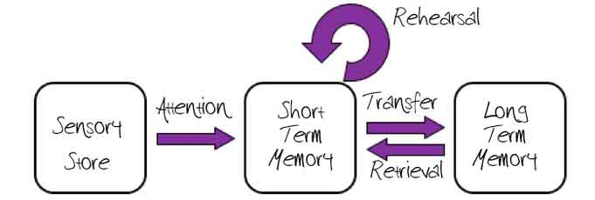THEORETICAL AND COMPUTER MODELS

**Theoretical models** of cognitive processes refers to psychologists identifying the likely stages of information processing which occurs between the stimulus-response link. Then they often display them in a sequence like format (such as the Multi-store Model of Memory). This lends itself to a scientific approach as each stage of the sequence can be tested and revised if needed.

As mentioned above Cognitive Psychologists often use the computer as a representation of the human mind. The **‘computer analogy’** suggests that computers processes information in a similar way to the human mind. With an input, using concepts like a Central Processing Unit (CPU) to code and process information into a useable format and stores to hold the information.

THE EMERGENCE OF COGNITIVE NEUROSCIENCE

**Cognitive neuroscience** is the study of how our underlying biological processes and structures might influence our thought processes (cognitions). 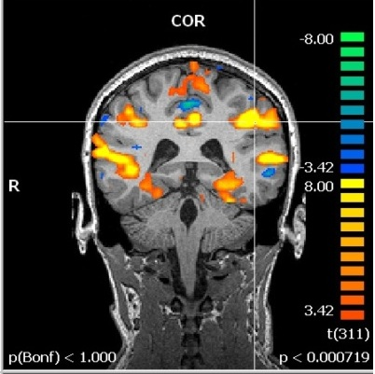This area of study has been long established, for example in the case of Broca’s area which was identified in the 1860s – an area of the brain which when damaged permanently impaired speech production but has seen much more focus since the advances in technology (such as fMRI and PET scans) which have enable scientists to map the brain to make inferences about how activation of certain areas are linked with a specific mental processes.



For example, Maguire et al’s (2000) research into taxi driver’s brains. The research compared MRI scans of London taxi drivers with age, gender and health matched controls. In order to become licensed, London taxi drivers have to take a test called the Knowledge, which involves 7 intense stages learning all the streets and landmarks in London and normally takes about 3-4 years. It was found that the grey matter was significantly larger in both the left and right posterior hippocampi in the taxi drivers, compared to the controls. A positive correlation was found between the amount of time spent as a taxi driver the size. The results provide evidence for structural differences between the hippocampi of London taxi drivers and control participants, therefore suggesting that extensive practice with spatial navigation affects the hippocampus.

Recent research into this field has involved the use of computer-generated models which can ‘read’ the brain which has led to the ideas of brain mapping and ‘brain fingerprinting’.

EVALUATION OF THE COGNITIVE APPROACH

A strength of the Cognitive approach is that it utilises scientific methodology. For example in Baddeley’s research into coding in STM and LTM. This provides psychologists with a rigorous methodology for collecting and evaluating evidence. It also means that cause and effect conclusions can be made.

|  |  |
| --- | --- |
|  | A strength of the Cognitive approach is that it has been able to identify and describe many of the internal mental process which occur in response to given stimuli. This has been useful and had practical application in fields such as the treatment of psychological disorders like Depression. One treatment of Depression is CBT, which focuses on challenging the faulty cognitions associated with depression, such as negative self-schemas. |
|  | http://www.rockinwproductions.com/images/smiley-face.jpgThe cognitive approach is also viewed as being less deterministic than some other approaches, such as the Biological or Behaviourist approaches. This is because it allows the individual to ‘think’ about how they wish to respond meaning it allows for a degree of free will in our behaviour. |
|  | A weakness of Cognitive approach is that much of the research is conducted using highly controlled and artificial settings, using artificial stimuli. For example, Baddeley’s research into coding in STM and LTM. This is a problem because is questions whether the mental processing which occurs to these artificial stimuli is truly representative of how we process everyday information. This mean the research in this field may lack external validity. |
|  | http://www.tucrs.utulsa.edu/images/smiley.jpgOther critics of the approach have argued that the use of a ‘computer analogy’ of the human mind is too simplistic. They argue that this machine-reductionism often means that role of emotion and how it influences our thoughts is overlooked and that this is a crucial difference between humans and machines. |

**Sample questions**

1. Explain what is mean by the term schema (2 marks)
2. Explain the difference between cognitive psychology and cognitive neuroscience (3 marks)
3. Joey lacks confidence when he goes on nights out with his friends. Even if a girl he likes comes over to talk to him, he doesn’t believe she’s attracted to him. His friends try to encourage him, but he still doubts he will ever find a girlfriend.

With reference to the scenario, explain how the cognitive approach would explain Joey’s situation (4 marks)

1. Evaluate the research methods used by cognitive psychologists (6 marks)

**THE BIOLOGICAL APPROACH**

**SPEC CHECK:**

The influence of genes, biological structures and neurochemistry on behaviour. Genotype and phenotype, genetic basis of behaviour, evolution and behaviour.



ASSUMPTIONS

* There is a direct correlation between brain activity and cognition.
* Biochemical imbalances and brain physiology can affect behaviour.
* Behaviour can be inherited (as it is determined by genetic information).

INFLUENCE OF GENES ON BEHAVIOUR



GENOTYPE AND PHENOTYPE

Each individual is thought to have around 100,000 genes, which they are born with and which are unique to them (with the exception of identical twins). These genes provide the code for how the individuals characteristics will develop (e.g. hair colour; eye colour). This is known as the **genotype** of the individual, it is the genetic material that we have.

The **phenotype** however is the extent to which each genetic characteristic is expressed, as a result of the genotype interacting with the environment.

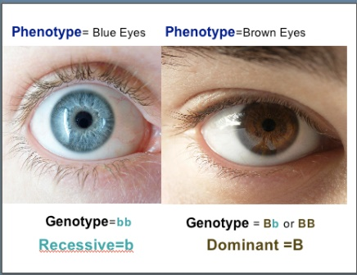For example, an individual will have a gene to determine their potential height (**genotype**), however their actual height (**phenotype**) will have been influenced by their environment (such as whether they have had a nutritional diet or not), meaning an individuals genotype does not necessarily directly relate to their phenotype. Likewise it is not always possible to determine someone’s genotype from their phenotype, for example someone with brown eyes may have a dominant gene for brown eyes, but may also possess a recessive gene for blue eyes.

GENETIC BASIS OF BEHAVIOUR

**Behavioural genetics** makes an assumption that our behavioural characteristics can be determined by our unique genetic make-up in the same way as our physical characteristics. Clearly there is variance between individuals in terms of characteristics, such as height or intelligence, and the more a trait is determined by genetics the greater its **heritability**. Therefore, it is claimed that the reason that offspring ‘take after’ their parents in terms of their behaviours and psychological characteristics is because they have inherited such characteristics from them. However, the extent to which these characteristics and behaviours develop is also dependent on the interaction of the genes with other genes and with the environment; which is why although identical twins have an identical genotype, they can still show subtle differences in their phenotype.

**Twin studies** are often used to attempt to draw conclusions about the genetic basis of a particular behavioural characteristic. By comparing the **concordance rates** (the extent to which both twins share the same characteristic) between monozygotic twins (identical) with dizygotic twins (non-identical) it can help to determine the extent to which the behavioural characteristic has a genetic basis. For example, Joseph (2001) studied thirty-two MZ twins who had been reared apart. The results showed that for both childhood and adult antisocial behaviour, there was a high degree of heritability involved as there were high concordance rates (Joseph, 2001).

Other methods of study include: Twin studies (DZ twins), adoption studies and family studies.

EVOLUTION AND BEHAVIOUR

[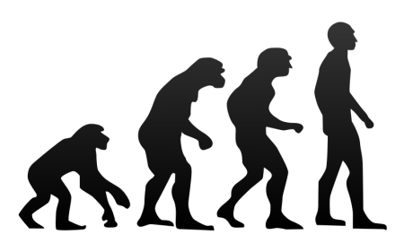](http://www.google.co.uk/url?sa=i&rct=j&q=&esrc=s&frm=1&source=images&cd=&cad=rja&uact=8&ved=0CAcQjRw&url=http://thetruthwins.com/archives/44-reasons-why-evolution-is-just-a-fairy-tale-for-adults&ei=102RVa39POTV7gbuypigCw&bvm=bv.96783405,d.ZGU&psig=AFQjCNHeQfXK344eFdACjPGQSsQlVddWiA&ust=1435672332055976)Biological psychologists believe that behavioural characteristics have evolved in the same way as our physical characteristics. The process of **natural selection** argues that behavioural characteristics which were more adapted to the environment (i.e. they helped the individuals to survive and to reproduce) were the ones which were passed on through genes to successive generations. Individuals without these **adaptive** characteristics were unable to survive and reproduce.

For example, it is suggested that characteristics such as intelligence and aggression would have increased the chances of survival for our ancestors, they would have been passed on through successive generations which is why these characteristics are still seen amongst the population today.

INFLUENCE OF BIOLOGICAL STRUCTURES ON BEHAVIOUR



NEURONS AND THE NERVOUS SYSTEM

The nervous system is divided into two branches – the **Central Nervous System** (CNS) and the **Peripheral Nervous System** (PNS).

The **Central Nervous System** consists of the brain and spinal cord and is responsible for all our higher order functions and for controlling all physiological processes within the individual (including breathing, eating, sleeping etc). The **Peripheral Nervous System** consists of all other neurons across the body. There are two further divisions of the Peripheral Nervous System; the **Somatic Nervous System** (SoNS) which is responsible for relaying messages to and from the CNS to the muscles; limbs and skin and the **Autonomic Nervous System** which is responsible for responding immediately to threats (e.g. fight or flight response) and returning the body to a state of calm. Messages throughout the CNS and PNS are sent via neurons. These are nerve cells which communication with one another via electrical and chemical signals.



THE BRAIN

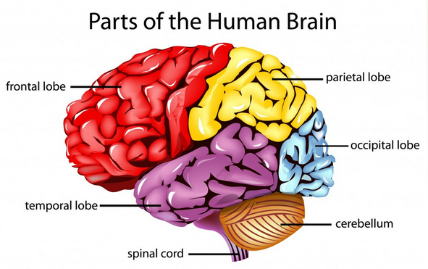The brain is divided into different structures. The **Brainstem** is primarily responsible for vital functions such as breathing and heartbeat. The **Limbic System** is primarily responsible for sexual and emotional behaviour and the largest part of the brain, the **Cerebrum**, is primarily responsible for higher order functions like thinking and language.

The **Cerebrum** is further divided into two halves, known as **hemispheres** – the right and left hemispheres and each hemisphere is divided into four regions, known as lobes – the Frontal Lobe; Occipital Lobe; Parietal Lobe and Temporal Lobe. It is claimed that activation of certain areas of the brain are directly related to certain behaviours.

INFLUENCE OF NEUROCHEMISTRY ON BEHAVIOUR



NEUROTRANSMITTERS

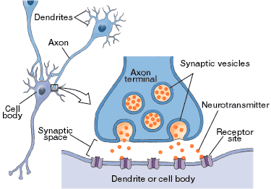Neurons communicate with one another via chemicals called neurotransmitters. There are several different types of neurotransmitters (e.g. Serotonin, Dopamine, Glutamate). Some neurotransmitters are *excitatory* neurotransmitters. This means when released into the synapse they activate an electrical signal in the receiving neuron. Other neurotransmitters are *inhibitory* neurotransmitters. This means when released they stop the activation of the receiving neuron – this is in order to calm the brain. Biopsychologists believe the activity and levels of these neurotransmitters can influence people’s behaviours.



HORMONES

[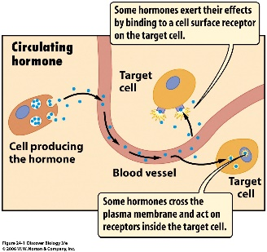](http://www.google.co.uk/url?sa=i&rct=j&q=&esrc=s&source=images&cd=&cad=rja&uact=8&ved=0CAcQjRw&url=http://www.csus.edu/indiv/l/loom/preview%2018.htm&ei=h8mTVYm_D-zU7AaLyKfoAg&bvm=bv.96952980,d.ZGU&psig=AFQjCNFv9fcKb3DNirM27k4m39CE40efKA&ust=1435835078272539)Other chemicals which transmit messages in the body are hormones. Hormones are produced by glands of the endocrine system. When their release is triggered by a signal from the brain they are secreted into the blood stream and travel to the required site in the body to have their action. It is believed that the level of hormones in a person’s system can influence their behaviour. For example, testosterone is a hormone which, in high levels, can result in a person behaving more aggressively.

EVALUATION OF THE BIOLOGICAL APPROACH

The biological approach takes a very scientific approach to studying the link between biological processes and behaviour. This is because it uses controlled experimental methods and advanced technology to collect objective data.

Another important strength of the biological approach is its real-life application. This is because the biological approach makes clear predictions about the effects of neurotransmitters on a person’s behaviour. As a result, drugs have been developed to alter the activity or levels of neurotransmitters such as serotonin – SSRI’s are frequently used to treat depression and OCD.

Critics of the biological approach argue that it is too reductionist. Reductionism involves explaining complex behaviours (such as psychological conditions like depression) by breaking them down into their smallest components, such as genes or hormones and claiming these are the primary cause of these conditions. In doing this other important influences are overlooked, such as cognitive, social or emotional influences.



A further limitation is that is does not account for the behaviour being transmitted by both genetic and cultural routes. For example, the incest taboo that exists in most societies has genetic and cultural bases. An evolutionary explanation would emphasise the problems of genetic mutations that would arise from inbreeding. However, most cultures also have strict, culturally determined moral codes of conduct and incest taboos would undoubtedly form a part of such codes.



There is also an issue with using a genetic explanation of behaviour. Critics claim this may lead to genetic screening of the population to identify this genetic susceptibility and subsequent discrimination against those with a genetic predisposition for criminality. However, other psychologists suggest that if individuals discover that they have a genetic predisposition for criminality, this gives them the opportunity to avoid environmental situations likely to trigger this predisposition.

**Sample questions**

1. Using an example, distinguish between genotype and phenotype (3 marks)
2. Complete the table below by writing which definition A, B or C describes the term (3 marks)
   1. This system consists of the brain and spinal cord
   2. This chemical transmits messages between
3. neurons (nerve cells)
   1. This is a measure of the extent of similarity
4. between twins, of a specific behavioural characteristic.
5. Describe how the process of evolution could explain IQ scores increasing across generations (4 marks)
6. Discuss the contribution of the biological approach to our understanding of human behaviour (16 marks)

**Sample questions**

1. Using an example, distinguish between genotype and phenotype (3 marks)
2. Complete the table below by writing which definition A, B or C describes the term (3 marks)
   1. This system consists of the brain and spinal cord
   2. This chemical transmits messages between

neurons (nerve cells)

* 1. This is a measure of the extent of similarity

between twins, of a specific behavioural characteristic.

1. Describe how the process of evolution could explain IQ scores increasing across generations (4 marks)
2. Discuss the contribution of the biological approach to our understanding of human behaviour (16 marks)

**Sample questions**

1. Using an example, distinguish between genotype and phenotype (3 marks)
2. Complete the table below by writing which definition A, B or C describes the term (3 marks)
   1. This system consists of the brain and spinal cord
   2. This chemical transmits messages between

neurons (nerve cells)

* 1. This is a measure of the extent of similarity

between twins, of a specific behavioural characteristic.

1. Describe how the process of evolution could explain IQ scores increasing across generations (4 marks)
2. Discuss the contribution of the biological approach to our understanding of human behaviour (16 marks)

**Sample questions**

1. Using an example, distinguish between genotype and phenotype (3 marks)
2. Complete the table below by writing which definition A, B or C describes the term (3 marks)
   1. This system consists of the brain and spinal cord
   2. This chemical transmits messages between

neurons (nerve cells)

* 1. This is a measure of the extent of similarity

between twins, of a specific behavioural characteristic.

1. Describe how the process of evolution could explain IQ scores increasing across generations (4 marks)
2. Discuss the contribution of the biological approach to our understanding of human behaviour (16 marks)

