**THE NERVOUS SYSTEM**

**SPEC CHECK:**

The divisions of the nervous system: central and peripheral (somatic and autonomic).



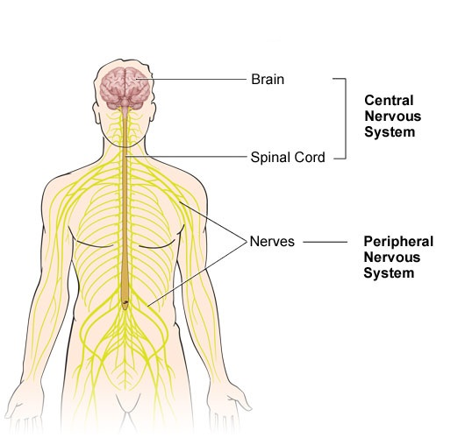There are two main divisions of the nervous system, these are the **Central Nervous System** (CNS) and the **Peripheral** **Nervous System (PNS)**.

CENTRAL NERVOUS SYSTEM (CNS)

The central nervous system is responsible for control of behaviour and the regulation of the body’s physiological processes.

The central nervous system is further divided into two parts: the **brain** and the **spinal cord**.

* **The brain** - analyses and stores information and directs the actions of the body
* **The spinal cord** - relays information to and from the brain and is also responsible for reflex reactions

The central nervous system is made up of two types of cells - **nerve cells** (neurons) and **support cells**. The brain contains about 100 billion nerve cells (neurons) and trillions of support cells called glia.

PERIPHERAL NERVOUS SYSTEM (PNS)

The peripheral nervous system transmits information to and from the central nervous system, to the rest of the body.

There are two main types of nerve cells (neurons) in the peripheral nervous system:

* **Sensory neurons** - which collect information from the body's sense organs - responding to touch, temperature, pain, position, smell, sound and sight.
* **Motor neurons** - which pass messages from the central nervous system. When information has been processed centrally (by CNS), these nerves carry the instructions for action in other areas of the body (such as to the muscles controlling movement, speech, internal organs or glands of the endocrine system).

The peripheral nervous system is further divided into two parts: The Somatic Nervous System (SoNS) and the Autonomic Nervous System (ANS).

SOMATIC NERVIOUS SYSTEM (SoNS)

This is the part of the peripheral nervous system that enables us to respond to sensory information and to perform movements and actions. It is the voluntary control of our muscles, meaning we are more aware of this part of our peripheral nervous system. Information from **sensory neurons** is relayed to the CNS and the CNS sends information about movement which is performed by the **motor neurons** connected to our skeletal muscles.

AUTONOMIC NERVIOUS SYSTEM (ANS)

This is the part of the peripheral nervous system that regulates the function of our internal organs (heart, stomach, intestines). Most of the time we are not aware of the ANS as it is involved in involuntary (automatic) or reflex functions such as breathing, dilation/constriction of blood vessels and increases/decreases in heart rate. The ANS also controls some of the muscles within the body.

The Autonomic Nervous system is further divided into two parts: The **Sympathetic Nervous System** and the **Parasympathetic Nervous System**

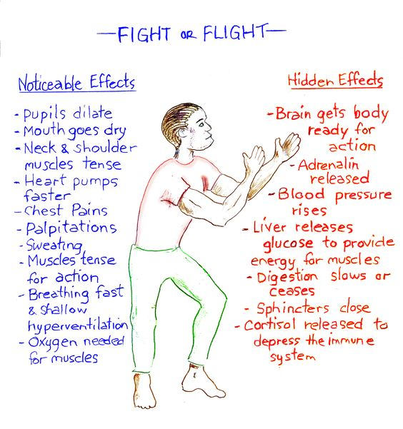

*SYMPATHETIC NERVOUS SYSTEM (SNS)*

This can be viewed as the body’s *quick response mobilizing system*. It gets the body ready for action and is what produces our “fight or flight” response.

EG Increased heart rate, breathing rate, pupils dilate, digestion is inhibited.

*PARASYMPATHETIC NERVOUS SYSTEM (PSNS)*

This has an opposite effect to the SNS and can be viewed as a *more slowly activated dampening system.* It helps the body to return to a calmer state after a period of activation/arousal – ‘rest and digest’.

EG Decreased heart rate, breathing rate, pupils constrict, digestion is restarted.

**Sample questions**

1. Outline the role of the central nervous system. (4 marks)

2. Identify the two divisions of the autonomic nervous system. (2 marks)

3. Identify the two components of the central nervous system. (2 marks)

4. Outline the role of the somatic nervous system. (4 marks)

5. Outline the role of the autonomic nervous system. (4 marks)

1. Explain the difference between the sympathetic nervous system and the parasympathetic nervous system (2 marks)
2. Identify the two components of the peripheral nervous system and explain two differences in their organisation and/or functions. (4 marks)

**NEURONS**

**SPEC CHECK:**

The structure and function of sensory, relay and motor neurons. The process of synaptic transmission, including reference to neurotransmitters, excitation and inhibition.

Neurons are nerve cells which communicate messages throughout the nervous system in the body. 80% of all our neurons are located in the brain.

STRUCTURE OF NEURONS

Neurons can rage widely in terms of shape and size, but all generally share the same basic structure.

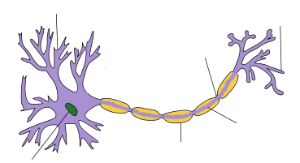

**Nodes of Ranvier** – are gaps between the Myelin sheath, which also help to speed up the transmission of the electrical impulse, by allowing it to ‘jump’ from node to node.

**Axon Terminals** – are at the end of the axon and they communicate the electrical impulse to the next neuron across a gap called a synapse.

**Axon** – carries the electrical impulse from the cell body to the axon terminal

**Myelin Sheath** – is a fatty tissue surrounding the axon, which protects the axon and also allows the electrical impulse to be transmitted more rapidly.

**Nucleus** – contains all the genetic information for the neuron

**Cell Body (Soma)** – the dendrites are connected to the cell body (Soma)

**Dendrites** – branch-like structures which receive an impulse from other neurons or from a sensory receptor



FUNCTION OF NEURONS

There are three main types of neurons: **Sensory Neurons, Relay Neurons** and **Motor Neurons**

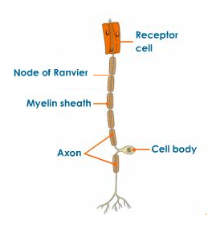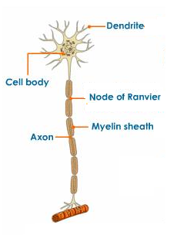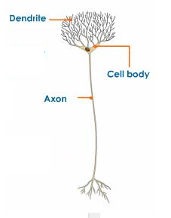

**Motor Neurons**

Carry impulses from the brain and spinal cord to muscles or glands

**Relay Neurons**

Connect sensory and motor neurons and interpret the impulse. They are only found in the brain and spinal cord.

**Sensory Neurons**

Receive impulses and carry them from the sense organs (eyes, nose, ears, tongue, skin) to the spinal cord or brain.

|  |  |  |  |
| --- | --- | --- | --- |
|  | Sensory | Relay | Motor |
| Function | Transmit impulses from receptor cells to CNS | Connect sensory and motor neurons to form nerve circuits | Transmit impulses from CNS to effector |
| Location | PNS | CNS | PNS |
| Structure | Cell body, long dendrites, short axon | Cell body, short dendrites, short axon | Cell body, short dendrites, long axon |
| Dendrites | Forms synapses with receptors | Forms synapses with sensory neurons | Forms synapses with relay neurons |
| Axon Terminals | Form synapses with relay neurons | Forms synapses with motor neurons | Forms synapses with effectors |

SYNAPTIC TRANSMISSION

Messages within the same neuron are transmitted via an electrical impulse. In a resting state a neuron is negatively charged, relative to its surroundings. When an impulse is received by the dendrites of the neuron, it changes the neuron from being negatively charged to positively charged for a very short period of time (~1m/s). This creates the electrical impulse which called an **Action Potential**. The action potential travels through the cell body to the axon.

**Synaptic transmission** however, refers to the process of transferring chemical messages from one neuron to another neuron. 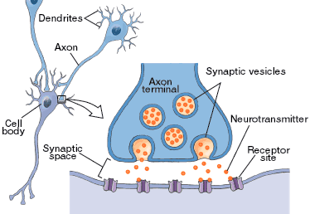When an electrical signal (action potential) reaches the axon terminal of the presynaptic neuron, it triggers **vesicles**, which are tiny sacs full of chemicals called **neurotransmitters** to fuse with the presynaptic membrane and release their contents into the **synapse**, the tiny gap between neurons. These neurotransmitters then diffuse across the synapse towards the receiving neuron. They then bind with **receptor sites** on the postsynaptic membrane. These receptors are specialised to bind with certain neurotransmitters – similar to a lock and key. This can then cause an action potential to occur in the postsynaptic neuron. The neurotransmitters are then either broken down by enzymes or are taken back up into the presynaptic neuron for reuse (known as reuptake).

EXCITATORY AND INHIBITORY NEUROTRANSMITTERS

Whether an action potential occurs in the postsynaptic neuron depends on whether the net effect of the neurotransmitters that are binding to the receptors are excitatory or inhibitory.

[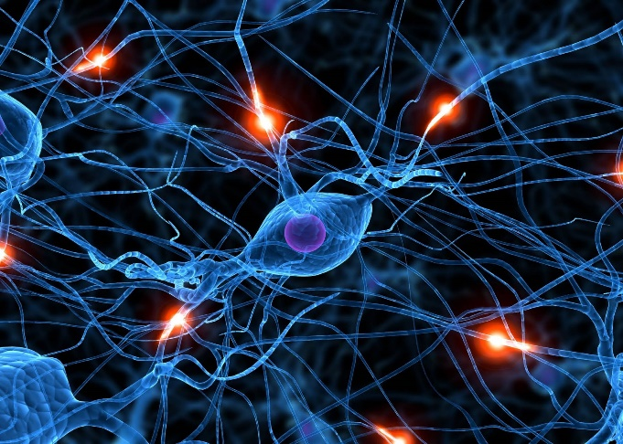](http://www.google.co.uk/url?sa=i&rct=j&q=&esrc=s&source=images&cd=&cad=rja&uact=8&ved=0CAcQjRxqFQoTCPr4y-emuscCFQOd2wodmAUCtw&url=http://psychoterapiazmienia.pl/&ei=iyrXVbqHLoO67gaYi4i4Cw&psig=AFQjCNFX84m0CrgcdeGNuXcInUm1Ou9lwQ&ust=1440250813242522)Excitatory neurotransmitters

This means that when it is released into the synapse and binds with its receptor site it causes the receiving neuron to be activated (to ‘fire’) by producing a new action potential in the postsynaptic neuron. These types of neurotransmitters can be viewed as the nervous systems’ ‘on switches’, because they continue the message.

Examples of excitatory neurotransmitters include Acetylcholine (motor neurons release this in order to activate muscles) and Noradrenaline (important for attentiveness, emotions, sleeping, dreaming, and learning).

Inhibitory neurotransmitters

This means that when it is released into the synapse and binds with its receptor site it causes the receiving neuron to NOT be activated (stops the receiving neuron from ‘firing’), so no new action potential can be created. It does this by enhancing the postsynaptic neurons negative charge (meaning it is harder for an action potential to occur). These types of neurotransmitters can be viewed as the nervous systems’ ‘off switches’.

Examples of inhibitory neurotransmitters include GABA (reduces the activity of the neurons) and Serotonin (regulates anxiety, happiness, and mood).

Summation

The excitatory and inhibitory influences are summed, if the net effect on the post synaptic neuron is inhibitory, the neuron will be less likely to ‘fire’ and if the net effect is excitatory, the neuron will be more likely to fire.



**Sample questions**

1. Label the following parts of a neuron (3 marks)

a…………………….

b…………………….

c……………………..

1. Explain the difference between a sensory neuron and a motor neuron (2 marks)
2. Outline the process of synaptic transmission (6 marks)
3. Explain what is meant by excitation and inhibition in synaptic transmission. (2 marks each)

**THE ENDOCRINE SYSTEM**

**SPEC CHECK:**

The function of the endocrine system: glands and hormones.

The nervous system is supported by another system in the body – the endocrine system.

The endocrine system is a network of glands which produce and secrete chemicals called hormones. Unlike the nervous system, the endocrine system does not use nerves to transmit messages, instead they it uses the blood stream to transmit hormones to their site of action.

[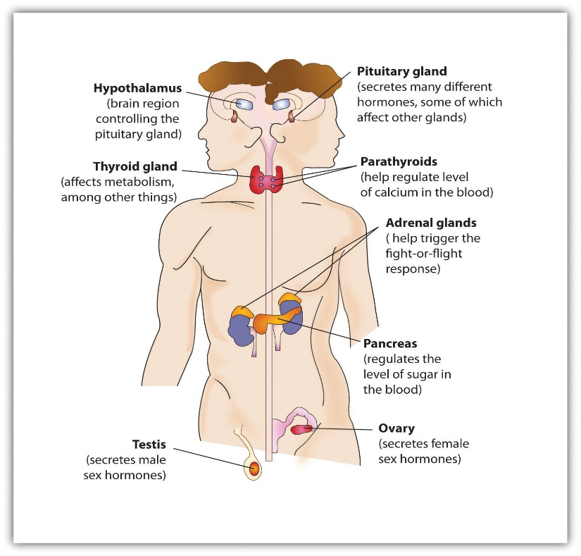](http://www.google.co.uk/url?sa=i&rct=j&q=&esrc=s&source=images&cd=&cad=rja&uact=8&ved=0CAcQjRxqFQoTCJGu45u7rccCFUEQFAodN3cApw&url=http://catalog.flatworldknowledge.com/bookhub/127?e%3Dstangor-ch03_s04&ei=HW_QVdGrEsGgULfugbgK&bvm=bv.99804247,d.d24&psig=AFQjCNFaSw1Ju3OsVgk0hl0VQLAzZwUUog&ust=1439809623566267)GLANDS OF THE ENDOCRINE SYSTEM

There are several main glands of the endocrine system and they are situated in various parts of the body (see image to right). However, one of the most important glands of the endocrine system is the **Pituitary Gland**. It is often called the ‘master gland’ as it controls the release of hormones from all the other glands in the body. It responds to messages from the hypothalamus (a structure in the brain situated just above the Pituitary Gland). The pituitary gland releases ‘stimulating hormones’ which transmit a message (via the blood stream) to the target gland to release its hormone. These stimulating hormones are specific to each target gland.

Hormones work on a negative feedback system, once the levels of a given hormone have been raised, this increase is registered and this information is relayed back to the pituitary gland. As a result, the Pituitary gland stops the release of the stimulating hormone, which in turn ceases the release of the hormone, consequentially reducing the levels of the hormone in the body.

HORMONES

Hormones are the chemicals produced and secreted by the glands of the endocrine system. There are several different hormones, a few examples include; Melatonin which is linked to inducing sleep; Oestrogen and Testosterone which are linked to growth of male and female sex organs; Adrenaline which is linked to arousal of the body.

Hormones travel through the blood stream until they reach their target site. The target site will have specific target cells with receptors which respond to that particular hormone.

**Sample questions**

1. Identify and briefly describe one gland of the endocrine system (3 marks)
2. Outline the functions of the endocrine system. (6 marks)
3. Explain the relationship between endocrine glands and hormones. (4 marks)

**THE FIGHT OR FLIGHT RESPONSE**

**SPEC CHECK:**

The fight or flight response including the role of adrenaline.

THE ACUTE STRESS RESPONSE (SUDDEN - ADRENALINE)

The fight or flight response is the acute stress response and is in response to an event that is perceived to be fearful or threatening. It involves both the nervous system as well as the endocrine system.

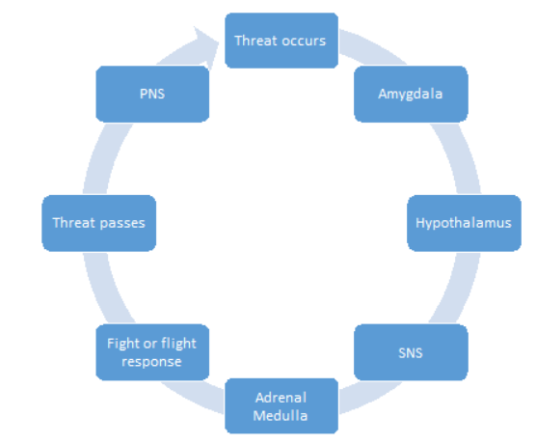A person enters a stressful or dangerous situation.

The **amygdala** (part of the limbic system in the brain which is responsible for the response and memory of emotions, especially fear) is activated and sends a distress signal to the **hypothalamus**.

The hypothalamus then activates the **sympathetic nervous system** via the sympathomedullary pathway (SAM pathway).

In turn, the SNS then sends a message to the **adrenal medulla** (part of the adrenal gland) which then secretes the hormone **adrenaline**.

Almost immediately, as number of physiological changes occur.

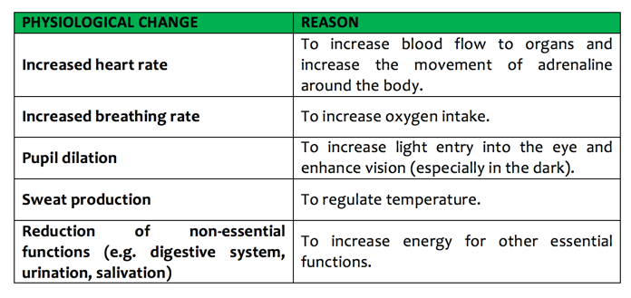

*For high grades (A*-B) you need to be able to describe this using key terminology, given in bold.*

Following the fight or flight response, the **parasympathetic nervous system**(‘rest and digest’) is activated to return the body back to its ‘normal’ resting state. Consequently, the parasympathetic nervous system slows down our heart rate and breathing rate and reduces our blood pressure. Furthermore, any functions that were previously slowed down are started again (e.g. digestion).

THE CHRONIC STRESS RESPONSE (ONGOING - CORTISOL)

If the brain continues to perceive something as threatening, the second system kicks in. As

the initial surge of adrenaline subsides, the hypothalamus activates a stress response system

called the HPA axis.

’H’ – The hypothalamus

The HPA axis relies on a series of hormonal signals to keep the SNS working. In response to

continued threat, the hypothalamus releases a chemical messenger, corticotrophin-releasing

hormone (CRH), which is released into the bloodstream.

’P’ – The pituitary gland

On arrival at the pituitary gland, CRH causes the pituitary to produce and release

adrenocorticotrophic hormone (ACTH). From the pituitary, ACTH is transported in the

bloodstream to its target site in the adrenal glands.

’A’ – The adrenal glands

ACTH stimulates the adrenal cortex (in the adrenal gland) to release various stress-related hormones, including cortisol. Cortisol is responsible for several effects in the body that are important in the fight-or-flight response.

Cortisol has some positive effects (e.g. a quick burst of energy and a lower sensitivity to pain) whereas others are negative (e.g. impaired cognitive performance and a lowered immune response).

**Sample questions**

1. The gland which releases Adrenaline is called the… (1 mark)
   1. Pituitary Gland
   2. Adrenal Gland
   3. Pineal Gland
   4. Hypothalamus
2. Outline the role of adrenaline in the fight-or-flight response. (3 marks)
3. Paul does not like rollercoasters. His mouth goes dry, his heart beats faster, and he sweats when in the queue waiting for the ride. With reference to the fight or flight response, explain why his body reacts in this way (4 marks)
4. Outline the fight-or-flight response. (6 marks)