Specified artist: Henri Matisse

“If I have succeeded in my painting in uniting the exterior with the interior world, it is because mthe atmosphere of the landscape and that of my room are one and the same” (Henri Matisse)

**TIMELINE**

1869 Born, Northern France

1891 Abandons career as a lawyer, studies at Academie Julian

1895 Studies under Moreau at the Ecole des Beaux Arts. Begins to paint en plein air.

1897 Discovers Impressionists

1900 With Marquet, paints the decorations for the Great Exhibition

1901 Exhibits at the Salon des Independents

1903: Exhibits at the first Autumn Salon with Rouault and Derain. Visits an exhibition of Islamic art

1904 First solo show at Vollard’s Gallery

1905 Exhibits at the Autumn Salon with Derain, Marquet, Vlaminck, Rouault and others, sparking the name Les Fauves, **Madame Matisse in a Hat**

1906 Travels to Biskra. Summers at Collioure. Meets Picasso and shows him African sculpture. **Joy of Life**

1908 Trip to Bavaria. First exhibitions in New York, Moscow and Berlin. Writes *‘Notes of a Painter’*

1909 Shchukin commissions **La Danse** and **La Musique**

1910 Major show at Bernheim-Jaune Gallery. **La Danse** and **La Musique** shown in the Autumn Salon. Travels to Munich with Marquet and sees Islamic exhibition.

1912 Winter in Morocco

1913 Winter in Tangier

1920 Designs the set and costumes for Stravinsky’s ballet *The Nightingale*

1922 Paints his series of **Odalisques**

1939 Leaves Paris on the outbreak of war and returns to Nice.

“What I am after, above all, is expression… Composition is the art of arranging in a decorative manner the various elements at a painter’s disposal for the expression of feelings.”

*Answer the following questions:*

1. When was he born?
2. Where did he complete his early artistic training?
3. Why did he move to Paris?
4. What was the name of the ‘proto-Fauvist canvas he completed in 1904?
5. List three influences for **Luxe, Calme et Volupte**?
6. And three for the **Joy of Life**?
7. Explain what changes in his technique between these works?
8. Now look at the **Souvenir of Biskra**. Where is Biskra?
9. [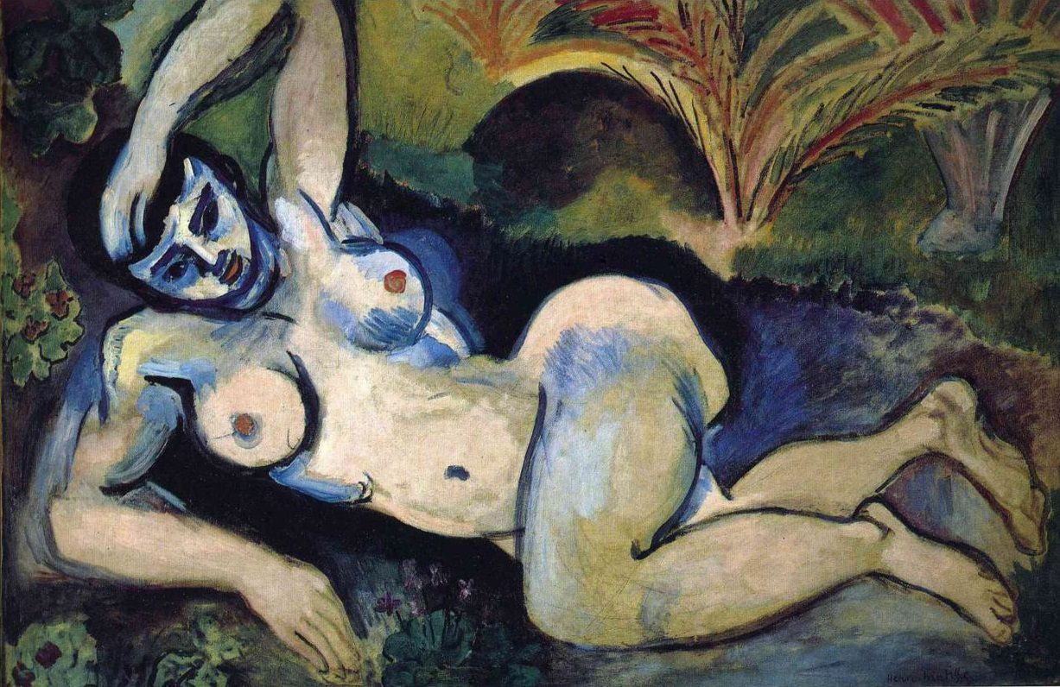](https://www.henrimatisse.org/images/gallery/blue-nude.jpg)What is the size of this work?
10. Why did Matisse go to North Africa?

Matisse, the bard of colour, and Picasso, the breaker of moulds: together the two shaped the world of modern art. Picasso called them “North Pole, South Pole”

Picasso

1. Now look at Cezanne’s **The Grand Bathers** (he painted a series of this subject, I suggest you focus on the one in the National Gallery, London and look at it at first-hand next time you are there.) Find three ways in which these works are similar – or that Matisse might have been influenced by Cezanne.
2. When did Cezanne die? What important event was organised to commemorate his contribution to painting in 1907?
3. Now list three ways in which **Souvenir at Biskra** demonstrates Matisse’s interest in the ideas and artefacts of ‘primitivsim’?
4. Now consider how and why **Souvenir at Bsikra** is revolutionary in the tradition of the representation of the female nude?
5. A version of this work was burnt as a protest at the New York Armory Show of 1913. Find one critical comment about this work which dates from this era. Why do you think the Americans found it so much more shocking than the French?
6. Chris Green explains the modernity of Matisse’s work as the shift between “a structured illusion on which nature is seen to a material surface on which coloured marks and drawn lines are disposed and it is the action of these on the spectator that any effect of light and space in nature is to be experienced.” *Rewrite this in your own words retaining a phrase of at least three words that will allow you to both understand and quote Prof Green.*
7. Now look at Matisse’s various paintings of goldfish. To which genre does this subject matter belong? But, how, obviously, does this simultaneously challenge the expectations of this genre?

Matisse ‘the king of the beasts (le roi des fauves)

Vauxcelles

1. How many works did he paint showing this subject? Why? What was the appeal?
2. [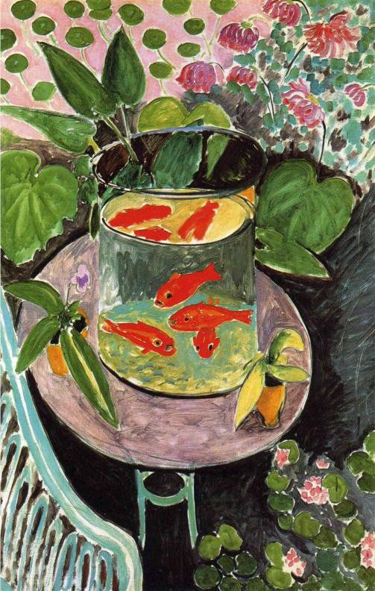](https://www.henrimatisse.org/images/gallery/goldfish.jpg)Look at the work from 1912 which we will include as one of our key works for this module. Annotate this image by listing the complementary colours and writing one sentence each about the composition, space and depth, light and tone and mark-making.
3. Find the size of this work.
4. 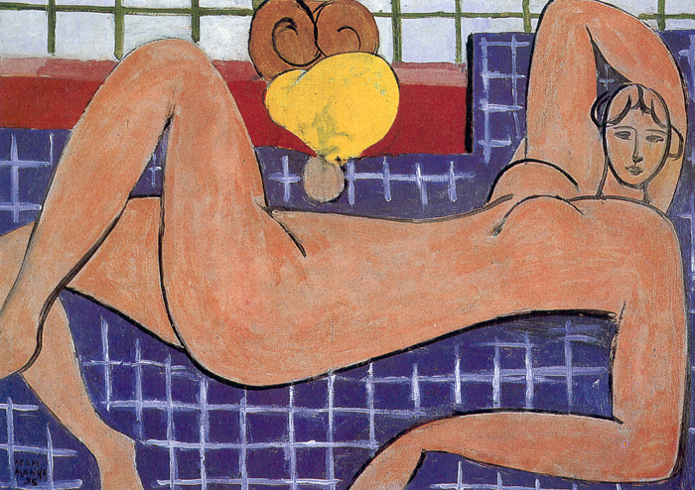This is Matisse’s Large Reclining Nude (sometimes called The Pink Nude) of 1935, which measures 66 x 92 cm. Actually, that means it’s not large at all – compare the size with Joy of Life or La Danse or La Musique for instance…… Throughout the post war years and through the 1920s, Matisse painted a series of paintings of the female figure, known as Odalisques.Look at some othese and note down how Matisse moves further in this work from the next decade.
5. Why do you think he paints her head disproportionately to her body?
6. What has happened to his ideas of space and depth here?
7. And light and tone?
8. As we have explored before, Matisse is known as he ‘king of the Fauves’. This style or movement is usually assumed to have finished by 1908, yet Matisse goes on working prolifically throughout the whole rest of our period (Please note that you may ONLY discuss Matisse’s work up to and including the year 1939 for this module. Later works – such as the cut-outs or the chapel at Vence will not earn you credit, so please do NOT use them!) If you had to find one (or more) labels to identify Matisse’s style/s after 1908, what would you choose? Give three with explanations:
9. Read and research what the critics say about Matisse and think about your own opinion as well as the discussions we have had in class. What do you think his biggest achievements were? Why do you think Matisse and Picasso are two of the biggest names of this era?

**Please make sure you read and watch the following:**

* From Honour and Fleming *A World History of Art*: p774-776 and p802-803
* All the relevant videos and articles on [www.smarthistory.org](http://www.smarthistory.org).
* The Art Story link here: <https://www.theartstory.org/artist-matisse-henri.htm>
* Matisse meets Picasso documentary: <https://www.youtube.com/watch?v=_b2eTU6fOEE>
* BBC Modern Masters series on Matisse with Alistair Sooke. The first episode is here: <https://www.youtube.com/watch?v=Ogn3t_OL9GE&list=PLM2eLesXIHiavBm2Nvr5rZm52XLEDV0MM> (Don’t go beyond Episode 6)
* Matisse ‘For me it’s always new’ Katie Hanson <https://www.youtube.com/watch?v=B7D08Qj3MvY> (lecture)