**Specified sculptor: Constantin Brancusi**

“The breakthrough for Brancusi came when he realised he wanted to be the opposite of Rodin. He wanted to be fully responsible for the final form of his work and how is sat in space, and his strength – unlike the additive modeller – was as a carver.” (Antony Gormley)

TIMELINE

1876 Born Hobita, Romania

1895 School of Arts and Crafts, Craiova and later the Bucharest Academy

1904 Joins Academie des Beaux Arts in Paris

1906 Showed in Salon d’Automne. Recognised by Rodin.

1908 The Kiss (limestone)

1912-3 Mlle Pogany

1909-10 Sleeping Muse (Carrera marble)

1915 Prodigal Son (wood)

1920 Sculpture for the Blind (veined marble)

1907-27 Sole studio in Paris

1928 Bird in Space (bronze)

1935 Targa Jiu ensemble: Endless Column, Gate of the Kiss and Table of Silence

“Direct carving was the true road to sculpture” (Brancusi)

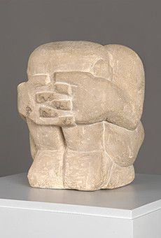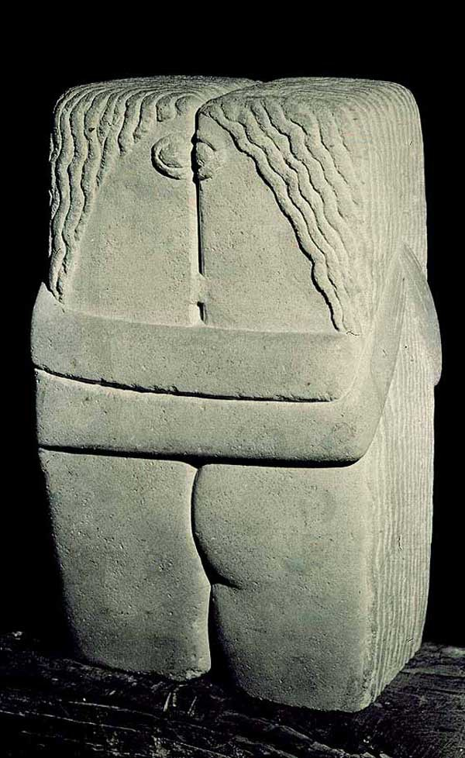[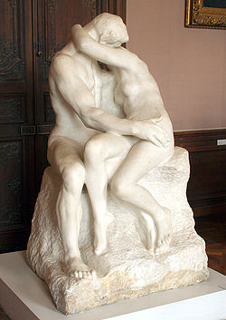](https://en.wikipedia.org/wiki/File:The_Kiss.JPG)1908 The Kiss

*Above:* Rodin **The Kiss** 1882 uses a mythological story to access a universal emotion. Notice how Brancusi strips away this layer of tradition, instead making something which is fundamentally both simple and profound – rudimentary and yet poignant. Also look at Derain **Sitting Man** 1907: *(right*) his search for volume and simplicity of ‘primitive’ (African art). Also influenced by Gauguin’s Retrospective at the Salon d’Automne and his awareness of the South Seas as a source of ‘the other’.

Both should be cited as influences on Brancusi at this stage.

1. Describe this work in your own words?
2. What size is it? Why is this significant?
3. How is limestone different to marble?

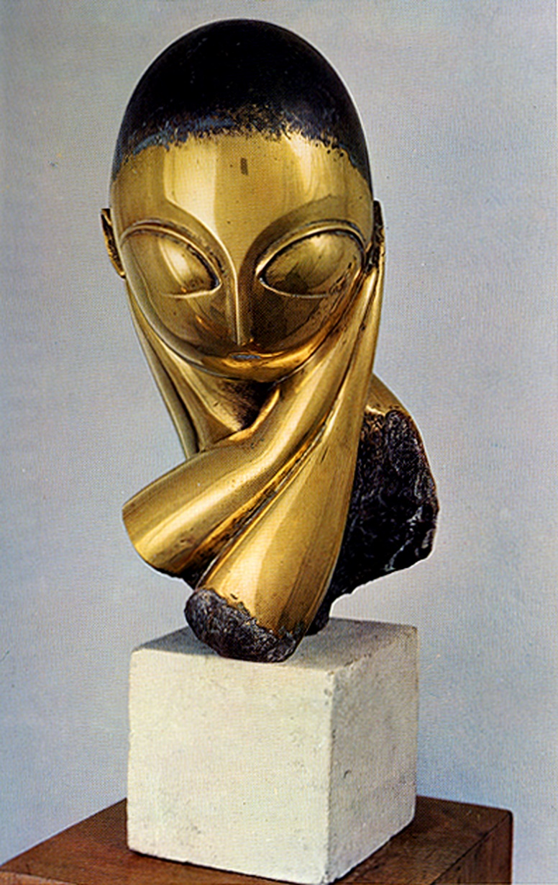Mlle Pogany 1913 (MOMA, New York)

This sculpture is a portrait of Margit Pogany, a Hungarian artist who sat for Brancusi several times in 1910 and 1911 while she was in Paris studying painting. Shortly after her return to Hungary, Brancusi carved a marble Mlle Pogany from memory, then made a plaster mold of the work, from which he cast four additional versions, including this one, in bronze. In representing its subject through highly stylized and simplified forms, the work was a significant departure from conventional portraiture. Large almond-shaped eyes overwhelm the oval face, and a black patina represents the hair that covers the top of the head and extends over the elaborate chignon at the nape of the neck. As with other motifs, this was a subject Brancusi would return to and rework in the years to come.

**From: Margit Rowell, from Constantin Brancusi 1876-1957 (1995), p.120.**

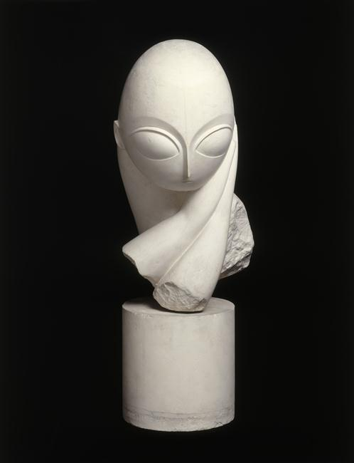Of all the works in Brancusi's first two American exhibitions (New York, Sixty-ninth Regiment Armory, International Exhibition of Modern Art {The Armory Show}, 1913; Chicago, The Art Institute of Chicago; Boston, Copley and Allston Hall, and New York, Gallery of the Photo-Secession, An Exhibition of Original Sculpture, in Bronze, Marble and Wood, by Constantine Brancusi of Paris [sic], 1914), Mademoiselle Pogany attracted the greatest attention. Its detractors likened it to a hard-boiled egg on a sugar lump; others, more enlightened, saw in it the finesse and technical perfection of a Chinese jade. The features that inspired the most comments were the nose (likened to a bird's beak by some critics); the enormous, bulbous, almond-shaped eyes; the delicate treatment of the ear; and the snake-like chignon.

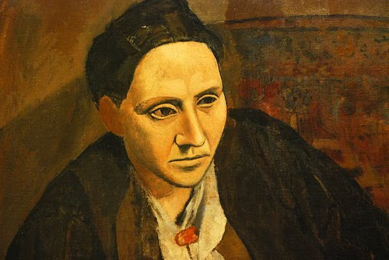The story of this motif, reworked in several variants by Brancusi over a long period of time has become legendary. The sitter was a Hungarian girl who had come to Paris to study painting; Brancusi first met her in 1910. After a number of visits to his studio, she asked him for a portrait and during her last two months in Paris, December 1910 and January 1911, she sat for him several times. The clay studies that he made in her presence were destroyed every time, though several drawings survive (see Philadelphia Museum of Art, 1947-88-10). After she returned to Hungary, he carved this marble portrait head from memory.

1. Select two brief quotes from this extract to use as Critical text references for this work:

Picasso: Portrait of Gertrude Stein 1905 notice the similarity of exaggerated almond shaped eyes…

1. Explore how this work functions as a portrait. (Think about composition, use of material, pose, gaze, gesture and the identity of Margit Pogany that is revealed….) You should write approximately 150 words.
2. Now write about this work again, but this time, exploring how it uses the interest in primitivism that was so popular at this time? What kind of ‘primitive’ artefacts is Brancusi interested and why? (again, write approximately 150 words)
3. Find some critical comment on this work? (You will find the American Armory Show of 1913 a good source of negative criticism!)

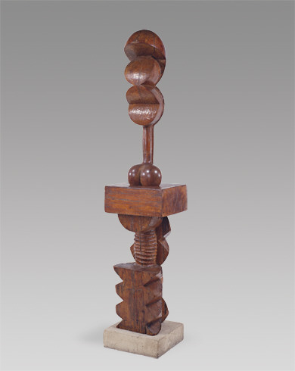https://d.adroll.com/cm/aol/out?advertisable=EFGV7GSZ3JGBJM23Z6QVORhttps://d.adroll.com/cm/index/out?advertisable=EFGV7GSZ3JGBJM23Z6QVORhttps://d.adroll.com/cm/n/out?advertisable=EFGV7GSZ3JGBJM23Z6QVORAdam and Eve 1921

Adam, the freestanding sculpture now becomes a socket for Eve. Adam is carved in oak and Eve is carved in walnut.  
Adam now has an allegorical meaning: the support the man is giving. Brancusi tries to ilustrate a belief from his village in Oltenia: that the man must be supportive of his woman.  
Eva is made of soft spherical shapes to convey sensualism, while Adam is made with zigzag edges.

1. Think about the use of wood and, specifically the use of two different woods for the figures here. How does this convey meaning?
2. What works have influenced Brancusi here? Make sure you are specific about both your attributions and how/where this influence can be seen?

[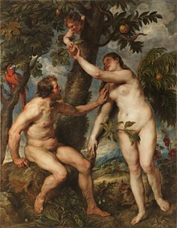](https://en.wikipedia.org/wiki/File:Peter_Paul_Rubens_004.jpg)

**Adam and Eve by Rubens,** 1628. Think about the significance of Brancusi’s choices here: why put one figure above the other, rather than show them adjacent?

1. Discuss the ways in which this sculpture draws on the interest in the ‘primitive’ at this time? (Please read this article: <https://smarthistory.org/the-reception-of-african-art-in-the-west/> )

In order to give yourself a wider understanding of Brancusi’s work, please also look up and download images of the following works:

* Bird in Space (Try this link: <https://smarthistory.org/constantin-brancusi-bird-in-space/> )
* The ensemble at Targu Jiu, Romania

1. Having looked at these works too, comment on **how** you think Brancusi’s art and style **develops** over the years between 1908 and 1935?
2. What do you think were the **most important influences** on Brancusi’s art and style over the years? (Make sure you explore at least three, giving specific details on how they have affected named works.)

Further watching and reading:

* On Mlle Pogany <https://smarthistory.org/constantin-brancusi-mlle-pogany/>
* On The Kiss: <https://smarthistory.org/constantin-brancusi-the-kiss/>