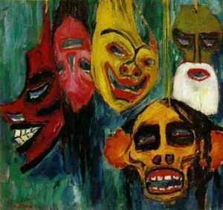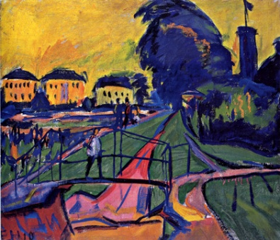German Expressionism: a quick summary

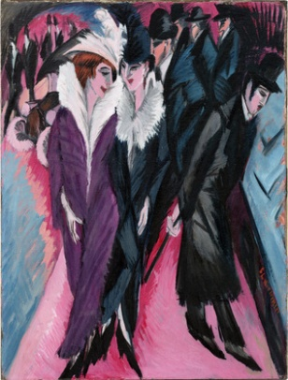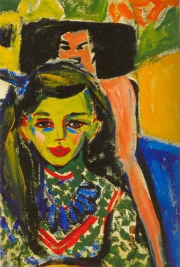Under influence of Frederick Nietzsche, a whole generation of writers and artists in central Europe was waiting for a violent change, their work exuding a heavy oppressive atmosphere of unease, guilt and foreboding. In literature, the works of Kafka demonstrate this. In painting, an increasing concern with contemporary psychology results in a new spontaneity and intensity of inner vision. Artists expressed their mood of anxiety, frustration and resentment with the modern world. Primitive art was primarily an emotional and spiritual experience – offering ideas of brutal simplicity and raw colours.

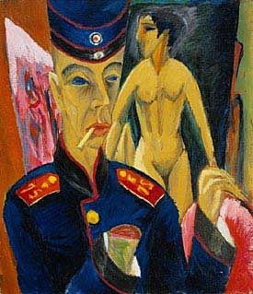The first organised group of German Expressionists was Die Brucke (The Bridge) formed in Dresden in 1905. The work of Munch was influential, particularly as he was living in Berlin during these years. The leader was Kirchner, who wrote “He who renders his inner convictions as he knows he must, and does so with spontaneity and sincerity is one of us.” The group was an avant-garde protest against academic naturalism and the conventions of a bourgeois German society.

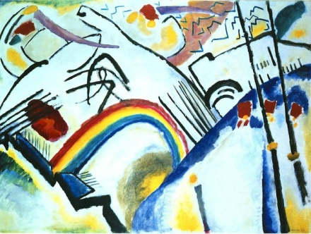The artists (Kirchner, Heckel, Nolde & Schmidt-Rottluff) met as architecture students in Dresden shared a workshop and the influence of Gauguin and the Post Impressionists together with Gothic angularity which sets their work apart from Fauvism. In 1911, the group moved to Berlin where their work becomes more political and an intense social critique in contrast to the more informal subjects of their early years. Kirchner became a soldier at the start of the war, and his psychological fears are conveyed in ‘Self Portrait as a Solider’ using many of the characteristics of German Expressionism.

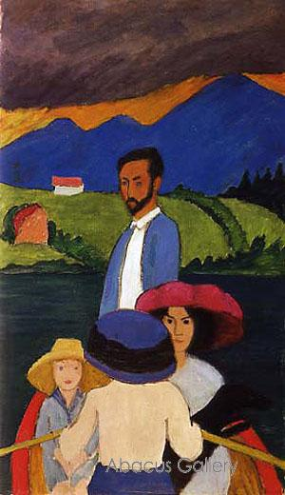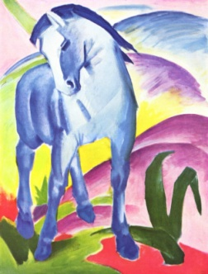The second group was Der Blaue Reiter (The Blue Rider) which formed in Munich between 1911-1916. These artists moved beyond representational art and, in their search for spiritualism, created some of the first completely abstract or non-objective works. Led by Kandinsky, they sought to strengthen the imaginative, emotional and spiritual content of their paintings. Kandinsky’s partner was Gabriele Munter and her work demonstrates the expressiveness of Fauve colour with simplified forms and strong, dark contour lines borrowed from folk and primitive art that are typical of German Expressionism. Another artist, Franz Marc believed that humans could experience closer affinity with nature through animals.

*Paintings from top:* **Heckel** ‘Landscape near Dresden’ 1910; **Nolde** ‘Masks’ 1911; **Kirchner** ‘Franzi in front of a chair’ 1910; **Kirchner** ‘Berlin Street Scene’ 1913; **Kirchner** ‘Self Portrait as a Soldier’ 1915; **Kandinsky** ‘Cossacks’ 1911; **Munter** ‘Boating’ 1910, **Marc** ‘Blue Horse’ 1911.