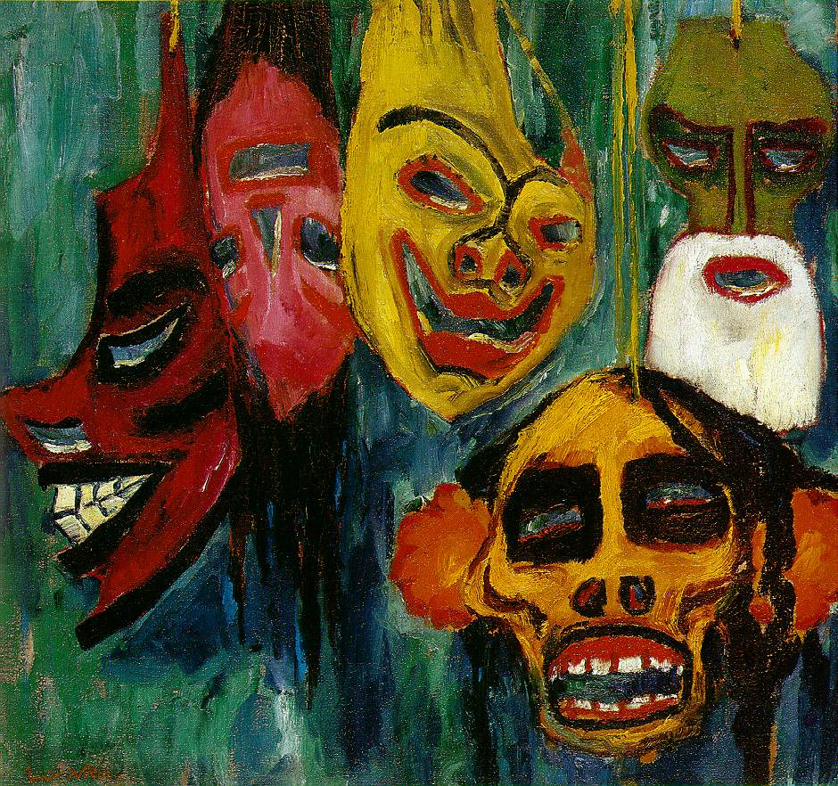‘Masks’ by Nolde, 1911

Oil on Canvas

73.03 by 77.47 cm

The Expressionist interest in primitivism and psychological unrest is clear in this painting, which is both disturbing and mysterious.

The masks hang from the top of the canvas, none taking a central position and the bright colours of drawing the eye to each face. Nolde does not seem to be breaking boundaries in terms of art and photography as perhaps the irregular composition would imply, he seems to do it for a far more dark reason. This painting has the feel of a hallucination, unreal and nightmare like which in relation to the impending war shows the horror and unrest that is expected. The swinging masks create the idea of a nightmare; with the blank eyes of the figures following the viewer from whatever angle it is viewed. It shows a direct, visual depiction of emotion which is heightened by the fast brushwork and expressive colour. The idea of non-Western masks and art can also be seen in Picasso’s ‘Les Demoiselles D’Avignon’, in which the masked women are aggressive and strong, and represent the power of women and primitivism. Nolde could also have influenced the Dada masks, which showed the loss of identity after the war.

The colours are typical Expressionist. Unlike the bright colours of the Fauves, the tones used by Nolde have a far more haunting feel to them. It shows the mystery and exoticism of the non-European art that he was inspired by and the dark, murky background allows the solid black to have real impact against the colours. The vivid colours of the masks don’t have the light, comfortable feel that they do in Fauvist works such as ‘Luxe, Calme and Volupte’ and this is in someway due to the more ominous background, the disturbing subject matter and the influence of more primitive art.

The masks are from Carnivals and the one on the far left was inspired by a Solomon Islands canoe prow. The mask at the lower right depicts the shrunken head of a Yoruna Indian from the Mundurucu people of Brazil. This work has an intensity of feeling and emotion, and the spontaneous brush handling heightens the energy. The strong, loose strokes create the feeling of movement, as if the masks are swinging towards the viewer, out of the darkness. Nolde wanted to show the ‘grotesque expression of power’ and ‘elemental force’. These faces do seem to have power over the viewer; they are threatening and their nightmarish make one feel vulnerable. The crowded nature of the canvas also creates the idea of over-crowding, and isolates the viewer in their hellish dream.