‘Street, Berlin’ Kirchner 1913

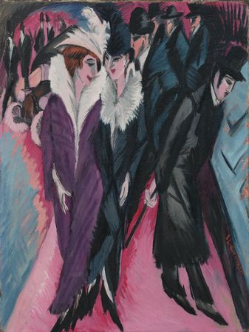This painting is from Kirchner’s famous collection of street paintings. He is influenced by the vibrant metropolis of the city, rebelling against the traditional Hapsburg bourgeoisie and stagnated society that restricted expression. The dramatic and modern atmosphere of the city is exaggerated through the dramatic lines and jagged, angular shapes along with acute perspective and menacing colour.

**Composition:** Kirchner’s ‘Street, Berlin’ is depicts a crowded street scene in which the men are dressed completely in black, depicted smaller and more bent, they lack individuality. This compares to the striking and dynamically posed women at the forefront of the painting. They appear with large fur coats and plumed hats identifying them as prostitutes. The women at the very front is turning her body towards the left of the painting, dramatically in contrast the direction the pink ground beneath her his turning. The jagged lines towards the front of the painting cause the picture to appear to be falling towards the viewer, yet there is a lack of a receding horizon which pushes the depiction forward and pushes the composition forward, relevant to the imminent danger of war felt in 1913 Germany.

**Perspective:** The perspective in this painting is irregular and sharp, exaggerated by the dramatic lines and jagged edges. The forefront of the painting appears to be tipping towards the viewer as the pointed feet of the figures appear to touch the frame directly in front of the viewer, the brightness of the pink at the base pushing the darker forms of the figures further towards the viewer.

**Colour:** Although the colours are bright purples and pinks, this enhances the menacing black of men’s clothing as well as well as the sharp, jagged outlining. The deep purples remind the viewer instead of dusk, the sun setting and therefore a sense of impending danger and doom. In the background the dark lines and the purples swirl together also creating a sense of confusion and multiple cosmopolitan.

**Brushanderling:** Within the painting are defined brushstrokes which enhance the angular from of the irregular shapes. They also create a sense of drama and vividness. They are also attributing to the primitivism and vivacity of the painting, causing it to seem more deliberate and menacing.

**Context:** Painted shortly after the turn of the century, and a year before the outbreak of World War One this painting captures the modern metropolis way of life as well as the vivacity of a city pulling away from the bourgeoisie of the past. The dark and purple also are subjective of the tension and imminent doom from the threat of war. Kirchner painted a series of street scenes between 1913 and 1915 depicting the decadence and vitality as well as danger of Berlin at this time. The painting all feature women wearing plumed hats that particularly caught the artist’s eye as it identified them as prostitutes. Kirchner and many of his fellow Expressionists were trained as architects rather than as artists and this is shown through the angular and primitive forms of their work.