Salvador Dali- Persistence of memory (1931)
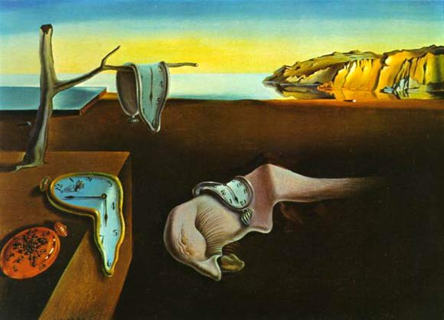

The surrealistic piece introduced the image of the soft melting pocket watch.
It epitomizes Dali’s theory of 'softness' and 'hardness', which was central to his thinking at the time.
The melting watches symbolize the irrelevance of time, and suggest Einstein's theory that time is relative and not fixed.
The orange clock at the bottom left of the painting is covered in ants. Dali often used ants in his paintings as a symbol for death, as well as a symbol of female genitalia.

The figure in the middle of the picture symbolizes a fading creature, often when you dream you cannot pin-point the exact form of a creature. The creature resembles the artist's own face in profile; its long eyelashes seem insect-like or even sexual. The iconography of this painting is of a dream that Dali had experienced. Freud's work with free association, dream analysis and the hidden unconscious was of the upmost importance to the Surrealists in developing methods to liberate imagination.
Dali called it one of his “hand-painted dream photographs”

The aim of surrealism was to free artists from the normal association of pictorial ideas and from all accepted means of expression, so that they might create according to the irrational dictates of their subconscious mind and vision. This being a depiction of a dream means that it is an image from his subconscious.

The painting is a combination of everyday and the dream-like, the symbolic and the irrational, nature and technology. The painting can be seen as a landscape, still-life and a portrait painting.

The piece is realistic in the style of the painting, which relates to surrealism (over- real), however there is a juxtaposition in the elements included in the painting, and the melting of clocks is very unrealistic. The colours are realistic, however slightly idealised and heavenly in the background, this links to the subconscious and it being dream-like. Generally there is not much use of shadow in the painting, so there is a lack of a solidity which gives it an other-worldliness. The only shadow is of the tree, which appears to be rooted into the table-top, this is an un-natural thing.

