Futurism: key facts

What?

* Not solely concerned with Art, less a style than an ideology.
* Exhilarated by the noise, speed and mechanical energy of the modern city, Marinetti wanted to obliterate the past “Burn the museums, drain the canals of Venice” and replace it with a new society, new art and new poetry based on new dynamic sensations.

WHO?

* Led by poet FT Marinetti.
* Key painters: Umberto Boccioni; Gino Severini; Carlo Carra; Giacomo Balla, Luigi Russolo and, further afield, influenced work of Joseph Stella in USA.
* In sculpture: Boccioni again & influenced Raymond Duchamp-Villon (brother of Marcel) too.
* In architecture: Antonio Sant’ Elia.

WHEN?

* 1908 FT Marinetti published Futurist Manifesto in Milan.
* 1909 Same manifesto published in Paris in 1909 taking it to an international audience.
* 1910 Manifesto of Futurist Painting published.
* 1911 Futurist Exhibition in Milan. Futurist artists travel to Paris.
* 1912 Technical Manifesto of Futurist Sculpture published.
* 1912 Futurist exhibition at the Bernheim-Jeune Gallery in Paris, then across Europe.
* 1913 Futurist Exhibition moves to Chicago. Marinetti lectures in Moscow.
* 1916 Movement ended during First World War when Boccioni was killed.

WHERE?

* In Milan, Italy first
* Then Paris
* Then internationally

6 key works

* Balla ‘Dog on a Leash’ 1912
* Boccioni ‘City Rises’ 1911
* Boccioni ‘States of Mind: Farewells’ 1911
* Boccioni ‘Unique Forms of Continuity in Space’ 1913
* Carlo Carra ‘Funeral of the Anarchist Galli’ 1911
* Joseph Stella ‘Battle of Lights Coney Island’, 1913

Summary

* Unlike other modern art movements, Futurism started in words rather than from a search for a new artistic language. It some ways it was the most radical: rejecting all traditions, spreading internationally from London to Moscow and across to the USA. It started in Italy (rather than Paris) and was short lived. It chose its own name – rather than being given a name (derisively) by the critics like Fauvism and Cubism.
* Marinetti had hesitated between Dynamism, Electricity and Futurism as the name for his movement. Shift into the arts, came with the Manifesto of Futurist Painters which demanded a new art for a new world and denounced every attachment to the arts of the past.
* In July 1910, Boccioni showed 42 works in Venice which were quite well received by critics, but did not strike anyone as revolutionary – showing the gap between the ideas and the visual translation. Subject matter was urban and violent, but methods quite traditional.
* First major Futurist showing: Milan 1911 included Carra’s ‘Funeral of an Anarchist’: again subject matter is futurist, but methods traditional. Criticism of this by Soffici resulted in violence – he was attached by Carra, Boccioni and Marinetti outside a cafe!
* At this point, Severini returned from paris and encouraged others to go north and see new work in France. Introduction to Picasso and Braque was highly influential and they began to include fragmentation in their work. Main difference is in their emphasis on action and rejection of static compositions in favour of ‘simultaneity’.
* Boccioni’s Manifesto of Futurist Sculpture encourages the inclusion of all sorts of materials in sculpture in an effort to rid it of its stifling jungle of bronze monuments. Same time as Picasso reaching similar ideas in his cubist sculptural experiments.
* Architect, Antonio Sant’ Elia brought building into Futurist sphere. Showed drawings under title ‘The New City’: proposed a new kind of city designed without reference to historical styles, but in accord with new materials and structural inventions of engineering. Searched for an architecture that “permitted the greatest elasticity and lightness”.
* Sant’ Elia and Boccioni both killed in 1916, in the war that they had claimed was “the world’s only hygiene”.
* Influence was fundamental and of long importance although movement was short.

Useful quotes

* “We declare that the splendour of the world has been increased by a new beauty: the beauty of speed.” (Marinetti)
* “A work that is not aggressive in character cannot be a masterpiece.” (Marinetti)
* “We shall sing the voracious stations devouring their smoking serpents.. the broadbreasted locomotives that paw the grounds of their rails like enormous horses of steel harnessed with tubes.” (Marinetti)
* “A figure is never stationary.... but appears and disappears incessantly.” (Boccioni)
* [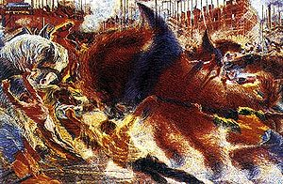](http://en.wikipedia.org/wiki/File:Immagine-Umberto_boccioni_la_citt%C3%A0_che_sale.jpg)“Our bodies enter into the sofa on which we sit, and the sofas enter into us, as also the tram that runs between the houses enters into them, and they in turn hurl themselves on to it and fuse with it.” (Boccioni)
* [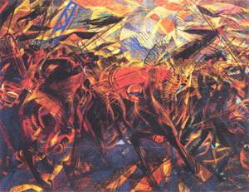](http://en.wikipedia.org/wiki/File:Funeraloftheanarchistgalli.jpg)“We want to represent not the optical or analytical impression, but the psychical and total experience.” (Boccioni, 1911)
* “Let us.... discard the finite line and.. closed form statue, let us tear the body open and let us include its surroundings in it” (Boccioni, Manifesto of Futurist Sculpture)

Influences

* Colour divisionism of Neo-Impressionists
* At beginning, did not know art of Paris and Northern Europe: admired Segantini and Previati.
* 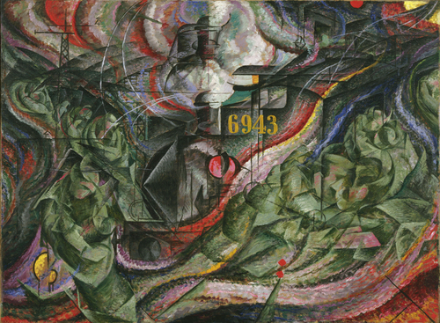Read Nietsche and Bakunin.
* After 1911, Cubist experiments of Picasso and Braque become important, as Futurist artists join cubist fragmentation to their existing colour divisionism.
* Photographic work of Muybridge and Marey.
* (Futurist typography and hell raising seems often very close to Dada)

*Top to Bottom:*

* **Umberto Boccioni** ‘City Rises’ 1911
* **Carlo Carra** ‘Funeral of the Anarchist Galli’ 1911
* **Umberto Boccioni** ‘States of Mind: Farewells’ 1911
* **Umberto Boccioni** ‘Unique Forms of Continuity in Space’ 1913
* **Joseph Stella** ‘Battle of Lights Coney Island’, 1913
* **Giacomo Balla** ‘Dog on a Leash’ 1912
* **Boccioni ‘**Charge of the Lancers’**, 1915**

