[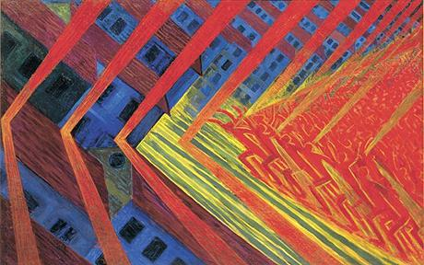](http://www.google.co.uk/url?sa=i&source=images&cd=&cad=rja&docid=JeF0Ucu8qp4xkM&tbnid=gigD8layBW3TBM:&ved=0CAgQjRwwAA&url=http://www.telegraph.co.uk/journalists/richard-dorment/5542683/Futurism-at-the-Tate-Modern-a-glimpse-into-tomorrows-whirl.html&ei=HzVhUv_DHIWl0QX6wIDYDg&psig=AFQjCNF0ywbidmaAnm7oo_ZldNwivyPolQ&ust=1382188703511279)Describe and comment on three works of art, each by a different artist, explaining how they are associated with Futurism.

* AO1 Detail
* AO2 Argument
* AO3 Language/organisation
* AO4 Context

Futurism (1908-1915) was an Italian ideology as well as an artistic movement. It was explained by Marinetti in his 1908 Manifesto which was published in both Paris and Milan. He saw it as an essential requirement of modern life to throw off the shackles of the past and to celebrate the progress of the modern age with its achievements of speed, dynamism and machinery. Essentially aggressive in tone, Marinetti (himself a poet and philosopher) set down the ideals of the movement but the key players (Boccioni, Carra, Balla, Russolo& Severini ) each brought their individual approach to the style. Thus analysis of the subject matter; composition; colour; brushhandling and perspective can reveal how each work is associated with Futurism.

Russolo’s ‘The Revolt’ shows a crowd of angry people advancing from the right hand side towards the town on the left. Sound waves emanate from the mob, hitting the town before the people. This is typically Futurist in its aggression and action and illustrates Marinetti’s belief that “war is the world’s only hygiene.” The composition of this work is asymmetric with a very strong diagonal thrust from right to left. The painting is further unbalanced by the tilting angle of the houses giving the viewer the sensation of space tipping in on itself. This shows Russolo’s personal approach to Futurism which was closely linked to his work on music and atonal harmonies.

Russolo uses only primary colours for this work. The sound is shown in red chevrons as are the mob, while the houses are largely blue. The confrontational space between them is lit by yellow which acts to highlight the imminent clash. This use of strong colours is typical of much Futurist work because the complementary tones set up an expectation of conflict. Russolo is more extreme than either Balla or Carra here, possibly because the strong colour matches the emphatic linear structure of his composition. The brushhandling is also different from his peers (many of whom used a divisionist or facetted approach). Russolo’s brushhandling is fine so that visible strokes do not disturb the focus from the conflict.

Finally, Russolo’s shows a world with an almost flat surface. He has totally rejected the academic laws of the past and ignores ideas of linear or atmospheric perspective. The high viewpoint thrusts the viewer into the middle of the scene emphasising the chaos. This is a perfect evocation of Marinetti’s suggestion that the Futurists wanted “to burn the museums and drain the canals of Venice.