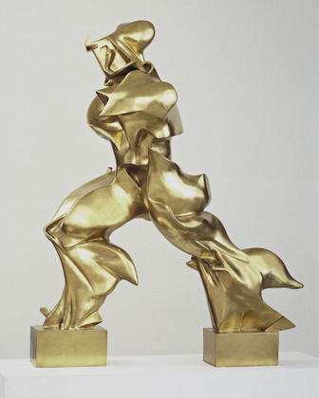Umberto Boccioni

‘Unique Forms of Continuity in Space’ 1913

1. Describe the ‘face’ of the figure with as much detail as possible in a single sentence.
2. In what way(s) does Boccioni’s choice here, illustrate his association with Futurist movement?
3. Identify three different ways in which Boccioni conveys the idea or suggestion of movement in this work?
4. Match each of these to an appropriate Futurist aim or quote.
5. 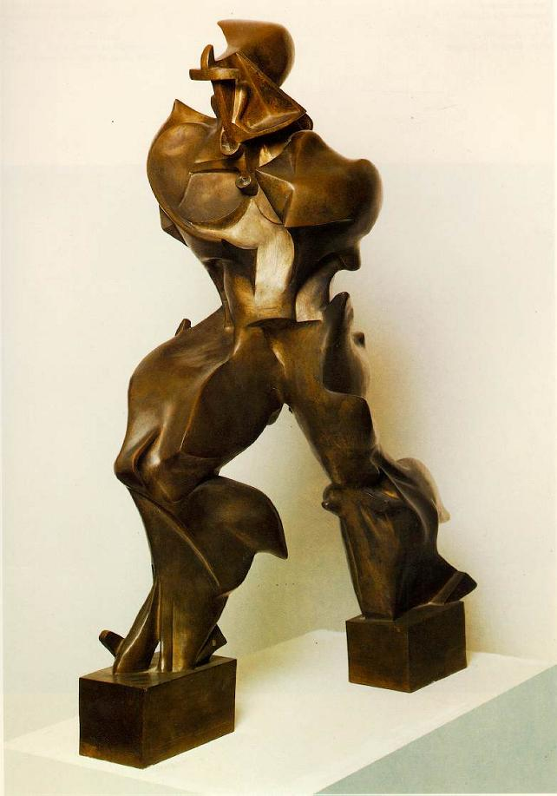Look at the image below of the ‘Victory of Samothrace’. In what ways, is Boccioni referencing this figure?
6. What did Marinetti say about the ‘Victory of Samothrace’?
7. What material was this work originally made in? When was it cast in bronze - and how does this possibly challenge/subvert the aims of the Futurists?
8. What written work did Boccioni publish in 1912? What intention or aim from this booklet is achieved in this work?
9. 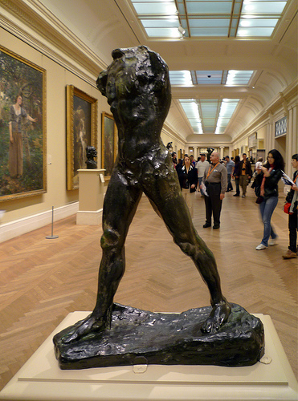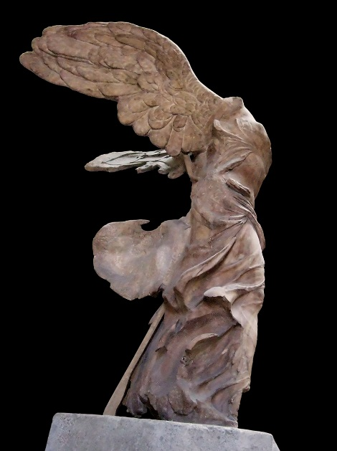The image on the bottom right is Rodin’s ‘Walking Man’. Where could Boccioni have seen this (and when)? Why is this relevant here?
10. Explain how this vision of man is modern?