

NAME:

Ancient History

**Period Study: Relations Between Greek States and Between Greek and Non-Greek States, 492-404 BC**

**INTRODUCTION**

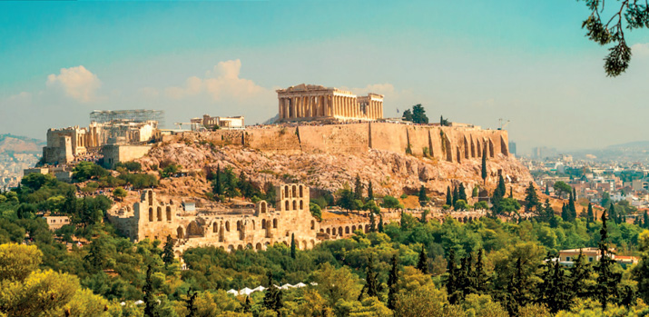

***Aims of this Booklet:***

* Introduce the Ancient History AS/A level course
* Introduce the Greek period study and its methods of assessment
* Understand the background of Greece and Persia before 492
* Familiarise you with the type and range of resources you will be using

**Introduction to the Course**

|  |  |  |  |
| --- | --- | --- | --- |
| **Greek Period Study** | **Relations between Greek and Between Greek and Non-Greek States, 492-404 BC** | ***A Level*** | ***AS*** |
| **25%** | **50%** |
|  |  |  | |
| **Roman Period Study** | **The Julio-Claudian Emperors, 31 BC-AD 68** | ***A Level*** | ***AS*** |
| **25%** | **50%** |
|  |  |  | |
| **Greek Depth Study** | **The Politics and Culture of Athens, c. 460-399 BC** | ***A Level*** | |
| **25%** | |
|  |  |  | |
| **Roman Depth Study** | **Ruling Roman Britain, AD 43-c.128** | ***A Level*** | |
| **25%** | |

In the first year of your Ancient History A level you will study two **period studies**, one **Greek** and one **Roman**. These are designed to give you a broad understanding of a period of ancient history so that you can see how relations between Greeks and their neighbours, and how the Roman Empire, developed and changed over time.

Both studies will get you looking at a wide variety of **primary sources** to help build you own knowledge of the period. These sources are written and archaeological and you will be tested on your understanding of them in the exam.

Those taking the **AS qualification** in Ancient History will take the two period studies as final exams in May/June of their first year. Students taking the **A level qualification** will take these as mock exams in their summer term and will have final exams in all four topics at the end of their second year at college (this is called a ‘linear’ course).

To gain the best understanding possible of the topics and sources being studied you are, from the start, encouraged to **read and investigate beyond the materials given to you in class**. This is the best way to strengthen your grasp of the content and to extend your interest. A good place to start is the college’s library (ILC), which has a growing selection of Ancient History books and resources. Online source such as [www.historytoday.com](http://www.historytoday.com) is also a good place to look for articles on both Greece and Rome.

In addition to any extension reading outside of class, there a number of things you can do to ensure you use class time as effectively as possible:

* Attend all lessons and make sure that you are on time
* Complete any homework set for the lesson given
* Listen carefully to the views and ideas of others
* Ask any questions or seek out any help that is needed (making full use of lunchtime help sessions)

**The Exam**

As you start the course you do not need to worry too much about the final exams and you will be taught the technique needed to answer questions as we go on. You will also have lots of occasions to practice these questions. At this stage it is good to have a sense of what types of questions you will be asked and the type of skills you will develop.

**AS Level:**

***Section A*** –

* One 10 mark question
* One 20 mark question based on primary sources

***Section B*** –

* One 30 mark essay from a choice of two

**A Level:**

***Section A*** –

* One 30 mark essay using own knowledge and primary sources from a choice of two
* One 20 mark question analysing a historian’s views based on your own knowledge and primary sources

***Section B*** –

* A 12 mark question and a 36 mark essay based on your second year Greek unit

*For past and sample papers go to the OCR website of the Ancient History section of Godalming Online.*

**ANCIENT HISTORY LUNCHTIME SUPPORT**

**If you need any help in Ancient History to go over content, complete homework, attempt assessed questions or prepare for exams, there will be a lunchtime support session each Wednesday between 1 and 2 pm in room 211.**

**Suggested Reading**

**History Today Articles (go to** [www.historytoday.com](http://www.historytoday.com) **username= Godalming; password= history)**

# **Re-running Marathon**

By [Barry Baldwin](http://www.historytoday.com/author/barry-baldwin)

Published in [History Today](http://www.historytoday.com/archive/history-today/latest) [Volume 48 Issue 5 May 1998](http://www.historytoday.com/archive/history-today/volume-48-issue-5-may-1998)

# **Herodotus: A Historian for All Time**

By [Paul Cartledge](http://www.historytoday.com/author/paul-cartledge)

Published in [History Today](http://www.historytoday.com/archive/history-today/latest) [Volume 63 Issue 10 October 2013](http://www.historytoday.com/archive/history-today/volume-63-issue-10-october-2013)

# **Herodotus**

By [Russell Meiggs](http://www.historytoday.com/author/russell-meiggs)

Published in [History Today](http://www.historytoday.com/archive/history-today/latest) [Volume 7 Issue 10 November 1957](http://www.historytoday.com/archive/history-today/volume-7-issue-10-november-1957)

# **The Battle of Marathon: An Essay in Historical Detection**

By [Stuart E.P. Atherley](http://www.historytoday.com/author/stuart-ep-atherley)

Published in [History Today](http://www.historytoday.com/archive/history-today/latest) [Volume 2 Issue 7 July 1952](http://www.historytoday.com/archive/history-today/volume-2-issue-7-july-1952-0)

# **Herodotus and the Strength of Freedom**

By [Irene Brown](http://www.historytoday.com/author/irene-brown)

Published in [History Today](http://www.historytoday.com/archive/history-today/latest) [Volume 31 Issue 2 February 1981](http://www.historytoday.com/archive/history-today/volume-31-issue-2-february-1981)

**Textbooks**

* C. Cottam, D. Hodgkinson *et al*, *OCR Ancient History, Component 1: Greece*, Bloomsbury, 2017

**Books in the ILC**

* J. T. Roberts, *The Plague of War: Athens, Sparta and the struggle for Ancient Greece,* Oxford, 2017
* J. Ober, *The Rise and fall of Classical Greece*, Princeton, 2016
* R. Garland, *Ancient Greece: everyday life in the birthplace of western civilisation,* New York, 2013
* R. L. Fox, The Classical World, Penguin, 2006
* P. Cartledge, *Ancient Greece: A very Short Introduction*, Oxford, 2011
* J. Boardman, *The Oxford History of Greece & the Hellenistic World*, Oxford, 1986

**eBooks on** [**www.dawsonera.co.uk**](http://www.dawsonera.co.uk)

* G. Cawkwell, *The Greek Wars: The Failure of Persia*, Oxford, 2005
* P. Rhodes, *A History of the Classical Greek World 478-323 BC*, Wiley-Blackwell, 2009
* P. Cartledge, *After Thermopylae,* Oxford, 2013
* Powell, *Athens and Sparta,* Routledge, 2016
* P. De Souza, *The Greek and Persian Wars 499-386 BC*

**Useful Websites**

<http://www.ancient.eu/>

<http://ancient-greece.org/index.html>

[www.ocr.org.uk](http://www.ocr.org.uk)



*For help in accessing the ebook catalogue on dawsonera, go to the ILC’s page on Godalming Online and read their guide to accessing ebooks.*

*Ebooks can be read using your college log on details whilst in college or at home.*

**The Greek Period Study Overview**

**Relations between Greek States and Between Greek and Non-Greek States, 492-404 BC**

*“This period study will focus on the unfolding narrative of the relations between the Greek city-states, particularly Athens and Sparta, and between Greek city-states and the Persian Empire during the period 492–404 BC.”*

**Introduction to the course and to Ancient Greece**

* Structure of Course and assessment
* Map work on Ancient Greece, key terms/tribes

**Topic 1: The Challenge of the Persian Empire, 492-479 BC**

* Introduction to Herodotus
* Darius’ Policy Towards the Greeks
* First Persian Invasion, Battle of Marathon
* Second Persian Invasion – Persian and Greek Preparations, conflict
* Historical Debate – why were the Greeks successful?

**Topic 2: Greece in Conflict, 479-446 BC**

* Introduction to the sources – Thucydides, Diodorus, Plutarch
* Consequences of the Persian Wars
* First Peloponnesian War

**Topic 3: Peace and Conflict 446-431 BC**

* The Peace of 446 – balance of power
* Causes of War in 431
* Historical Debate – The Causes of the Peloponnesian War in 431

**Topic 4: The Archidamian War, 431-420 BC**

* Athenian and Spartan Strategies
* Course of the war
* Peace of Nicias

**Topic 5: The End of the Peloponnesian War and its Aftermath, 419-404 BC**

* Breakdown of relations
* Course of the war – Sicilian Expedition
* Occupation of Decelea
* Persian Involvement
* Historical Debate – Why did Athens fail in the Peloponnesian Wars?

**Ancient Greece – Some Basic Ideas**

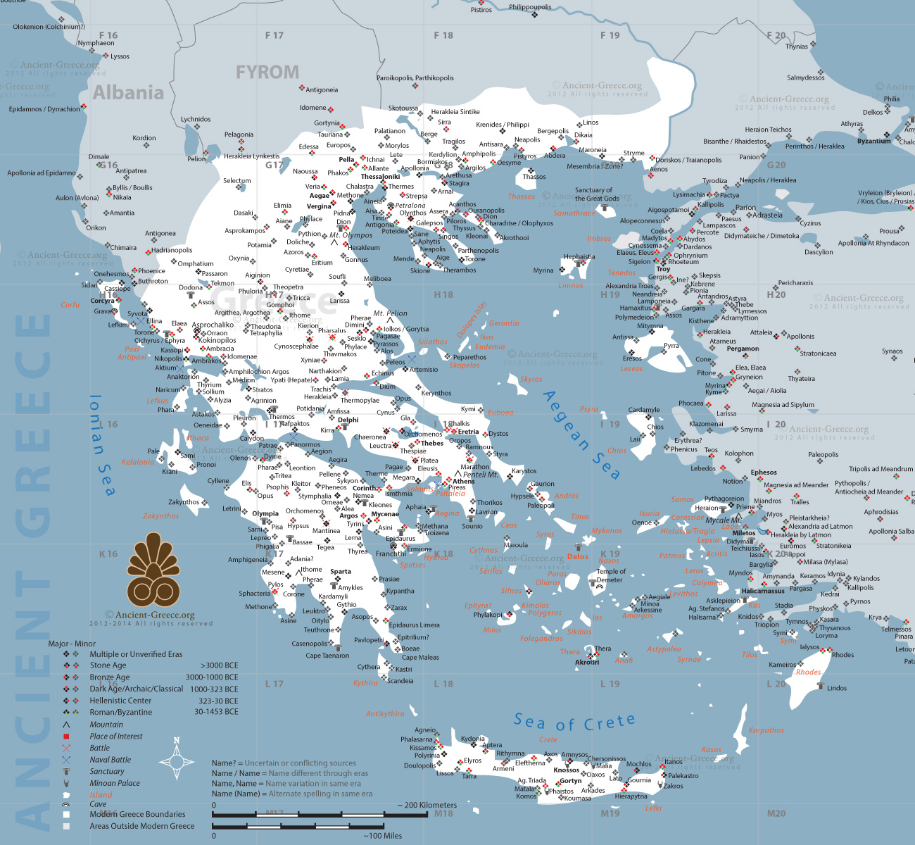

* At the start of our period (492) there was no such thing as a single ‘Greece’ as we would understand it today
* Instead modern-day Greece was made up of over 1,000 ‘city states’ each known as a ***polis***
* Each *polis* was, in theory, independent and self-governing, and had its own unique government, culture and society
* These city-states and their inhabitants did, however, share a common identity and would have called themselves *Hellenes* and the area they lived in *Hellas*. They shared the same religion and language, and similar cultures and ways of fighting
* The ancient Greeks referred to non-Greeks as ‘barbarians’ as they thought that when they spoke it sounded like ‘*bar-bar’* or gibberish
* The Greeks were confident that anyone from the outside was inferior to them.

***TASK -***  find and highlight the following city-states on the map opposite: **Athens, Sparta, Corinth, Argos, Thebes, Megara** and **Miletus**

**Ancient Greece – Some Basic Ideas cont.**

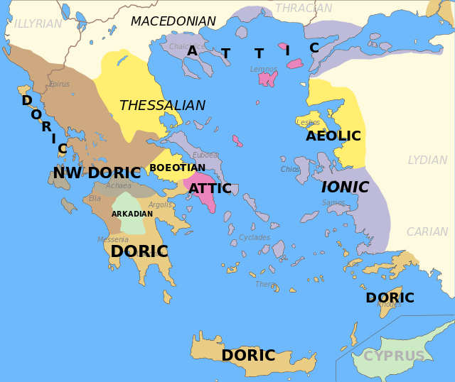

Ancient Greek history can be divided into four main periods:

**The Greek Dark Ages,** 1200 BC – 800BC

The period between the collapse of the Mycenaean civilisation and the rise of Greek city states. It is called the ‘Dark Ages’ because **literacy** was lost and there are no surviving written sources which survive from this period so evidence is archaeological. During this period Greeks began to work and use iron.

**The Archaic Period,** 800 BC – 479 BC

A period of growing population that saw tremendous change in Greek language, society and politics. The ***polis***or ‘city-state’ began to emerge as the centre of Greek life and there would come to be over 1,000 *poleis* (e.g. Athens, Sparta, Corinth, Thebes). The main form of government during this time was rule by a **tyrant.** It was also a period of **colonisation** as Greek city-states expanded their power over the Mediterranean. The Archaic Period included the **Persian Wars** and would end with the final Greek victory over the Persians in 479 BC.

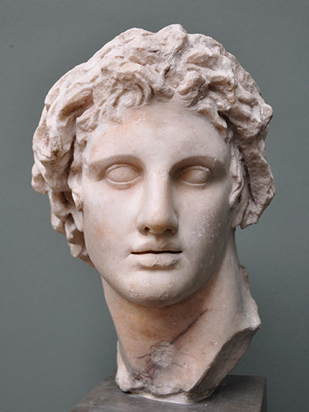**The Classical Period,** 510 BC – 323 BC

This is the best documented period of Ancient Greek history and for many starts with the overthrow of the last Athenian tyrant in 510 and the establishment of democracy in 508 BC. Following victory over the Persians, Sparta and Athens emerged as the most powerful city-states and a golden age of art, literature and architecture began. However, the Classical Period also saw the destructive **Peloponnesian Wars** which ended in Athens’ defeat. The period ended with the rise of Macedonia as the dominant period under **Alexander the Great**

**The Hellenistic Period,** 323 BC – 31 BC

Following the death of Alexander the Great the Greek world was divided between larger kingdoms usually ruled by one person. This saw a decline in the idea of the city state and the Greek world declined until it would be taken over by the Roman Empire.

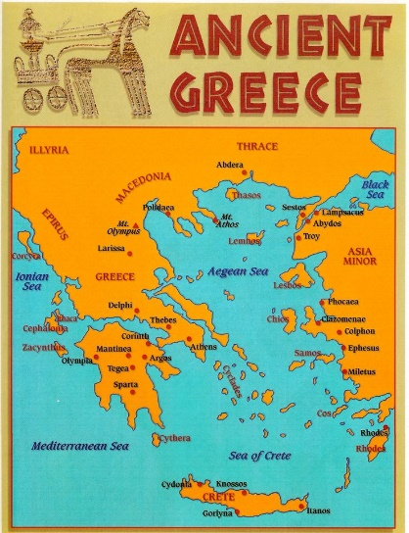**Ancient Greece – *Hellas***

As you watch the 10 minute introduction to Ancient Greece ([www.youtube.com/watch?v=gZ7cPAnO4po](http://www.youtube.com/watch?v=gZ7cPAnO4po)) provide brief answers to the following questions:

(Don’t worry about adding too much detail, just record key words or ideas)

1. What was ancient Greece centred around?
2. Due to the importance of the sea to Greeks, what two things became significant?
3. What is the name of the region Sparta was located in?
4. What is the name of the region Athens was located in?
5. Give two examples of things that made Ancient Greeks view themselves as part of one ‘Hellas’
6. What three periods made up iron-age Greece?
7. Which city states fought the devastating Peloponnesian Wars?
8. Give two reasons why we know so much about iron-age Greece

**Ancient Greece – Some Basic Ideas**

**Research Task**

**TASK:** working in groups of 2-3 you will prepare a PowerPoint presentation introducing yourself and the rest of the class to one key idea or place of the ancient Greek world. Your group’s presentation will include images and information on your topic and needs to be clearly presented so that others can take notes as you present. Spend a minimum of 20 minutes researching your topic and making separate notes before then producing your PowerPoint.

Your Power Point can be a maximum of **3 slides** so be selective about what you include – you can’t talk about everything so choose the most important information you want to pass on.

|  |  |  |
| --- | --- | --- |
| **Topic Area** | **Things to Include** | **Suggested Resources** |
| **The Polis** | * Definition * Idea of how/when developed * The Agora * Significance | The following are good websites to get you started but feel free to search beyond these. As with all online research, do not just cut and paste information and instead select key points to record in your own words:  [www.ancient-greece.org/index.html](http://www.ancient-greece.org/index.html)  [www.ancient.eu/](http://www.ancient.eu/)  Wikipedia |
| **Religion** | * Definition of Polytheism * Olympian Gods * How religion was practised * Festivals/games |
| **Types of Government** | * Tyranny – explanation and example * Democracy - explanation and example * Oligarchy - explanation and example |
| **Athens** | * Location * Historical background e.g. when was it founded * Type of city-state e.g. government, economy, society |
| **Sparta** | * Location * Historical background e.g. when was it founded * Type of city-state e.g. government, economy, society |

**Ancient Greece – Timeline**

To gain a broad understanding of when some of the key events of Ancient Greece occurred, complete the following timeline. Place the events given in the correct order.

*Athens Defeat in Sicily; Final Persian defeat at the Battle of Plataea; Thirty-year Peace Treaty signed between Athens and Sparta; A democratic constitution established in Athens; Persians defeated at Marathon; Helot revolt against Sparta; Final tyrant of Athens overthrown; The Battle of Thermopylae; War between Athens and Sparta; Athens Surrenders to Sparta*

|  |
| --- |
| **510** |
| **508** |
| **490** |
| **480** |
| **479** |
| **465** |
| **446/5** |
| **431** |
| **413** |
| **404** |