**Artist:** Berthe Morisot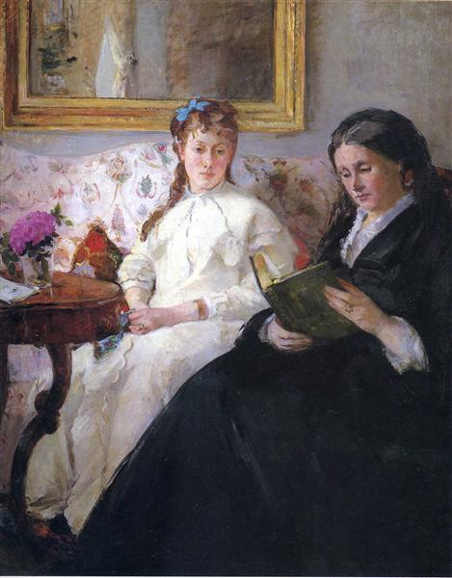

**Title:** *Portrait of the Artist’s Sister and Mother*

**Date:** 1869-70

**Material:** oil on canvas

**Scale:** 81 x 101cm

**Location:** National Gallery of Art, Washington

**Theme/Scope of Work:** Scenes of Leisure in Painting

Berthe posed her sister Edma and mother Cornélie in an intimate domestic setting. Edma sits centrally on a richly upholstered floral settee. Her hands are placed on her lap, her gown covers her pregnant form. Cornélie sits in the right foreground reading, the black of her gown contrasts with Edma’s white clothing. This colour combination shows the influence of Édouard Manet who was a significant presence in Berthe’s life, offering her professional and personal advice.

The interior setting is lavishly decorated. A heavily gilt frame in the background, ornately carved table, flowers and silk wall-hanging all indicate the affluence and style of the Morisot family. Both Edma and her mother clearly show their wedding rings, emphasising their respectability. Neither woman looks at the viewer, Edma appears lost in her own thoughts, giving a casual relaxed air to the scene.

Despite Berthe showing her work at the official Paris Salon she was considered avant-garde and this painting contains many Impressionist techniques. Paint has been applied loosely, giving the forms an unfinished appearance. The background forms are hazy, in particular the framed picture or mirror which hangs behind Edma and the pattern on the settee. Both the left and right side of the painting are cropped, showing the influence of photography which had become an important tool for avant-garde artists at this time. Photographs were used to aid an artist in devising a composition which looks less staged and broke with the conventions of centrally placed figures and objects within a painting. Cornélie’s form appears as a solid mass of black which diagonally divides the work and appears as a block of colour. The Impressionists rarely used black in their works, preferring lighter tones, however Manet uses this colour frequently in his own art.

Light enters the scene from the left and illuminates Edma. Depictions of light falling on forms and figures were a fundamental aspect of Impressionist painting and here it’s used to emphasise the white of the dress and drawing our attention to Edma’s face. Forms are sinuous, we see this in the curved table leg, the trim on Edma’s dress and the pattern on the settee fabric.

The overall appearance of the work is feminine and this is reinforced by the soft application of paint, gentle lighting and the presence of both women who fill the picture. Props including flowers and ribbons strengthen this theme as does the passive attitude of the women.

As a female artist in this period Morisot was limited in the subjects she could depict and thus her focus was on domestic scenes. Female artists were generally restricted from training in the academies favoured by male artists and were predominantly privately tutored. They also had limited access to the nude figure which was a pre-requisite in the training of academic artists of the period. Despite this, Morisot exhibited at the official Paris Salon from 1864 until 1874 when she then worked with the Impressionists. Her associations with the Impressionists exposed her to criticism and ridicule. They were described as “"five or six lunatics—among them a woman—a group of unfortunate creatures” by one art critic. Her mother feared that Berthe’s associations with an avant-garde group such as the Impressionists would limit her marriage prospects and the life of comfort and respectability she had grown up in. Nevertheless Berthe would marry Manet’s younger brother Eugène. The Manet family were themselves affluent and distinguished, securing Berthe social and personal stability and the opportunity to continue her art.

How is this work Impressionist? Analyse the following formal features of this painting in your own words:

|  |  |
| --- | --- |
| Colour | Composition |
| Light/tone | Space/depth |
| Figure handling | Technique (application of paint) |

Consider this work in terms of a depiction of leisure. What does it show? How might it be an illustration of class/gender roles of the era?

How does the artist present her family? Look at the setting, costume, props and the activities they engage in.

What does the subject and its representation tell us about the artist herself?

Specify the influence of photography on this painting and the Impressionists in general.

Consider how this work differs in theme from William Powell Frith’s ‘The Derby Day’. Look at how class is presented in each, the activities depicted in each work and the stylistic differences of Morisot’s Impressionist painting with Powell Frith’s Victorian Academic example.

Find images of women in interior/domestic settings by artists including James Tissot and Alfred Stevens. How does their work differ to Morisot’s?

<https://www.britannica.com/biography/Berthe-Morisot>

<https://arthistoryproject.com/artists/berthe-morisot/portrait-of-the-artists-mother-and-sister/>

<http://www.thelandofdesire.com/2016/09/22/episode-6-berthe-morisot/>

Written response: In your own words and using *Portrait of the Artist’s Sister and Mother* to support your argument, discuss the challenges facing female artists as this time. How did Morisot challenge these conventions? How/why was she perceived as an avant-garde artist? Consider her career in relation to successful male artists of the time such as James Tissot and Alfred Stevens. (500-750 words)