**Artist:** William Powell Frith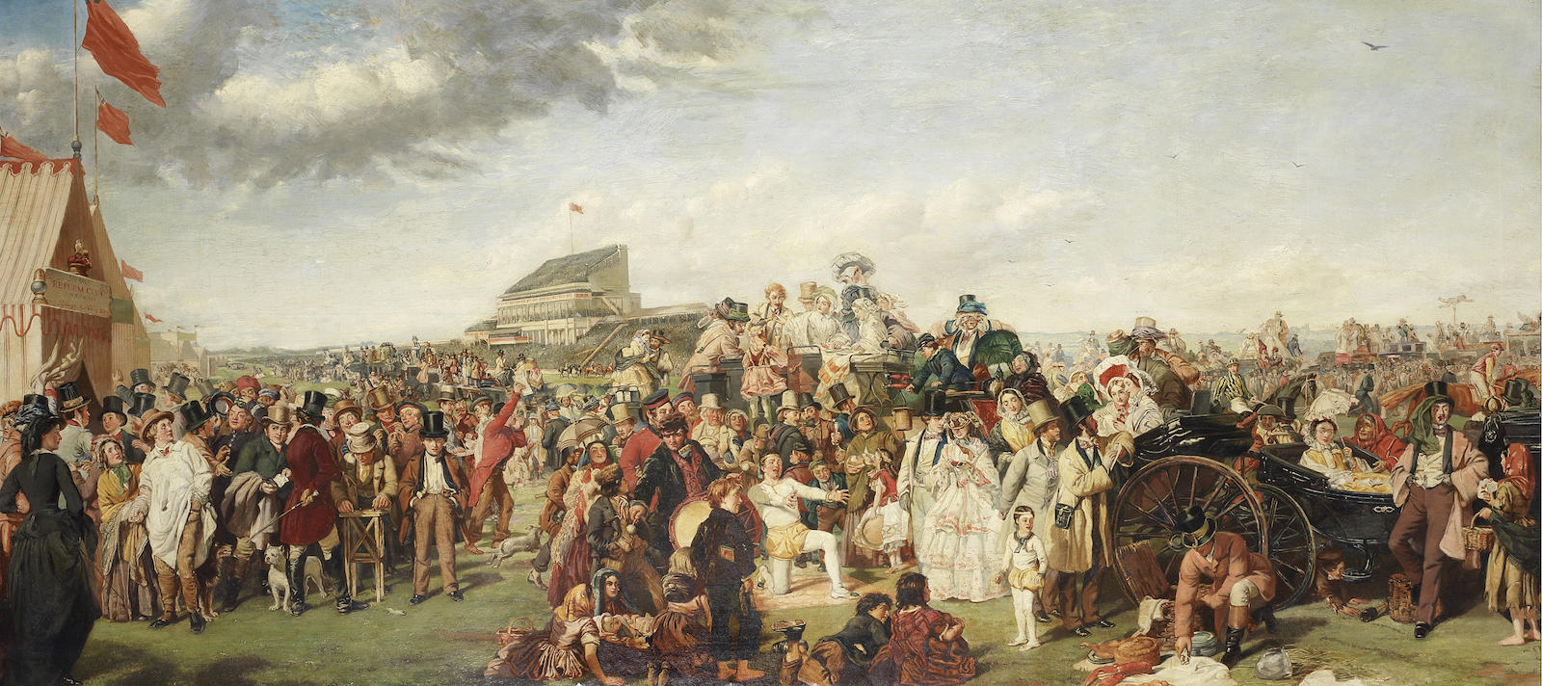

**Title:** *The Derby Day*

**Date:** 1856-58

**Material:** oil on canvas

**Scale:** 101 x 223cm

**Location:** Tate Britain

**Theme/Scope of Work:** Scenes of Leisure in Painting

Inspired by a visit Powell Frith made to the Epsom Derby in 1856, this panoramic scene contains 88 individuals placed across the foreground who represent all strata of Victorian society. The Epsom Derby was the most prestigious event in the race calendar and this annual meeting attracted both the elite and the impoverished. Powell Frith’s painting can be considered a satire on Victorian leisure where the behaviour and appearance of the moneyed upper classes are placed in contrast to their poorer peers.

Powell Frith organised the composition to be ‘read’ from left to right, with distinct groups of individuals interacting with each other across the scene. On the left we see a group of men gathered around a ‘thimble-rigger’ outside a tent for the Reform Club. This group of men range in age and status. Many wear top hats and bet on which of three thimbles contains a pea or coin. A well dressed young man walks away from the scene, his pockets are empty and he has lost his gold pocket watch and shirt studs through betting. His youthful expression and surprised stare is in direct contrast to the sly older features of the men who have conned him. A young man in a farmer’s smock is tempted to join the game but his wife attempts to restrain him. Powell Frith might here be indicating the foolish reckless behaviour of young men, irrespective of their status in life.

The central group shows a father and son acrobatic duo. The father kneels with arms outstretched towards his son, encouraging him to participate in an acrobatic stunt. However the son’s attention has turned towards an expensive picnic being unpacked by the footman of a wealthy couple. The picnic contains items including game but also lobster and a huge block of ice, both decadent luxuries in this period. In front of this grouping we see young children in tattered clothing and a boy selling cigarettes. They have come to look at the acrobats, however they too turn their attention towards the picnic and the well dressed individuals in the open-top carriages.

The potential owners of this picnic are featured on the right. A young lady holding a parasol sits in the carriage ignoring a gypsy who attempts to read her palm. The pale skin and refined features of the lady contrast dramatically with the haggard features of the old gypsy woman and show Powell Frith’s interest in the study of physiognomy. Her ostentatious dress and jewellery suggests she might be a mistress to a wealthy man. Her lover is shown leaning against the carriage, presumably waiting for the picnic to be served. He is approached by a young girl selling flowers. However his facial expression suggests he is more interested in her than her wares. Beneath the carriage we see the hand of a thief reaching to grab a bottle which has rolled away from the picnic. The young lady in the carriage appears disinterested by the scene and her role in life is mirrored on the far left by a standing woman in a riding habit. This individual is presumably a high-class prostitute as she is unchaperoned and placed in close proximity to the large group of wealthy men whose attention she might be hoping to attract.

Despite the race itself being a popular event the artist instead focusses on the actions of those attending. The horses and jockeys are placed in the background and instead the public become the subject. Patches of red appear throughout the scene, carrying our eye across the picture. The horizontal emphasis makes the scene spread out before us, giving a sense of vast space filled by a huge crowd. Depth is achieved through atmospheric perspective and the scaling of forms. The composition is split horizontally with figures occupying the lower half of the painting and a cloudy skill filling the upper portion. This gives a crowded and chaotic appearance, suggesting that all classes have been forced together on this day, with the viewer allowed to compare those attending. Powell Frith relies on stereotyping in his depiction of the people and they appear as if illustrations for characters from a Victorian era novel. We sympathise with many of the people shown, in particular the poverty stricken children such as the flower seller or the young acrobat who are exposed to wealth and luxury they can never achieve.

Powell Frith made great efforts to depict the scene as accurately as possible; making sketches on location, hiring as models real acrobats and using photographs as visual aids he commissioned from friends. He pays particular attention to details, including costumes and props which assist the viewer in comprehending the actions and behaviour of those depicted. The painting is highly finished, as was typical of Victorian Academic art and gives a photographic quality to the work. It was exhibited to great acclaim at the Royal Academy Summer Show and had to be protected using a rail from huge crowds keen to see it. Powell Frith specialised in painting scenes which captured individuals from all sectors of society and was a close friend of Charles Dickens, whose novels shared a similar aim at highlighting social injustice, Victorian stereotypes and the class system using satire.

**Weblinks:**

<https://en.wikipedia.org/wiki/The_Derby_Day>

<https://www.independent.co.uk/arts-entertainment/art/epsom-derby-william-powell-frith-oil-painting-racegoers-horses-crowd-victorian-britain-a8376921.html>

<http://www.costumecocktail.com/2016/08/05/derby-day-1856-8/>

<http://www.epsomandewellhistoryexplorer.org.uk/TheDerbyDay.html>

<https://www.youtube.com/watch?v=MlUeReMUvMk>

**Quotes:** Powell Frith first visited the Epsom Derby in 1856 and wrote in his autobiography “*My first Derby had no interest for me as a race, but as giving me the opportunity of studying life and character it is ever to be gratefully remembered*”.

The Royal Academician John Evan Hodgson noted: "*The races on Epsom Downs, the great Saturnalia of British sport, bring to the surface all that is most characteristic of London life. In this picture we can discern its elements, its luxury, its wealth, its beauty and refinement, its hopeless misery*”.

**Questions to answer:**

1. What is a panorama?  
  
2. List as many items of luxury you can see in this painting.

3. **You will not be able to recall all of the above information in an exam, nor will it be expected.** So, identify the three key sections of the painting and note some of the principal characters in each.

4. Why might Powell Frith have been inspired by the literature of Charles Dickens and why might Dickens have visited the Epsom Derby in the 1850s?

5. Find a definition for the phrase ‘satire’.

6. What is Powell Frith’s motivation for painting this scene? What is he hoping to achieve?  
  
7. How did photography assist Powell Frith in the development of this painting? Use the weblink above to research the role of photography in this painting.

8. Powell Frith was interested in the study of ‘phrenology’ and ‘physiognomy’. Research these terms and examine this painting for any evidence or examples of phrenology and/or physiognomy.

9. How does this work typify Victorian painting? Make a list of the similarities it shares with Ford Madox Brown’s painting ‘*Work*’?

10. How does “Derby Day’ differ to Renoir’s painting ‘Bal du Moulin de la Galette’? Explain the motivations of each artist that differentiate these two key paintings.

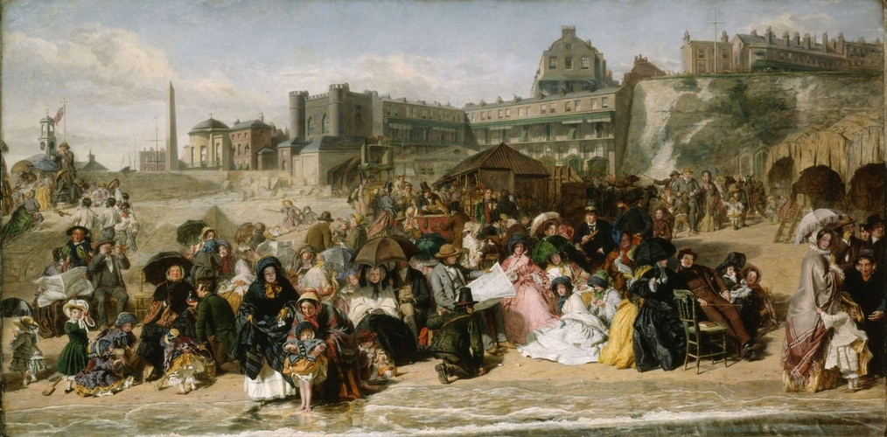Powell Frith visual observations on Victorian society.

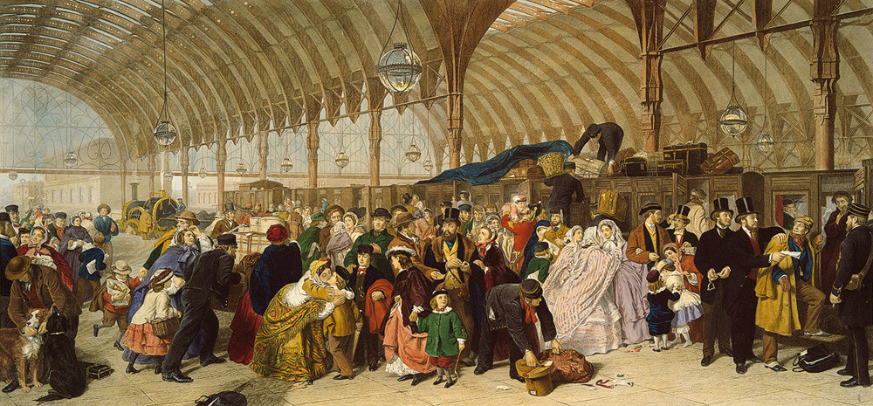*“Ramsgate Sands (Life at the Seaside)”,* 1852-54.

“*Paddington Station*”, c1862

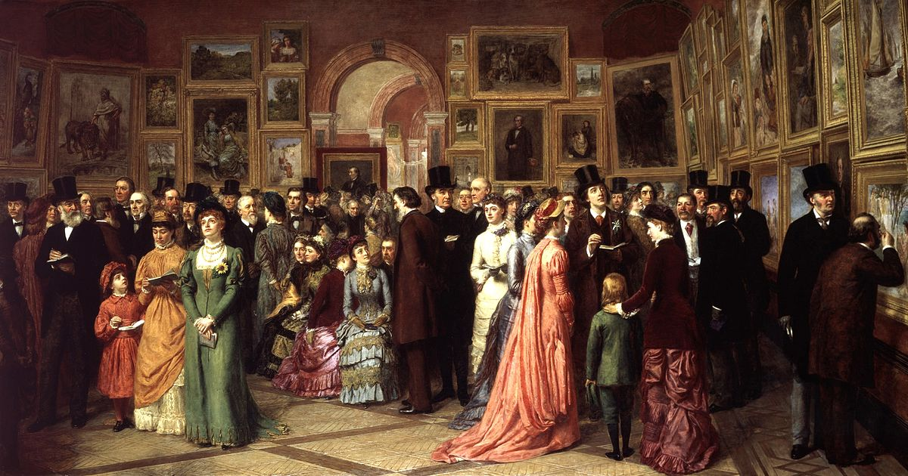

*A Private View at the Royal Academy, 1881,* 1883

**Exam questions this key work can be used to answer.**

Part A: Analyse the composition of one British painting of this period.

Part B: Analyse one painting which depicts a scene of leisure.

Part B: Explain how one British painting has been shaped by its political, social and/or cultural context.

Part B: Explain how one British painting is Victorian in style.