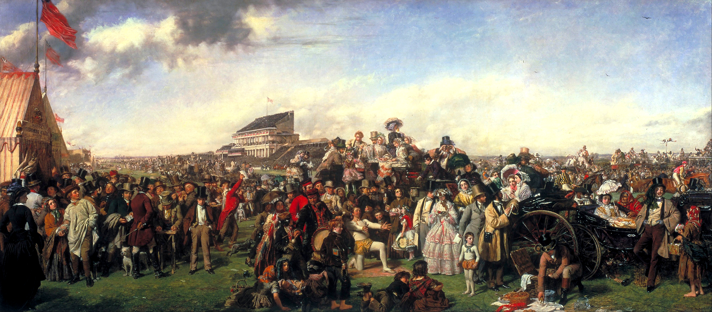

William Powell Frith, *The Derby Day*, 1856-58, oil on canvas, 101 x 223cm

Theme/Scope of Work: Scenes of Leisure in Painting (British)