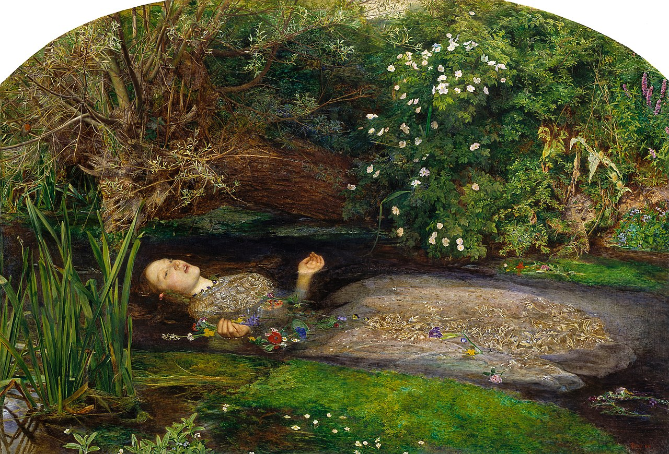

John Everett Millais, *Ophelia*, 1851-52, oil on canvas, 76 x 111cm