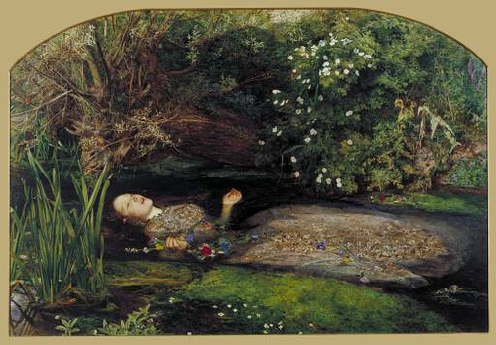**Artist:** John Everett Millais

**Title:** *Ophelia*

**Date:** 1851-52

**Material:** oil on canvas

**Scale:** 76 x 111cm

**Location:** Tate Britain

**Theme/Scope of Work:** Mythological/literary in painting or sculpture

**Context:**

* Ophelia, a character from Shakespeare’s ‘Hamlet’.
* Driven mad by the death of her father at the hands of her lover Hamlet, Ophelia wanders the countryside picking flowers and falls into a river. Grief-stricken at the loss of her father and rejected by Hamlet, she drowns rather than save herself.
* Millais used Queen Gertrude’s speech from Hamlet as source material:

“*There is a willow, grows aslant a brook,*

*That shows his hoar leaves in the glassy stream,*

*There with fantastic garlands did she come,*

*Of crow-flowers, nettles, daisies and long-purples*”.

* The botanical specimens mentioned in the speech were symbolic in Shakespeare’s time but also in the Victorian era and were used to represent various characteristics of human personality and behaviour.
* Additional flowers were added by Millais. Roses represent love and beauty, daisies = innocence and poppies = death. This allows the viewer to understand the narrative and Ophelia.
* The Pre-Raphaelites frequently used literature as inspiration in their work. Shakespeare was popular with these artists.
* Works by poets including Shelley, Keats and Tennyson were also referenced, particularly those relating to the plight of beautiful but tragic female characters or doomed romances.
* Such themes appealed to a Victorian audience who enjoyed sentimental works or art with a moralising tone.
* Due to the immense popularity of the novel at this time, the public were eager to see works of art which illustrated characters they had read about. A large proportion of such works were displayed at the annual Royal Academy exhibition.
* The painting is typically Pre-Raphaelite- intense level of detail and vibrant use of colour.
* Millais was the first to depict Ophelia’s actual death.
* Millais spent five months working on the landscape background, en plein air, capturing as accurately as possible a setting to match the description given in the play.
* He followed the advice of art critic John Ruskin who urged artists to “go to nature in all singleness of heart….rejecting nothing, selecting nothing”.
* This meant artists should paint what they see rather than ‘edit’ their subject matter.
* Shown at the 1852 annual Royal Academy Exhibition the work met with mixed reviews.
* Some of the Victorian audience were shocked by the unflinching depiction of Ophelia’s madness.
* Others felt that Millais was more concerned with the natural setting to the detriment of such a dark subject matter.
* Many recognised the pathos of the image. One critic commenting on the abundance of flowers and plants within the painting wrote: "*I tell you, I am aware of none of these. I see only that face of poor drowning Ophelia. My eye goes to that, and rests on that, and sees nothing else til….the tears blind me, and I am fain to turn from the face of the mad girl to the natural loveliness that makes her dying beautiful*”.
* The above quote identifies what is now celebrated about this painting but was criticised at the time; a scene of tragedy which takes place within a beautiful countryside setting.
* However what Millais may have been trying to highlight was how Ophelia’s mental state made her oblivious to the beauty of nature surrounding her.

**These links relate specifically to this painting and will help you answer the questions below**.

<https://www.tate.org.uk/art/artworks/millais-ophelia-n01506>

<https://en.wikipedia.org/wiki/Ophelia_(painting)>

<https://smarthistory.org/millais-ophelia/>

<https://theculturetrip.com/europe/united-kingdom/england/london/articles/the-meaning-of-ophelia-by-john-everett-millais/>

**Potential exam questions which this work can be used to answer.**

Part A) Explain how colour has been used in one British painting of this period.

Part B) Explain how narrative is conveyed in one painting of this period.

Part A) Explain how one painting is Pre-Raphaelite in style.

Part B) Explain how one British painting has been shaped by its political, social and/or cultural context.

Part B) Explain how one British painting of this period is avant-garde

Q. How is this work Pre-Raphaelite?

Q. Analyse the following formal features of this painting in terms of style, in your own words:

|  |  |
| --- | --- |
| Colour | Composition |
| Light/tone | Space/depth |
| Figure handling | Technique (application of paint) |

Q. In your opinion, why was this work considered radical and avant-garde at the time?

Q. How is the influence of Ruskin evident in the work? **Look at a high resolution image of the work**

Q. The works of the Pre-Raphaelites have been discussed as using ‘symbolic realism’. What is meant by this phrase? Do you consider this to be a contradictory term?

Q. Why might the Pre-Raphaelites have used works by writers such as Shakespeare as inspiration or source material? **(Think about the era of art they were interested in and the theme of revivalism**)

Q. How does Millais cater to a Victorian audience with this painting? What makes this work typically Victorian?

Q. What does the word ‘fidelity’ mean and where/how can it be applied to the production of this painting?

Q. Look for other 19th century depictions of Ophelia by British artists, pre and post 1852 (e.g Arthur Hughes, John William Waterhouse) and attach to this sheet. How do they differ to Millais’ and do any attempt to reference his work?