**Q1.**

Herbicides can be used to reduce the growth of weeds.

Scientists completed seven studies to determine how the use of the herbicide Atrazine affected the yield of sugarcane. In each study, some plots were treated with Atrazine and some plots were not treated with Atrazine.

The graph below shows the scientists’ results. (1 hectare = 10 000 m2)

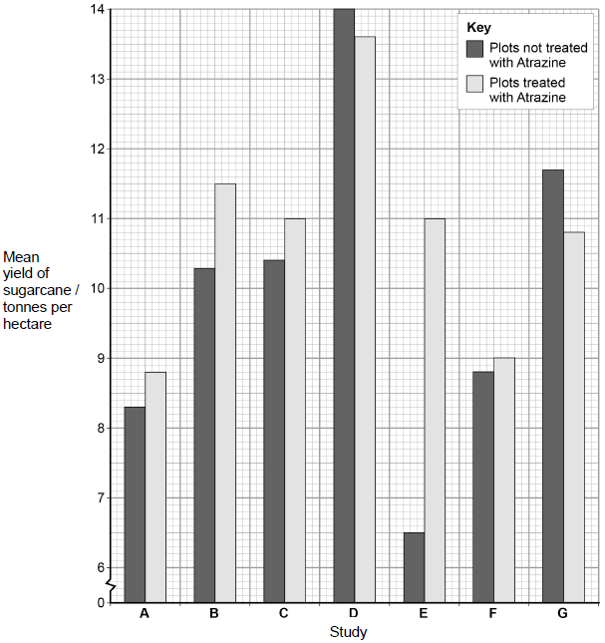

(a)     Calculate the percentage decrease in yield caused by the use of Atrazine in study **G**.

Answer = _________________ %

**(1)**

(b)     A teacher studying these data with her students told her class that no definite conclusions could be drawn when comparing the mean values in the graph.

Suggest why the teacher said this.

___________________________________________________________________

___________________________________________________________________

___________________________________________________________________

___________________________________________________________________

___________________________________________________________________

**(2)**

(c)     Atrazine binds to proteins in the electron transfer chain in chloroplasts of weeds, reducing the transfer of electrons down the chain.

Explain how this reduces the rate of photosynthesis in weeds.

___________________________________________________________________

___________________________________________________________________

___________________________________________________________________

___________________________________________________________________

___________________________________________________________________

___________________________________________________________________

___________________________________________________________________

___________________________________________________________________

___________________________________________________________________

___________________________________________________________________

___________________________________________________________________

**(4)**

(d)     When treated with Atrazine, weeds have been shown to give off small amounts of heat.

Suggest an explanation for this observation.

___________________________________________________________________

___________________________________________________________________

___________________________________________________________________

___________________________________________________________________

**(1)**

**(Total 8 marks)**

**Q1.**

(a)     7.7(%);

**1**

(b)     1.      No error bars / SD;

2.      To show if overlap occurs so difference (in means) is not significant / due to chance

**OR**

To show if no overlap occurs so difference (in means) is significant / is not due to chance.

*Do not accept ‘no statistical test performed’ as Chi squared / Spearman’s rank would be inappropriate.*

*Ignore references to sample size as it can be assumed that scientists completed the study using appropriate methodology.*

**2**

(c)     1.      Reduced transfer of protons across thylakoid membrane

**OR**

Reduced chemiosomotic gradient / proton gradient across thylakoid membrane;

2.      (So) less ATP produced;

3.      (So) less reduced NADP produced;

*Accept NADPH / NADPH2 / NADPH+*

*Reject reduced NAD*

4.      (So) light-independent reaction slows / stops;

**OR**

Less reduction of GP to triose phosphate.

**4**

(d)     Idea that energy is released from high energy / excited electron/s (that were lost from chlorophyll)

**1**

**[8]**