Students investigated the response of beetle larvae to light. They marked sectors on a large circular sheet of cardboard. A lamp with a 100 W bulb was placed close to the cardboard sheet at position **X**. The larvae were released, one at a time, in the centre of the sheet. The direction in which each larva moved was determined by recording the sector into which it first crawled.

The results of 300 trials are shown in the diagram. The length of the bars indicates the number of larvae moving into each sector.

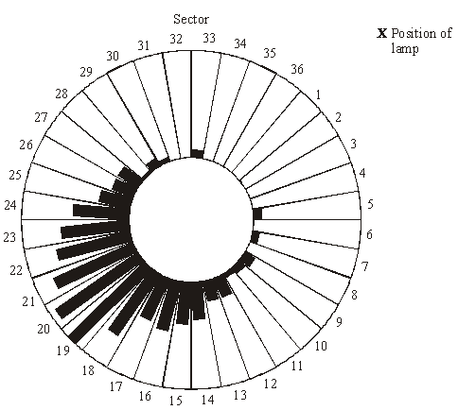

(a)     The students concluded that the larvae respond by moving away from light.

(i)      What is the evidence for this conclusion?

______________________________________________________________

______________________________________________________________

**(1)**

(ii)     Suggest **one** precaution that would ensure the response really was due to light.

______________________________________________________________

______________________________________________________________

**(1)**

(iii)     The larvae moved to a wide range of different sectors. Suggest an explanation for this.

______________________________________________________________

______________________________________________________________

**(1)**

(b)     The sector which gave the median result was sector 20. Explain how the median result would be calculated.

___________________________________________________________________

___________________________________________________________________

___________________________________________________________________

___________________________________________________________________

___________________________________________________________________

**(2)**

**(Total 5 marks)**

**Mark Scheme**

(a)     (i)      majority of larvae move to sectors on opposite side to lamp;  
*(reject largest number / most in sector 19)*

**1**

(ii)     use heat filter in front of lamp

*(allow lamp not too close);*

*rotate card and lamp to eliminate magnetic field;  
alter direction of larval head when releasing;  
(reject general references to keeping variables constant)*

**1 max**

(iii)     wide beam from lamp;  
variability of organisms;  
positioning of larvae variable;

**1 max**

(b)     idea of middle value;  
method of determining middle value in rank order, e.g. sector in which  
300 / 2 occurs;

**2**

**[5]**

**Examiner report**

Many candidates performed well on this question, although it also discriminated quite well in showing those who had not fully absorbed how the investigation was carried out before embarking on their answers.

(a)     (i)      The majority of candidates recognised that most of the larvae had moved to sectors in the opposite direction to the light. Those who carelessly stated that the majority had moved to sector 19 were not credited.

(ii)     Many candidates merely suggested ‘controls’, such as repeating the experiment in the dark or moving the light to other side, or general procedures, such as turning off other lights. These measures, however, would not eliminate the possibility that some other factor than the light itself was the stimulus for the movement. Better candidates did recognise that a heat filter would rule out heat from the lamp as a possible factor.

(iii)     A large number of candidates had not appreciated that the larvae were released one at a time in 300 separate trials. Consequently they suggested that the larvae were being forced into neighbouring sectors by overcrowding. The most common acceptable explanation was based on the idea of variability between larvae. None suggested the practical point that a lamp would give a wide beam.

(b)     It was pleasing to discover that a good number of candidates did understand in principle how to find a median. Some found difficulty in expressing their answer, and many chose a very laborious method involving writing down the results of all 300 trials and then crossing out from either end of their list until they got to the middle. Weaker candidates proposed a wide range of unsuitable mathematical procedures, such as subtracting ‘the highest sector from the lowest and dividing by two’. One candidate’s method even involved multiplying by the wattage of the lamp.