It is believed that each person is born with a certain percentage of slow and fast muscle fibres in their skeletal muscles. Most people have about 50% slow fibres and 50% fast fibres.

A sports scientist wondered if these percentages could change over time depending on the type of sport in which a person was involved. He knew from previous investigations that:

•        the number of mitochondria within a fibre can change

•        the diameter of a fibre can change

•        the number of muscle fibres in a skeletal muscle remains constant over time.

He determined the mean percentages of slow and fast fibres in skeletal muscles of different types of athletes.

His results are shown in the graph below in the form in which he presented them.

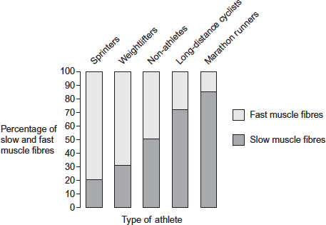

(a)     (i)      In which type of athlete would the sports scientist expect to find muscle fibres with the highest number of mitochondria?

______________________________________________________________

**(1)**

(ii)     Explain the reason for your choice of athlete.

_____________________________________________________________

______________________________________________________________

______________________________________________________________

______________________________________________________________

**(2)**

(b)     The leg muscles of long-distance cyclists are usually larger than the leg muscles of non-athletes.

Suggest why.

___________________________________________________________________

___________________________________________________________________

___________________________________________________________________

___________________________________________________________________

___________________________________________________________________

___________________________________________________________________

**[Extra space]** _______________________________________________________

___________________________________________________________________

___________________________________________________________________

**(3)**

(c)     A reader of the sports scientist’s results stated that ‘the results show that regular weightlifting changes your proportion of slow and fast skeletal muscle fibres.’

Do you agree with this statement? Explain your answer.

___________________________________________________________________

___________________________________________________________________

___________________________________________________________________

___________________________________________________________________

___________________________________________________________________

**(2)**

**(Total 8 marks)**

**Mark Scheme**

(a)     (i)      (Group) 5 / marathon runners.

*Must only include this group and no other.*

**1**

(ii)     1.      (5 / marathon runners) have highest percentage of slow  
         fibres;

*Maximum of* ***1*** *mark if the wrong fibres have been identified.*

2.      (Slow fibres) use aerobic respiration / aerobic respiration occurs in mitochondria;

*Either approach requires identification of aerobic respiration.*

3.      (Slow fibres) best for endurance / long periods of exercise / to avoid fatigue.

**2 max**

(b)     1.      No (overall) change in number of fibres;

*Reject any suggestion of an increase in number of fibres.*

2.      Increase in diameter of fibres;

*‘Size’ without qualification is insufficient.*

3.      (Due to) training / exercise;

4.      (Long-distance) cyclists have more / higher percentage of slow fibres (than fast);

*A comparison is required to meet this MP.*

5.      Slow fibres of wider diameter than fast fibres;

6.      (Long-distance) cyclists have more mitochondria;

7.      (Long-distance) cyclists have more capillaries (in muscles).

*Idea of ‘more’ (than non-athletes) is required to gain credit.*

*Accept converse (for non-athletes) in MP4, MP6 and MP7.*

**3 max**

(c)     1.      Weightlifting favoured by / weightlifters have a high proportion of  
         fast / low proportion of slow fibres

OR

Weightlifters have more fast / fewer slow fibres than non-athletes;

But (cannot tell because):

*Reward for general statement or comparison with non-athletes.*

*For ‘proportion’, accept percentage (or idea of a ratio).*

2.      Do not know what ‘weightlifters’ (tested) were born with / had before started weightlifting / training

OR

Don’t know if there has been a change (in proportion due to weightlifting / training);

3.      No information about age / gender / number of weightlifters (in  
         sample).

*For this MP, accept another relevant factor that might affect ‘weightlifter’ e.g. weights lifted, sex, diet, ethnicity, country of birth.*

*Ignore general statements about ‘other factors’.*

**2 max**

**[8]**

**Examiner report**

(a)     (i)      Nearly all students scored this mark; the wording in the resource should have been used, ‘long distance runners’ is not the name of the group.

(ii)     This was generally well answered and 2 marks were common. Mark point 3 was the least often awarded.

(b)     This was well answered, although mark point 2 was not always awarded, even though it was attempted, due to lack of reference to ‘diameter’; students often referred to ‘thickness’ instead.

(c)     Most students scored mark point 1 and many went on to give mark point 2 or 3.