Exenatide is a drug used for treating Type 2 diabetics. Scientists investigated the effects of exenatide on insulin production.

The scientists used three groups of volunteers who were treated in the following ways.

**Group 1**: healthy, non-diabetics who were injected with exenatide in salt solution   
**Group 2**: Type 2 diabetics who were injected with exenatide in salt solution   
**Group 3**: Type 2 diabetics who were injected with salt solution.

Three hours after these injections, the scientists injected the same amount of glucose into the blood of each volunteer.  
The scientists measured the rate of insulin production by each person before and after injecting the glucose.

(a)     (i)      **Group 1** and **Group 3** were control groups in this investigation.

Explain why each group was used.

**Group 1** _______________________________________________________

______________________________________________________________

**Group 3** _______________________________________________________

______________________________________________________________

**(2)**

(ii)     The scientists measured the rates of insulin production per unit body mass.

Explain why.

______________________________________________________________

______________________________________________________________

**(1)**

(b)     The graphs show the mean rates of insulin production for each group.

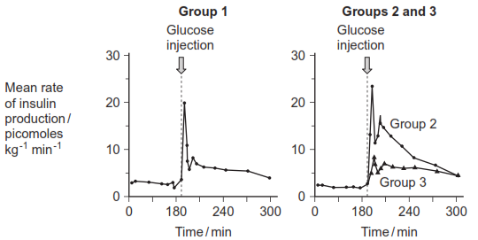

Suggest how exenatide could help people with Type 2 diabetes.

___________________________________________________________________

___________________________________________________________________

___________________________________________________________________

___________________________________________________________________

___________________________________________________________________

___________________________________________________________________

*(Extra space)* ________________________________________________________

___________________________________________________________________

___________________________________________________________________

**(3)**

**(Total 6 marks)**

**Mark Scheme**

(a)     (i)      Group 1:  To see ‘normal’ response / non-diabetic response /  
as comparison with diabetic response;

Group 3:  To ensure any difference was due to exenatide /  
not due to salt / as comparison to show effect of exenatide on  
diabetes / to ensure effect was not psychosomatic /  
to see placebo effect;

**2**

(ii)     Different mass of person → different amount insulin secreted /  
larger person secretes more insulin / (valid) basis for comparisons  
between people;

*Ignore refs to accuracy*

**1**

(b)     Any **three** from:  
Increases sensitivity of pancreas cells to glucose;  
Increases insulin secretion (by pancreas) / similar insulin production  
as healthy / non-diabetic / Group 1;  
So more stimulation of cells / of liver / of muscles;  
Causes more glucose uptake (from blood) / blood glucose level  
lowered / kept at normal level / can control blood glucose conc.;  
Person can consume more carbohydrate / glucose / doesn’t need  
special diet / will not develop symptoms of diabetes;

**3 max**

**[6]**

**Examiner report**

(a)     In part (i), poor expression quite often made it difficult to interpret candidates’ responses, in particular with control **Group 1** which showed the healthy or non-diabetic response. There was often more success in explaining that control **Group 3** showed that **Group 2**’s response was due to the drug exenatide, or was not just due to the salt solution, or that **Group 3** showed any placebo effect.

In part (ii), two-thirds of candidates appreciated that the amount of insulin produced might vary in people of different sizes and, thus, it was necessary to express the results per unit body mass, in order to allow comparisons to be made.

(b)     The vast majority of candidates correctly interpreted the data in terms of the drug exenatide increasing insulin secretion in type 2 diabetics. Many went on to explain how this increase in insulin could help in the control of blood glucose levels. A few indicated that this was due to increased stimulation of cells to take up glucose. Similarly, some indicated that this would mean the diabetic could have a much less restricted diet. Very few gave a full account and hardly any suggested that the drug might possibly increase the sensitivity of pancreas cells to glucose.