The graph shows the concentration of urea in the blood of a mammal after the kidneys stopped working (**P**) and after both the kidneys and the liver stopped working (**Q**).

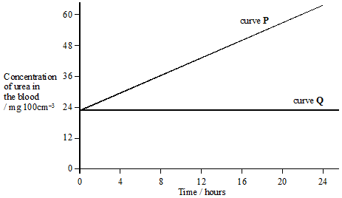

(a)     Explain how the evidence from the graph shows **one** function of

(i)      the kidneys;

Function _______________________________________________________

Evidence from graph _____________________________________________

______________________________________________________________

**(1)**

(ii)     the liver.

Function _______________________________________________________

Evidence from graph _____________________________________________

______________________________________________________________

**(1)**

(b)     On the graph, draw the curve you would expect if the liver stopped working at time 0, and the kidneys stopped working 12 hours later.

**(2)**

**(Total 4 marks)**

**Mark Scheme**

(a)     (i)      (Kidneys) *function*: removes urea from blood, *evidence from graph*: when kidneys not working the level of (blood) urea rises;

**1**

(ii)     (Liver) *function*: makes urea / adds urea to blood, *evidence from graph*: no rise in urea (when liver not working) OR when working, urea not removed, so level rises;

**1**

(b)     *Shown on graph. Firstly need to demonstrate change in gradient at 12 hours.*

Time 0 to 12 hours − steady decline in urea level (below line Q);

Curve horizontal from 12 hours;

*Still award full credit if the line falls to x axis within first 12 hours and remains on the x axis thereafter.*

**2**

**[4]**

**Examiner report**

This question, which required candidates to understand the rudiments of kidney and liver function, provided them with a simple graph to use as a source of evidence. Most candidates were able to gain the mark for (a)(i), giving kidney function as the removal of urea from the blood and explaining this using relevant evidence from the graph. Candidates found (a)(ii) more difficult, with a surprising number failing to realise that the function of the liver was the production of urea. Some who realised this were still unable to justify their answers using evidence from the graph. A relatively large number of candidates confused deamination with urea production, although such a mistake did not necessarily preclude the award of the mark here. Part (b), in which candidates were required to predict the nature of the graph in different circumstances, proved too difficult for around half of the candidates. Up to two marks were available for part (b), with many candidates gaining both of these.