Answers should be written in continuous prose, where appropriate.

Quality of Written Communication will be assessed in these answers.

The waste material from coal mines is deposited in pit heaps. A particular mine closed and the colonisation of an area of its pit heap was studied for a period of 80 years. Species of plants that were found growing on the pit heap were recorded in two categories, short-lived plants that grow for one or two years before dying and long-lived plants that continue to grow for several years. The graph shows the percentages of short-lived and long-lived plants on the pit heap.

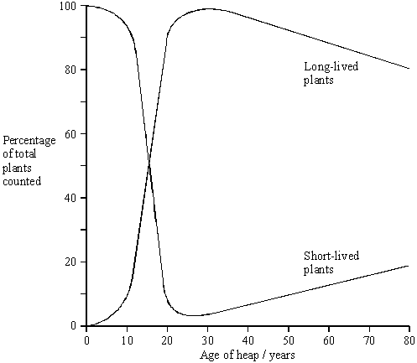

(a)     Using your knowledge of succession, suggest explanations for the changes in the percentages of short-lived and long-lived plants

(i)      over the first 20 years;

______________________________________________________________

______________________________________________________________

______________________________________________________________

______________________________________________________________

______________________________________________________________

______________________________________________________________

______________________________________________________________

______________________________________________________________

(ii)     between 30 and 80 years.

______________________________________________________________

______________________________________________________________

______________________________________________________________

______________________________________________________________

______________________________________________________________

______________________________________________________________

______________________________________________________________

______________________________________________________________

**(6)**

(b)     Mine waste often contains metal ions at concentrations that are toxic to plants. Populations of two species of grass, red fescue and common bent, have been found on pit heaps contaminated with zinc ions.

Describe an experiment you would carry out in order to determine which of the two species has the greater tolerance to zinc ions in the soil.

___________________________________________________________________

___________________________________________________________________

___________________________________________________________________

___________________________________________________________________

___________________________________________________________________

___________________________________________________________________

___________________________________________________________________

___________________________________________________________________

**(3)**

**(Total 9 marks)**

**Mark Scheme**

(a)     (i)      tips colonised by short-lived plants / short lived plants are pioneers;  
short-lived plants fast growing / spreading / distribute seeds quickly;  
short-lived plants change the environment e.g. make conditions  
more favourable for long-lived plants;  
valid reference to competition;

(ii)     long-lived plants compete with each other;  
death of some long-lived plants;  
more niches / leaving spaces / areas for growth of short-lived  
plants; short-lived plants recolonise;

**6 max**

(b)     control of named variable e.g. light, water-content, nutrients;  
large numbers of both species / 10+ individuals;  
range of different concentrations of zinc;   
valid measurement of growth, height / leaf area / root   
growth / numbers / mass / % germination;  
statistical analysis / correlation between the two sets of data;  
OR  
large number of samples taken (in the field);  
principle of determining zinc concentration of soil;  
valid measurement of growth, height / leaf area / root  
growth / numbers / mass / % germination;  
statistical analysis / correlation between the two sets of data;

**3 max**

**[9]**

**Examiner report**

Candidates gave variable answers. Most students recognised the question was concerned with succession but often failed to achieve good marks by not clearly interpreting the data or by simply giving an account of succession not linked to the information given.

(a)     (i)      Usually students gained marks by appreciating that the short-lived plants were the colonisers and that competition with the long-lived plants resulted in the changes observed. Fewer gave good explanations of how or why these changes occurred.

(ii)     This was answered less well with students often failing correctly to link the time period with the data in the graph and many referring to competition between the short and long-lived plants. Few appreciated that the death of long-lived plants enabled recolonisation by short-lived plants.

(b)     Most gained one or two marks but the expression of ideas was generally poor and few gave a good account of a controlled experiment which generated valid data. There were vague references to ‘adding varying amounts of zinc’ or ‘seeing when the plants died.‘