Scientists investigated the effect of bromelain on cancer cells. They took cells from skin cancers in mice and added them to a liquid growth medium in two dishes.

Four hours later they added a solution of bromelain to one of the dishes. They left the other dish as a control. They also added a substance to both dishes that is turned purple by respiring cells.

Both dishes were placed in an incubator. The scientists measured the intensity of the purple colour at intervals over a period of 100 hours.

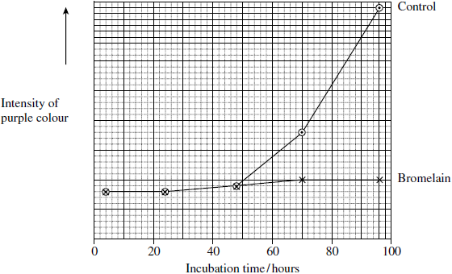

(a)     The scientists put the same number of skin tumour cells in each dish at the start of this investigation. Explain why it was important to put the same number of cells in each dish.

___________________________________________________________________

___________________________________________________________________

**(1)**

(b)     The scientists concluded that bromelain did not kill cancer cells but stopped them dividing. Does the graph support this conclusion? Explain your answer.

___________________________________________________________________

___________________________________________________________________

___________________________________________________________________

___________________________________________________________________

**(2)**

(c)     An article in a newspaper claimed that these data show that bromelain can be used to treat cancer.

Give **three** reasons why we should be careful about accepting this claim.

1. _________________________________________________________________

___________________________________________________________________

2. _________________________________________________________________

___________________________________________________________________

3. _________________________________________________________________

___________________________________________________________________

**(3)**

(d)     The rate of cell division is important in investigations into cancer. Suggest why.

___________________________________________________________________

___________________________________________________________________

___________________________________________________________________

___________________________________________________________________

**(2)**

(e)     Scientists have investigated the effects of bromelain on cancer growth in humans. Suggest why they gave bromelain in addition to, rather than instead of, the usual treatment.

___________________________________________________________________

___________________________________________________________________

___________________________________________________________________

___________________________________________________________________

**(2)**

**(Total 10 marks)**

**Mark Scheme**

(a)     To ensure the colour is the same at the start;

**1**

(b)     Yes – curve on graph with bromelain present remains approximately constant / rises very slightly;  
Would decrease if killing of cells occurred / would increase if cells still dividing;

**2**

(c)     Use of mouse cells (rather than human);  
(Carried out) *in vitro* / not in living organisms;  
Only tested on one type of cancer;  
Not possible to predict effect on humans (as no data collected);

**3 max**

(d)     The faster the rate of division the faster the cancer would grow;  
By measuring rate of cell division you could see how effective the treatment was;

**2**

(c)     Not ethical to replace conventional treatment;  
As life of patient is at risk (if bromelain not effective);

**2**

**[10]**