**Why did we sell off the railways?**

The Transport Secretary Chris Grayling announced that the East Coast main line was to be taken back into public ownership. The FT have released a fantastic video that asks the question; "Why did we sell off the railways?"

[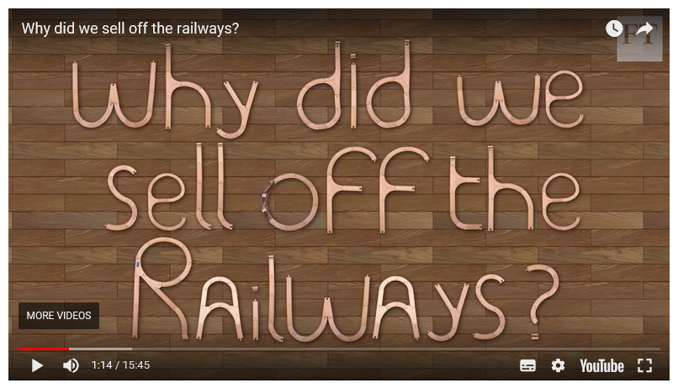](https://www.youtube.com/watch?v=U6V-HDbX9A8)

Link: <https://www.youtube.com/watch?v=U6V-HDbX9A8>

Related topics: private and public sector / privatisation / nationalisation